Management Control System

Software Training Materials

**Table of Contents**

1. INTRODUCTION OF MANAGEMENT CONTROL SYSTEM 7

How to Log in the MCS 8

2. ADMINISTRATION WING 8

3.ESTATE MANAGEMENT (SUB MODULE) 10

4.ESTATE MENU OVERVIEW 11

4.1: Add Lease Menu Overview 12

4.1.1: (Add Lease) Add Lease Information Input field 12

4.2: Lease Payment Menu Overview 13

4..2.1: (Lease Payment) Add Lease payment input field 13

4..2.2: (Lease Payment) View of Lease Payment List 14

4..2.3: (Lease Payment) Update input field 14

4..2.4: (Lease Payment) Delete 15

4..2.5: (Lease Payment) Search 16

4.3: Single Report Menu Overview 16

4..3.2: (Single Report) View of Lands report 17

4..3.2.1: (Single Report) view of lands report(Details) 17

4..3.2.2: (Single Report) view of lands report (Update) 18

4..3.2.3: (Single Report) view of lands report (Delete) 19

4..3.3: (Single Report) View of ponds report 20

4..3.3.1: (Single Report) View of ponds report(Details) 20

4..3.3.2: (Single Report) View of ponds report(Update) 21

4..3.3.3: (Single Report) View of ponds report(Delete) 22

4.3.4: (Single Report) View of others report 22

4.3.4.1: (Single Report) View of others report(Details) 23

4.3.4.2: (Single Report) View of others report(Update) 23

4.3.4.3: (Single Report) View of others report(Delete) 24

4.3.5: (Single Report) View of all report 25

4.3.5.1: (Single Report) View of all report(Delete) 25

4.4: All Report Menu Overview (Same as Single report……Incomplete) 26

4.5: Settings Menu Overview 27

4.5.1.1: Add Pond (Settings) add new pond input field 27

4.5.1.2: Add Pond (Settings) view details of add new pond 28

4.5.1.3: Add Pond (Settings) Update 29

4.5.1.4: Add Pond (Settings) Delete 29

4.5.1.5: Add Pond (Settings) Search 30

4.5.2.1: Add Agriculture land (Settings) add new agriculture land input field 31

4.5.2.2: Add Agriculture land (Settings) view details of agriculture land 31

4.5.2.3: Add Agriculture land (Settings) Update 32

4.5.2.4: Add Agriculture land (Settings) Delete 33

4.5.2.5: Add Agriculture land (Settings) Search 33

4.5.3.1: Add Non-Agriculture land (Settings) Add nonagriculture land input field 34

4.5.3.2: Add Non Agriculture land (Settings) View details of non agriculture land 35

4.5.3.3: Add Non Agriculture land (Settings) Update 35

4.5.3.4: Add Non Agriculture land (Settings) Delete 36

4.5.3.5:Add Non Agriculture land (Settings) Search 37

4.5.4.1: Add Others/Tariff (Settings) Add new others/tariff input field 37

4.5.4.2: Add Others/Tariff (Settings) view details others/tariff 38

4.5.4.3: Add Others/Tariff (Settings) update 39

4.5.4.4: Add Others/Tariff (Settings) Delete 39

4.5.4.5: Add Others/Tariff (Settings) Search 40

4.5.5.1: Add Person (Settings) Add person input field 41

4.5.5.2: Add Person (Settings) view of add person details 41

4.5.5.3: Add Person (Settings) view document 42

4.5.5.4: Add Person (Settings) Download document 42

4.5.5.5: Add Person (Settings) Update 43

4.5.5.6: Add Person (Settings) Delete 44

4.5.5.7: Add Person (Settings) Search 44

4.5.6.1: Add Institute (Settings) add new institute input field 45

4.5.6.2: Add Institute (Settings) Add institute view details 46

4.5.6.3: Add Institute (Settings) download document 46

4.5.6.4: Add Institute (Settings) view document 47

4.5.6.5: Add Institute (Settings) Update 48

4.5.6.6: Add Institute (Settings) Delete 48

4.5.7.1: Add Govt/Others (Settings) add new govt/others input field 49

4.5.7.2: Add Govt/Others (Settings) add govt/others view details 50

4.5.7.3: Add Govt/Others (Settings) download document 50

4.5.7.4: Add Govt/Others (Settings) view document 51

4.5.7.5: Add Govt/Others (Settings) Update 52

4.5.7.6: Add Govt/Others (Settings) Delete 52

4.5.8.1: Update Vat/Tax (Settings) View details 53

4.5.8.2: Update Vat/Tax (Settings) Update 54

5.TRANSPORT (SUB MODULE) 54

6.TRANSPORT MENUS OVERVIEW 55

6.1: New Requisition Menu Overview 56

6.1.1: (New Requisition) Add new requisition input field 57

6.2: Requisition List Menu Overview 58

58

6.2.1: ( Requisition List)View of Requisition List 58

6.2.2: ( Requisition List) Update 59

6.2.3: ( Requisition List) Download Requisition list 59

6.3: Manage Drivers List Menu Overview 61

6.3.1: ( Manage Drivers) Add new (Outsource driver record form) 61

6.3.2: ( Manage Drivers)view of details 62

6.3.3: ( Manage Drivers) Download the report 62

6.3.4: ( Manage Drivers)Search Driver 63

6.4: Vehicle Menu Overview 65

6.4.1.1: Vehicle Record (Vehicle )Add vehicle 65

6.4.1.2: Vehicle Record (Vehicle )View of Details 66

6.4.1.3: Vehicle Record (Vehicle )Vehicle Update 67

6.4.1.4: Vehicle Record (Vehicle )Driver Update 67

6.4.1.5: Vehicle Record (Vehicle )Download Report 68

6.4.1.6: Vehicle Record (Vehicle )Search 69

6.4.2.1: Types (Vehicle )Add New(Vehicle Category Record form) 70

6.4.2.2: Types (Vehicle )View of details 70

6.4.2.3: Types (Vehicle )Download Report 71

6.4.2.4: Types (Vehicle ) Vehicle Category Update 72

6.4.3.1: Models (Vehicle )Vehicle Model record from 73

6.4.3.2: Models (Vehicle )View of models details list 73

6.4.3.3: Vehicle Model Update Form 74

6.4.3.4: Models (Vehicle ) Download Model list Report 75

6.4.4.1: Manufacturers (Vehicle )Vehicle Manufacturer record from 76

6.4.4.2: Manufacturers (Vehicle )View of manufacturers details list 76

6.4.4.3: Manufacturers (Vehicle )Download Report 77

6.4.5.1: Pools (Vehicle )Vehicle pool record form 78

6.4.5.2: Pools (Vehicle )View of details vehicle pool list 79

6.4.5.3: Vehicle Pool Update Form 79

6.4.5.4: Pools (Vehicle )Download Report 80

6.4.6: Settings (Vehicle ) 81

6.4.6.1: Settings (Vehicle )Vehicle common user add form, vehicle common user list, edit and download report. 81

6.4.6.2: Settings (Vehicle )Vehicle common Route add form, vehicle route list, edit and download report. 84

6.5: Requisition Menu Overview 87

6.5.1.1: Requisition Record (Requisition)View of all requisition list 87

6.5.1.2: Requisition Record (Requisition)Report download 88

6.5.1.3: Requisition Record (Requisition)Search 89

6.5.2.1: Control Officer (Requisition)View of pending requestion for controller officer. 90

6.5.2.2: Control Officer (Requisition)Download report. 90

6.5.3.1: Pending (Requisition)View of pending requisition list. 91

6.5.4.1: Approved(Requisition)Approved requisition list. 92

6.6: Maintenance Menu Overview 93

6.6.1.1: Maintenance Record(Maintenance)Add new vehicle servicing 93

6.6.1.2: Maintenance Record(Maintenance)View of servicing list 94

6.6.1.3: Maintenance Record(Maintenance)Single Details servicing 95

6.6.1.4: Maintenance Record(Maintenance)Search 95

6.6.1.5: Maintenance Record(Maintenance)Service report download 96

6.6.1.6: Maintenance Record(Maintenance)Details report download 97

6.6.2.1: Product Category(Maintenance)Add new Category 98

6.6.2.2: Product Category(Maintenance)Update category data 99

6.6.2.2: Product Category(Maintenance)Download Report 99

6.6.3.1: Product List(Maintenance)Add new product 100

6.6.3.2: Product List(Maintenance)Product Update 101

6.6.3.3: Product Lists(Maintenance)Download Report 102

6.6.4.1: Workshop(Maintenance)Add workshop 103

6.6.4.2: Workshop(Maintenance)Update workshop data 103

6.6.4.3: Workshop(Maintenance)Download Report 104

6.6: Fuel Menu Overview 105

6.7.1.1: Fuel Record(Fuel)Add new fuel record form 106

6.7.1.2: Fuel record(Fuel)View of fuel record list 106

6.7.1.3: Fuel Record(Fuel)Update fuel record data 107

6.7.1.4: Fuel Record(Fuel)Download Report 108

6.7.1.5: Fuel Record(Fuel)Search 109

6.7.2.1: Fuel Type(Fuel)Add new fuel type form 109

6.7.2.2: Fuel Type(Fuel)View of fuel type list 110

6.7.2.3: Fuel Type(Fuel)Update fuel type data 111

6.7.2.4: Fuel Type(Fuel)Download Report 111

6.8: Manage Rank Menu Overview 112

6.8.1: (Manage Rank)View of requisition hierarchy rank list 113

6.8.2: (Manage Rank)Update Requisition hierarchy 113

6.8.3: (Manage Rank)Report download 114

7.IT (SUB MODULE) 115

8.IT MENUS OVERVIEW 116

8.1: Requisitions Menu Overview 118

118

8.1.1:Pending(Requisitions) View the pending all requisitions list 118

8.1.2:Approved(Requisitions) View approved all requisitions list 119

8.1.3:Done(Requisitions) Complete all requisitions list view 119

8.1.4:Denied(Requisitions) **some problem has been occured** 121

8.2: Maintenance Menu Overview 121

8.2.1.1:(Maintenance)View all the maintenance products information 122

8.2.1.2:View(All Requisition)Search 122

8.2.2.1.:Products(All Requisition)view requisition product details 122

8.2.2.2:Products(All Requisition)Search 122

8.3: Store Menu Overview 121

8.3.1:Products(Store)View all bba store products 122

8.3.2:Supplier(Store) View Supplier wise product information. 122

8.4: Reports Menu Overview 124

8.4.1:Products(Reports)Products report generator input field & Result 124

8.4.2:MRR(Reports)Supplier wise products view and receipt list 125

8.4.3:Requisitions(Reports)Category wise requisitions report generator 125

8.4.4:Maintenance(Reports)Product maintenance report generator & result 129

# 1. INTRODUCTION OF MANAGEMENT CONTROL SYSTEM

……….

….

…….

…….

…….

Link for MCS is <http://192.168.3.7:3000/> which is accessible within BBA’s local network . After search will open a login page. Which is like –

### How to Log in the MCS

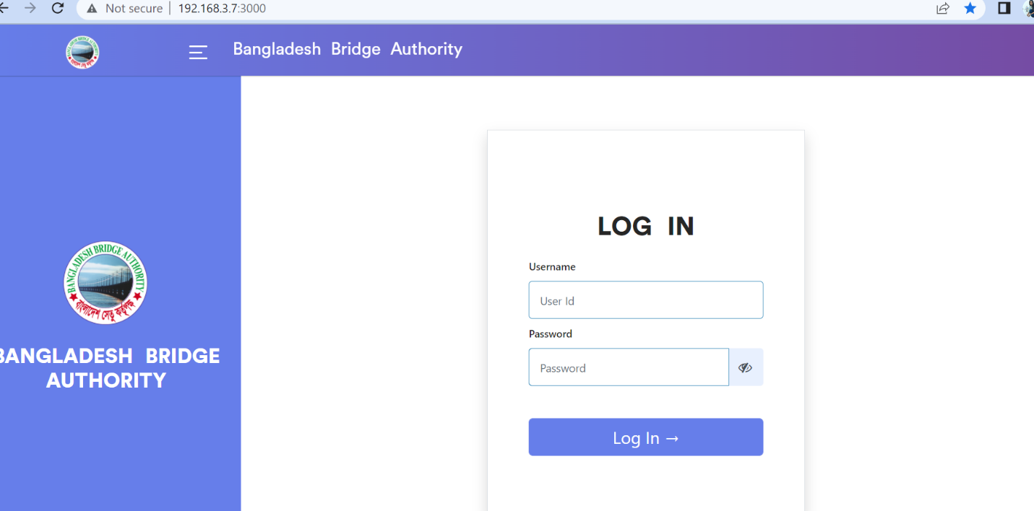

Figure 1: Log in Page

**Steps to Log in MCS**

1. User will input his Username
2. User will input his Password
3. Click Log In Button

If the username & password are correct, users will get access to the system.

# 2. ADMINISTRATION WING

For the Administration module –

**Steps to Enter in Administration**

1. After login will show this dashboard of MCS.

2. Click on the Administration.

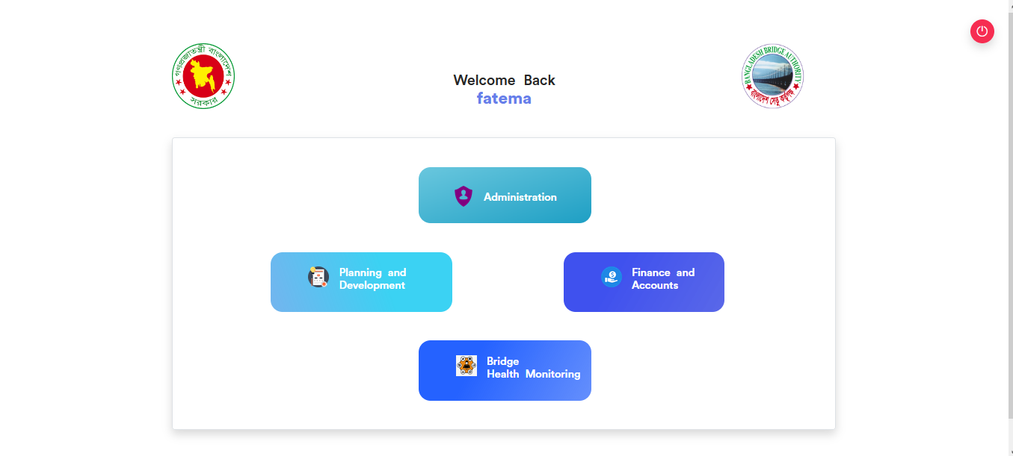

Figure 2.1: Dashboard of MCS

After entering into Administration then there will show another dashboard with another Five (5) Submodules. Such as-

1.Human Resources

2.Estate

3.Transport

4.IT

5.Store

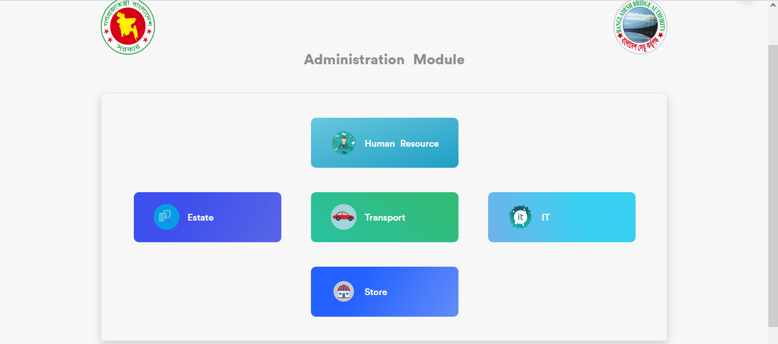

Figure 2.2: Dashboard of Administration Module.

**Overview of Administration Sub Modules**

# 3.ESTATE MANAGEMENT (SUB MODULE)

After clicking into Estate, it will redirect to the (Estate Sub Module) dashboard with some menus.

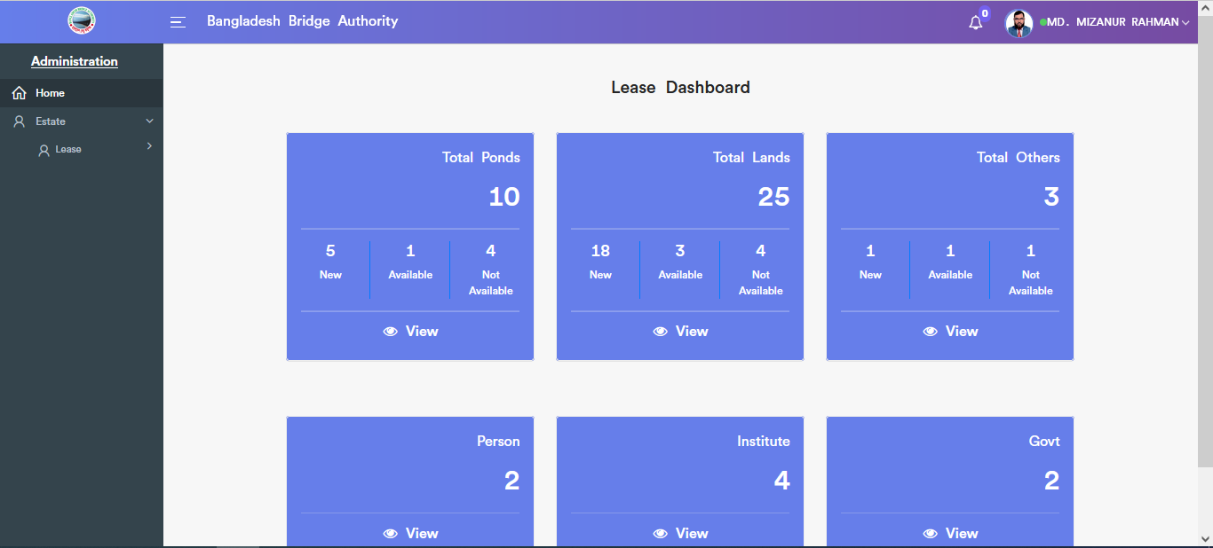

Figure 3: Dashboard of the estate (sub module).

There are six segments on the right side of the Estate Dashboard Such as **Total Ponds, Total Lands ,Total Others, Person, Institute** And **Govt.**

To get the details info about (**Total Ponds, Total Lands ,Total Others, Total person , Institute ,Govt**) just click on the view after that it will redirect to the relevant details info page.

# 4.ESTATE MENU OVERVIEW

**Estate Menus Overview**

## 4.1: Add Lease Menu Overview

**Overview of Add Lease**

### 4.1.1: (Add Lease) Add Lease Information Input field

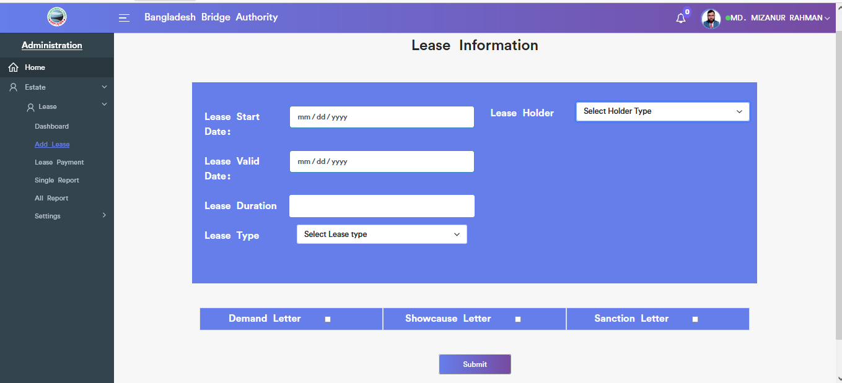

Figure 4.1.1.: add lease information input field

## 4.2: Lease Payment Menu Overview

**Overview of Lease Payment**

### 4..2.1: (Lease Payment) Add Lease payment input field

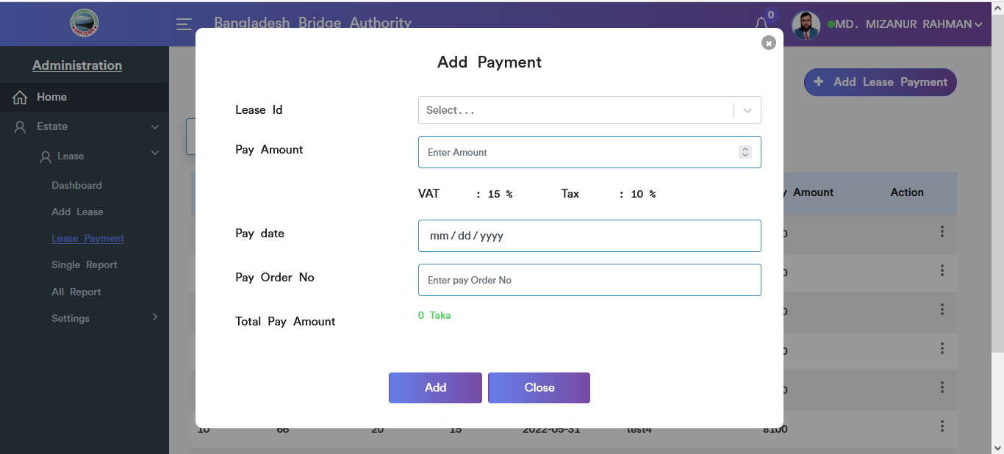

Figure 4.2.1.: add lease payment input field

### 4..2.2: (Lease Payment) View of Lease Payment List

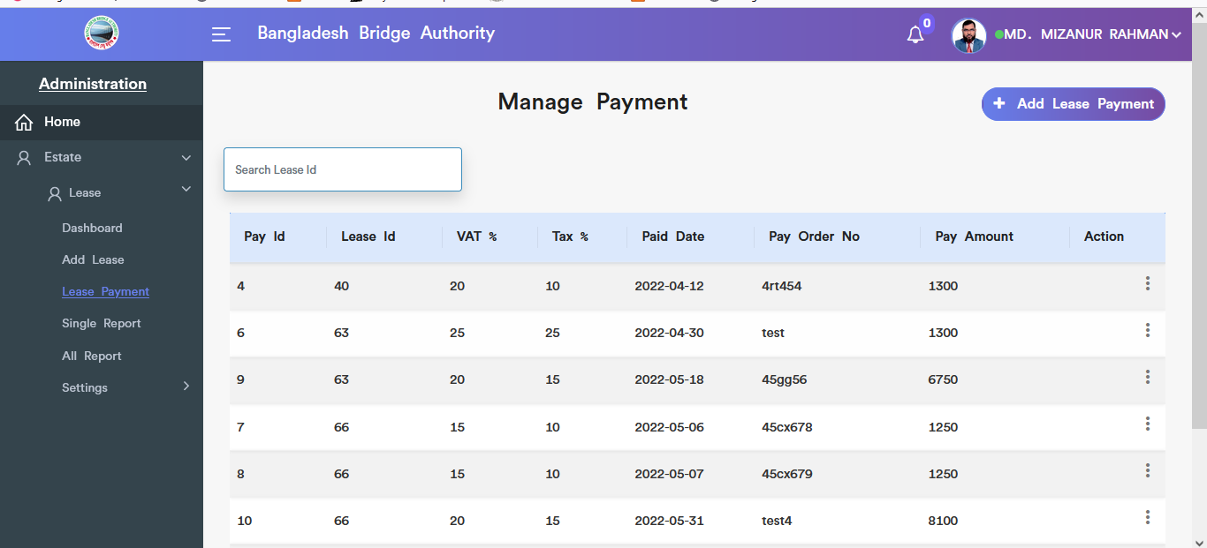

Figure 4.2.2.: view of lease payment list

### 4..2.3: (Lease Payment) Update input field

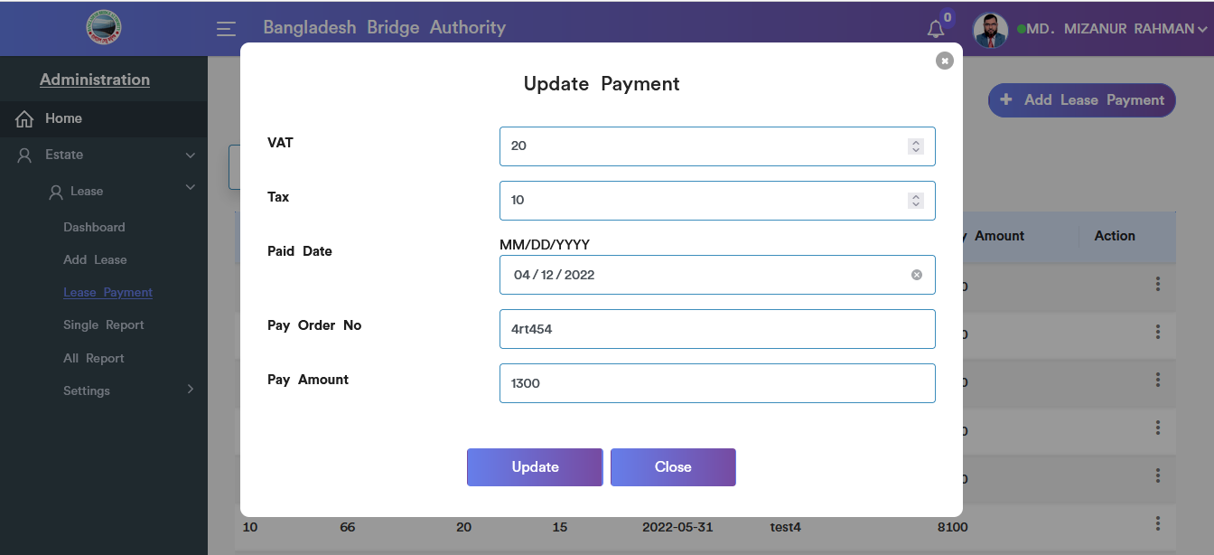

Figure 4.2.3.: Lease payment Update input field

### 4..2.4: (Lease Payment) Delete

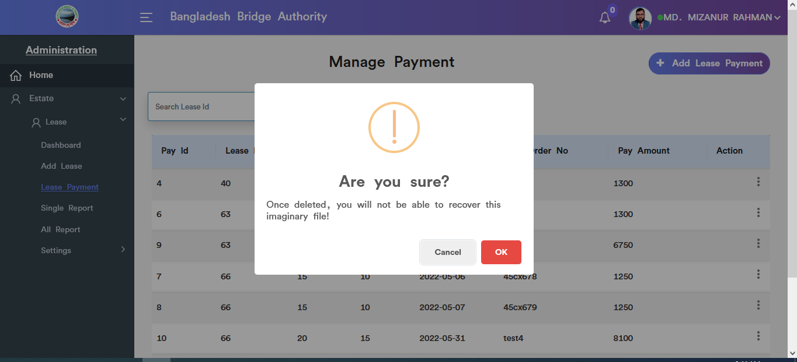

Figure 4.2.4.: Lease payment data delete

### 4..2.5: (Lease Payment) Search

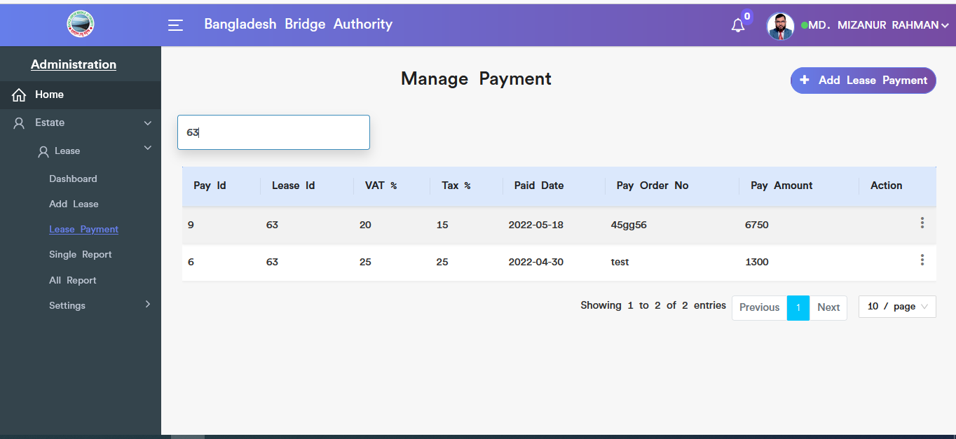

Figure 4.2.5.: Lease payment Search

## 4.3: Single Report Menu Overview

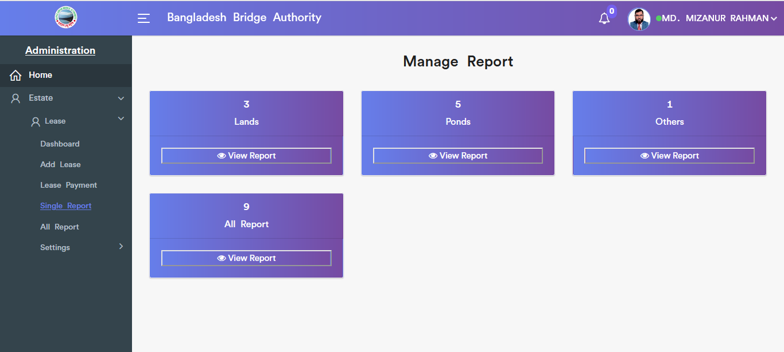

Figure 4.3.: (single report) view of single report (all) options

**Overview of Single Report**

### 4..3.2: (Single Report) View of Lands report

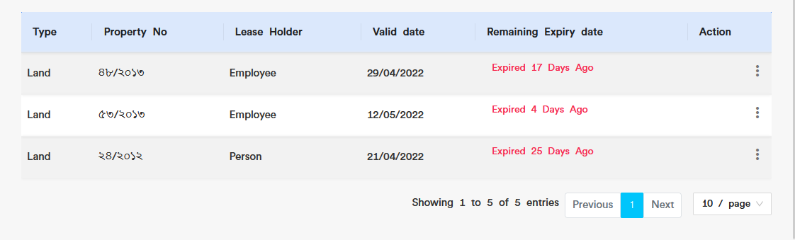

Figure 4.3.2.: (single report) view of lands report

### 4..3.2.1: (Single Report) view of lands report(Details)

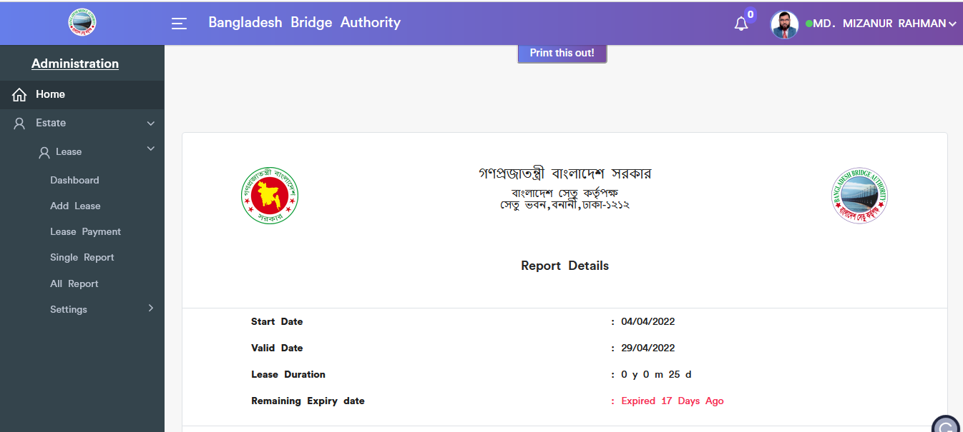

Figure 4.3.2.1.: view of lands report(details)

### 4..3.2.2: (Single Report) view of lands report (Update)



Figure 4.3.2.2.: view of lands report update input field

### 4..3.2.3: (Single Report) view of lands report (Delete)

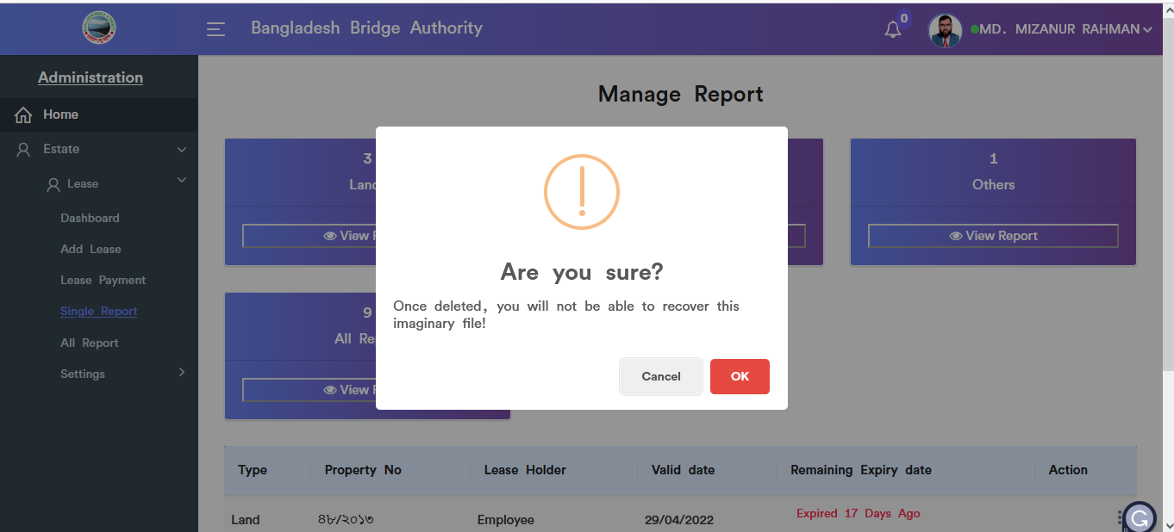

Figure 4.3.2.3.: view of lands report(delete)

### 4..3.3: (Single Report) View of ponds report

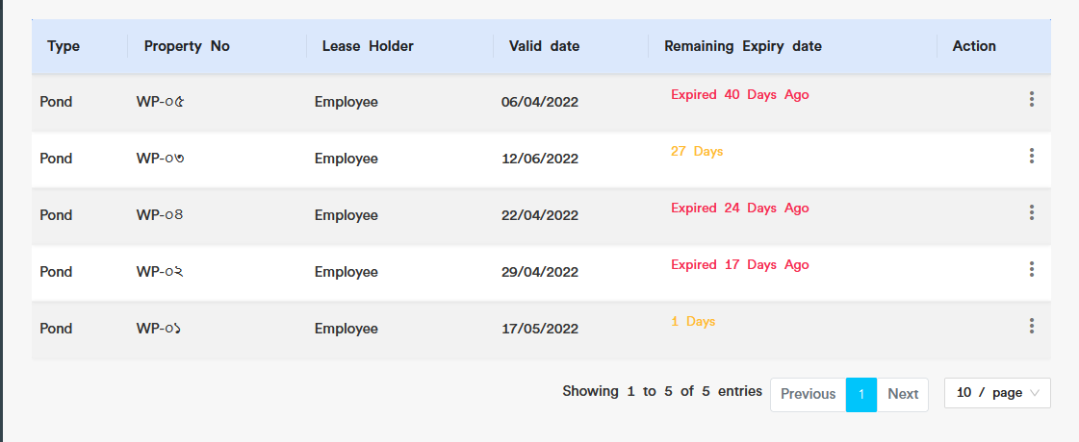

Figure 4.3.3.: view of ponds report

### 4..3.3.1: (Single Report) View of ponds report(Details)

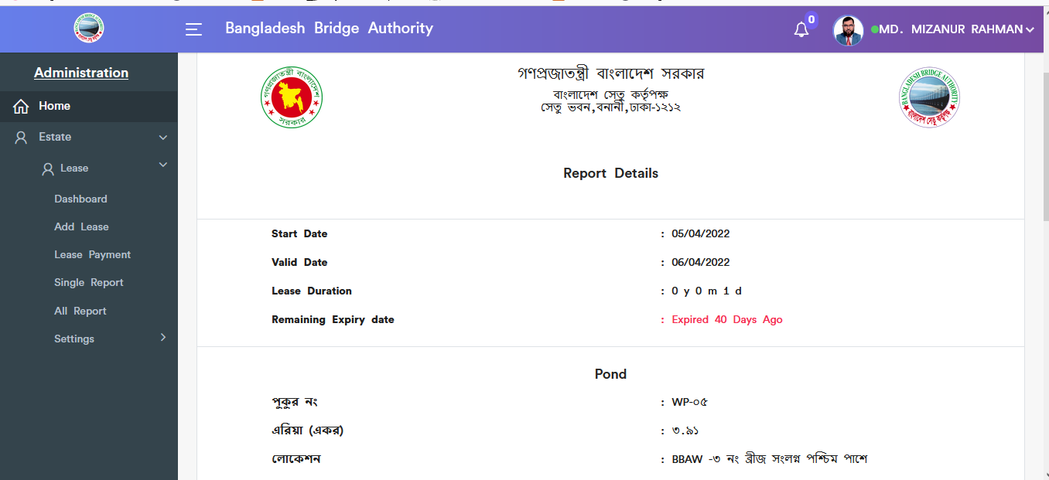

Figure 4.3.3.1: view of ponds report(details)

### 4..3.3.2: (Single Report) View of ponds report(Update)



Figure 4.3.3.2: view of ponds report(Update)

### 4..3.3.3: (Single Report) View of ponds report(Delete)

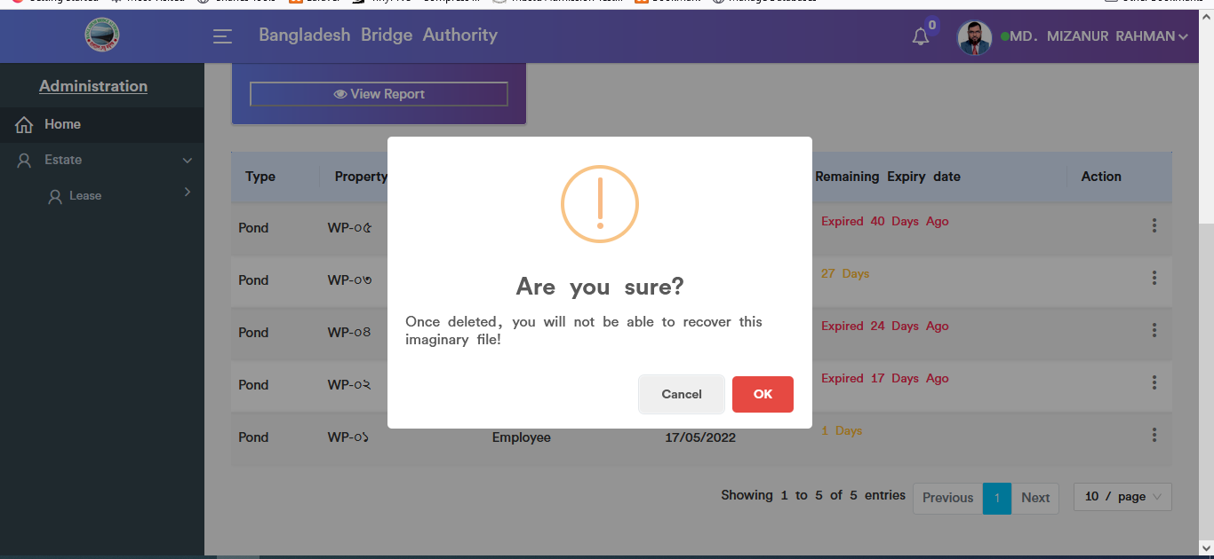

Figure 4.3.3.3: (single report) view of ponds report(delete)

### 4.3.4: (Single Report) View of others report

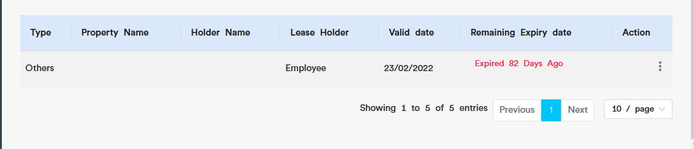

Figure 4.3.4: view of others report

### 4.3.4.1: (Single Report) View of others report(Details)

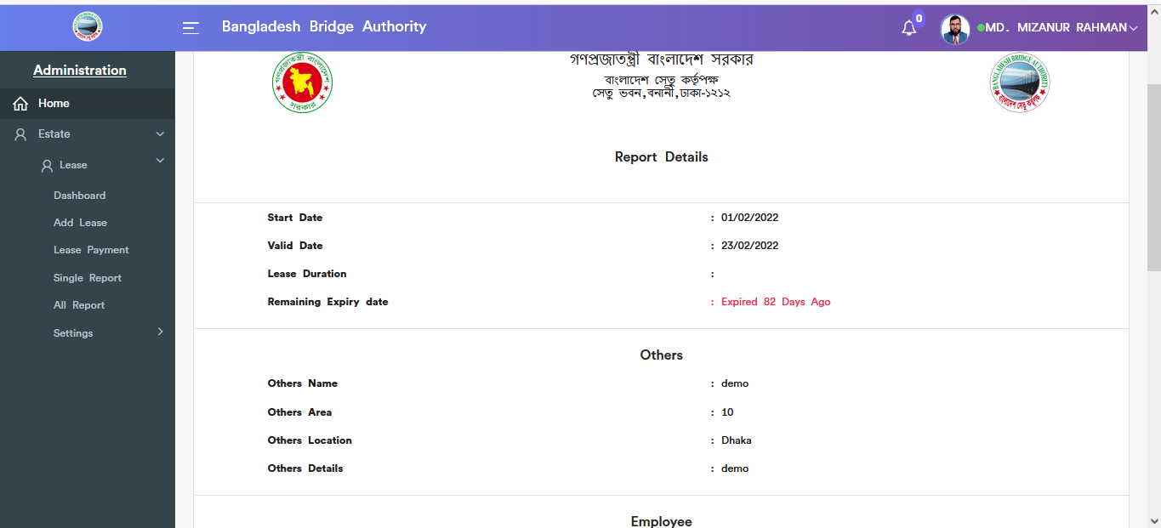

Figure 4.3.4.1: view of others report(details)

### 4.3.4.2: (Single Report) View of others report(Update)



Figure 4.3.4.2: view of others report(update)

### 4.3.4.3: (Single Report) View of others report(Delete)

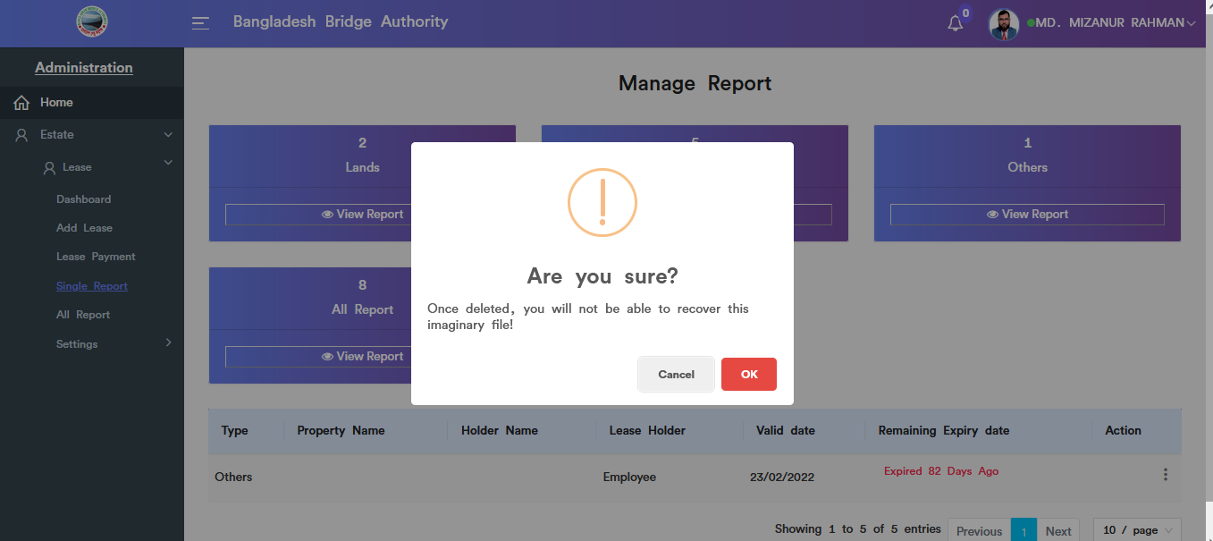

Figure 4.3.4.3: view of others report(delete)

### 4.3.5: (Single Report) View of all report

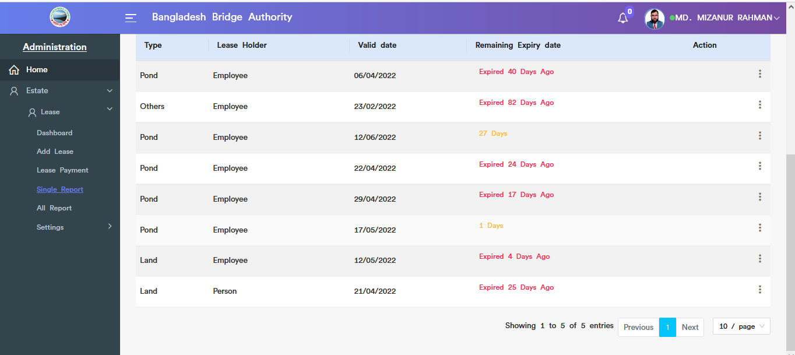

Figure 4.3.5: view of all report

### 4.3.5.1: (Single Report) View of all report(Delete)

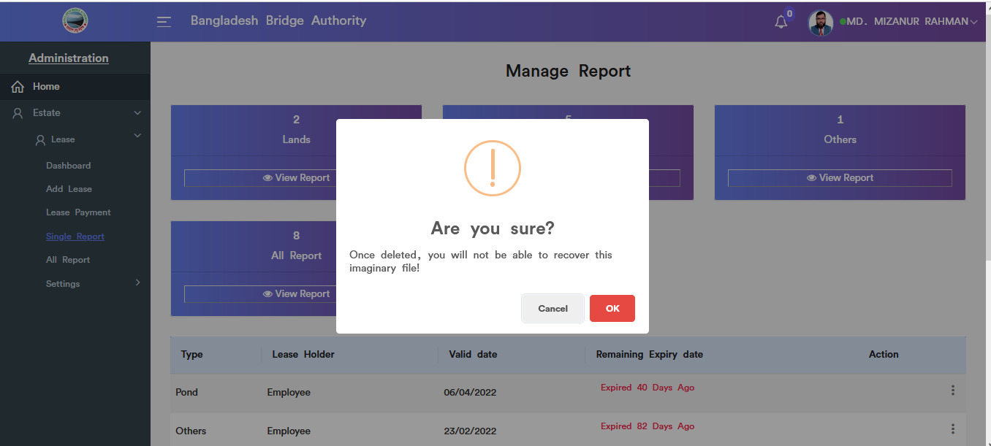

Figure 4.3.5.1: view of all report(delete)

## 4.4: All Report Menu Overview (Same as Single report……Incomplete)

## 4.5: Settings Menu Overview

**Overview of Settings**

### 4.5.1.1: Add Pond (Settings) add new pond input field

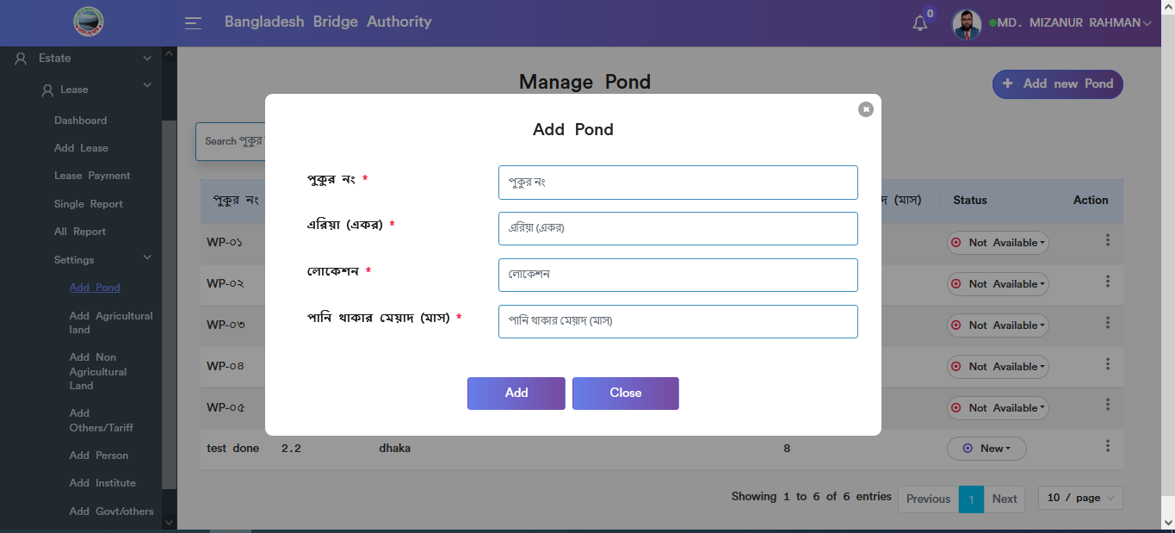

Figure 4.5.1.1: add new pond input field

### 4.5.1.2: Add Pond (Settings) view details of add new pond

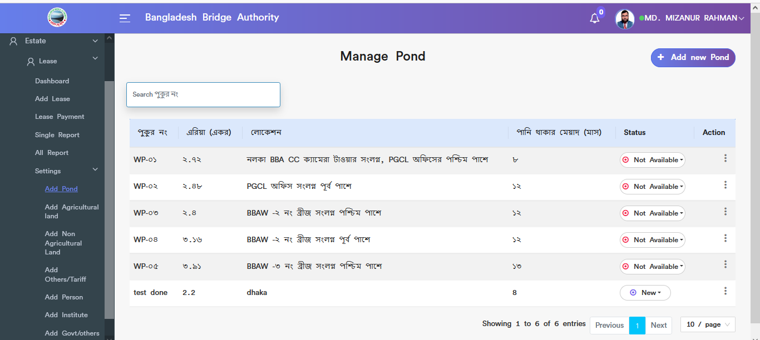

Figure 4.5.1.2: view details of add new pond

### 4.5.1.3: Add Pond (Settings) Update

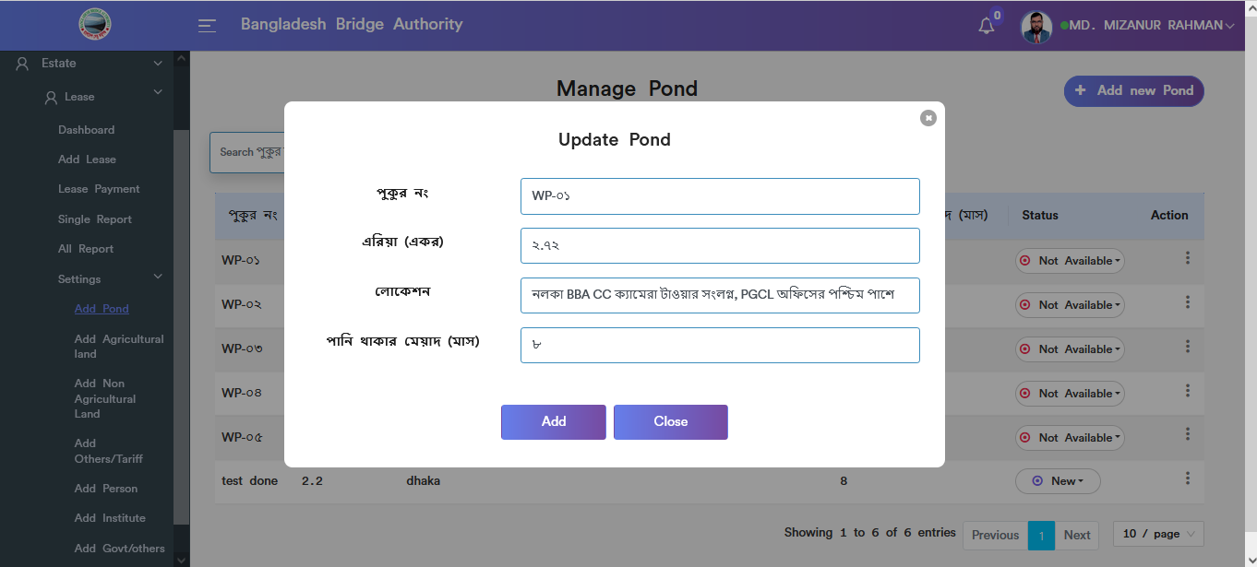

Figure 4.5.1.3: pond update input field

### 4.5.1.4: Add Pond (Settings) Delete

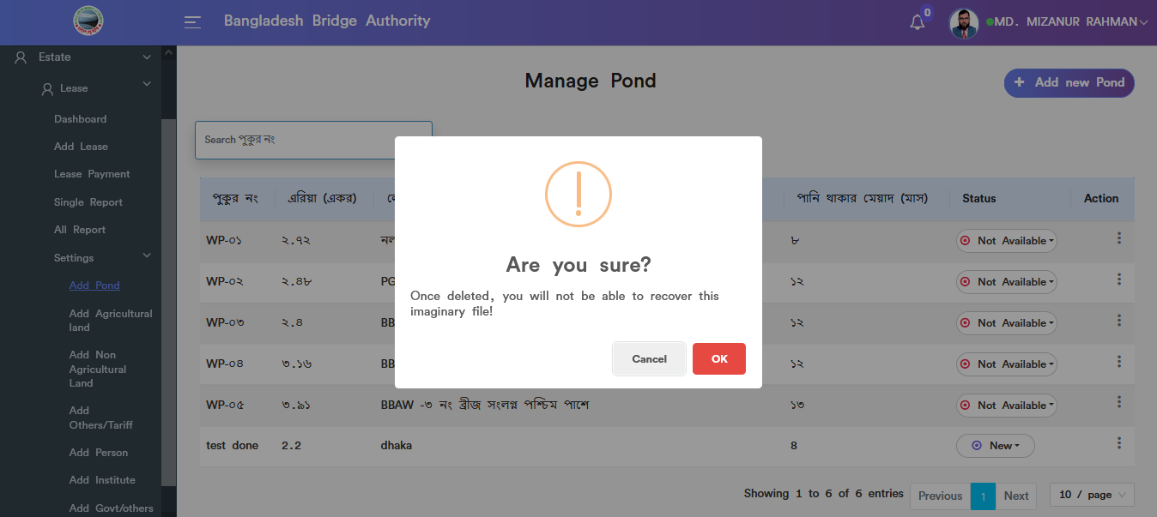

Figure 4.5.1.4: pond data Delete

### 4.5.1.5: Add Pond (Settings) Search

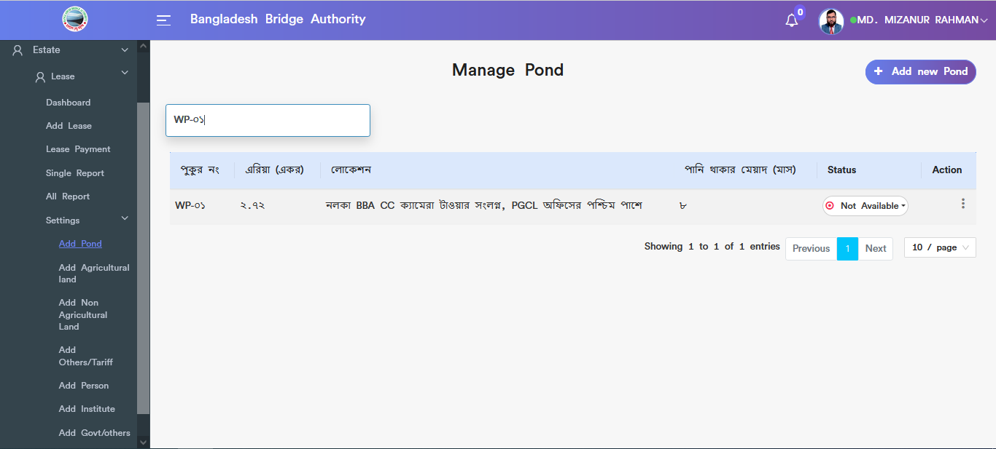

Figure 4.5.1.5: pond data Search

### 4.5.2.1: Add Agriculture land (Settings) add new agriculture land input field

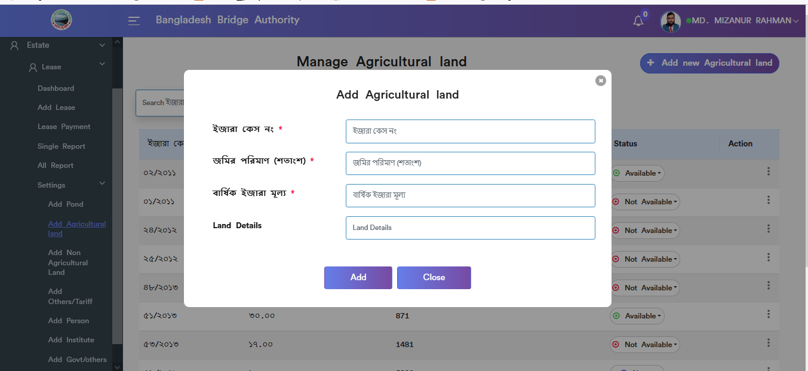

Figure 4.5.2.1: add new agriculture land input field

### 4.5.2.2: Add Agriculture land (Settings) view details of agriculture land

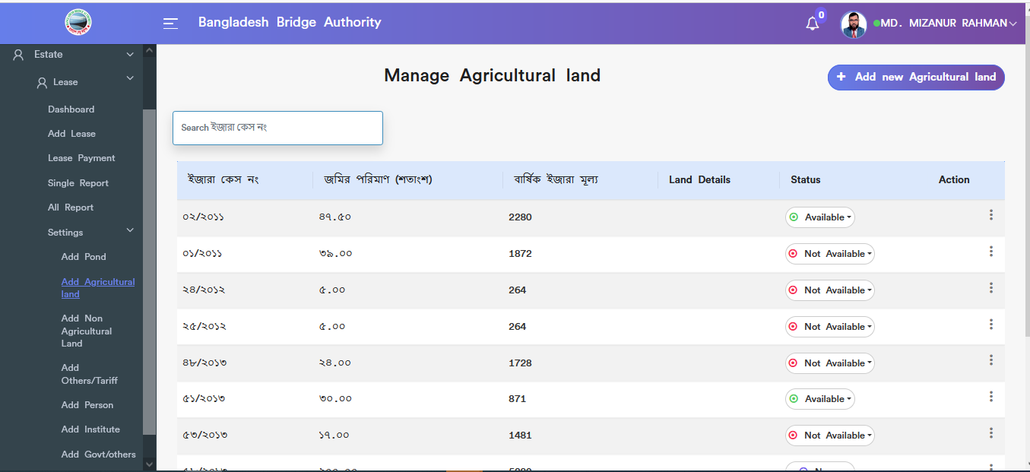

Figure 4.5.2.2: view details of agriculture land

### 4.5.2.3: Add Agriculture land (Settings) Update

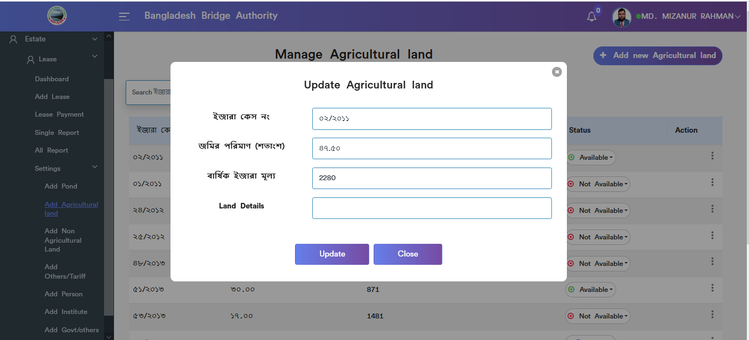

Figure 4.5.2.3: agriculture land update input field

### 4.5.2.4: Add Agriculture land (Settings) Delete

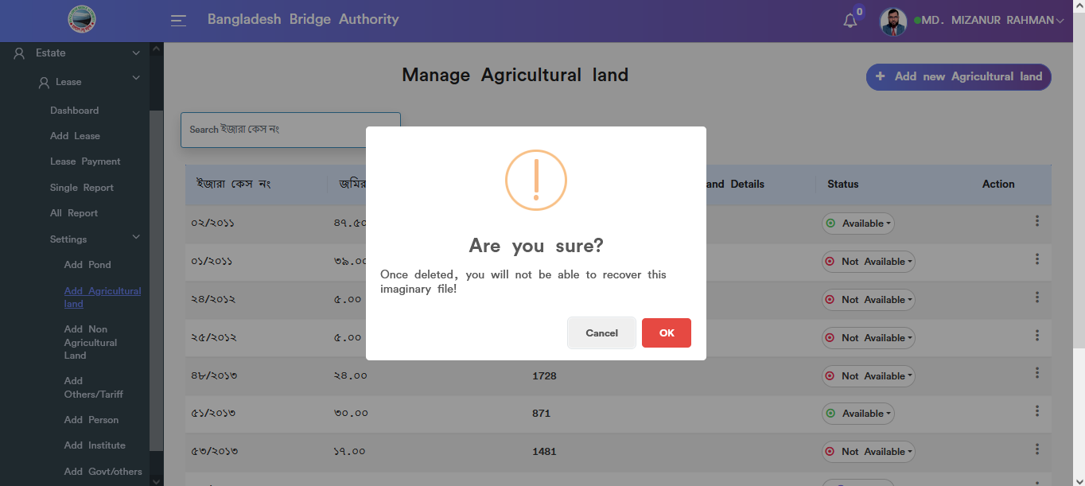

Figure 4.5.2.4: agriculture land data Delete

### 4.5.2.5: Add Agriculture land (Settings) Search

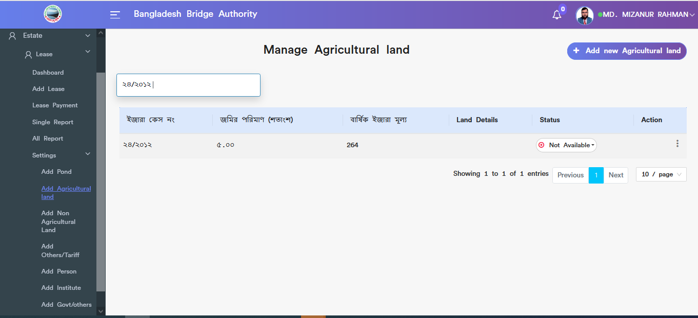

Figure 4.5.2.5: agriculture land data Search

### 4.5.3.1: Add Non-Agriculture land (Settings) Add nonagriculture land input field

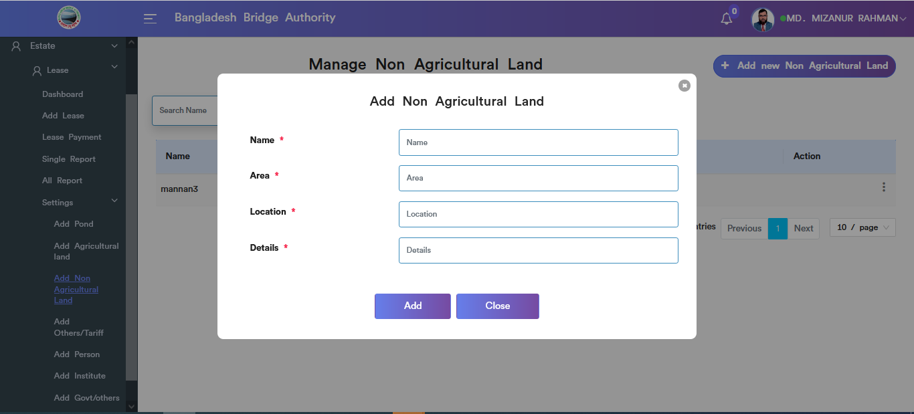

Figure 4.5.3.1: add non agriculture land input field

### 4.5.3.2: Add Non Agriculture land (Settings) View details of non agriculture land

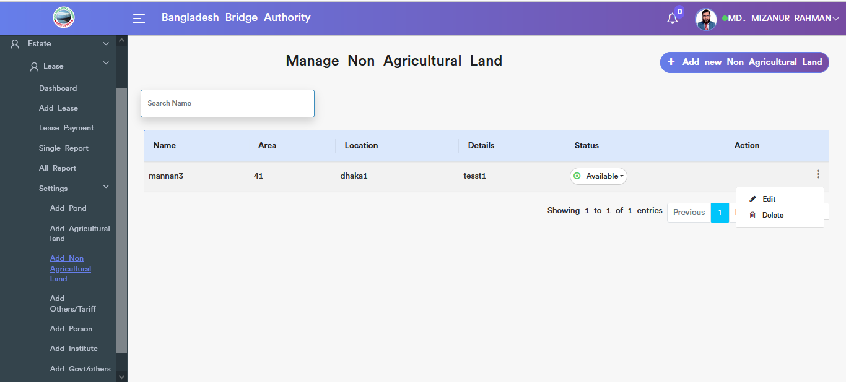

Figure 4.5.3.2: view details of non agriculture land information

### 4.5.3.3: Add Non Agriculture land (Settings) Update

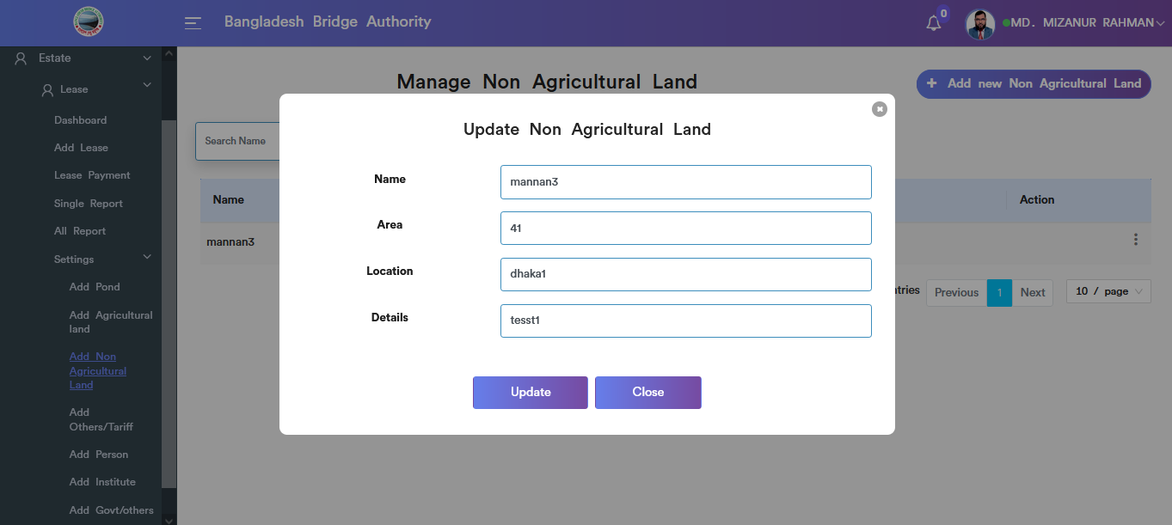

Figure 4.5.3.3: Add non agriculture land Update input field

### 4.5.3.4: Add Non Agriculture land (Settings) Delete

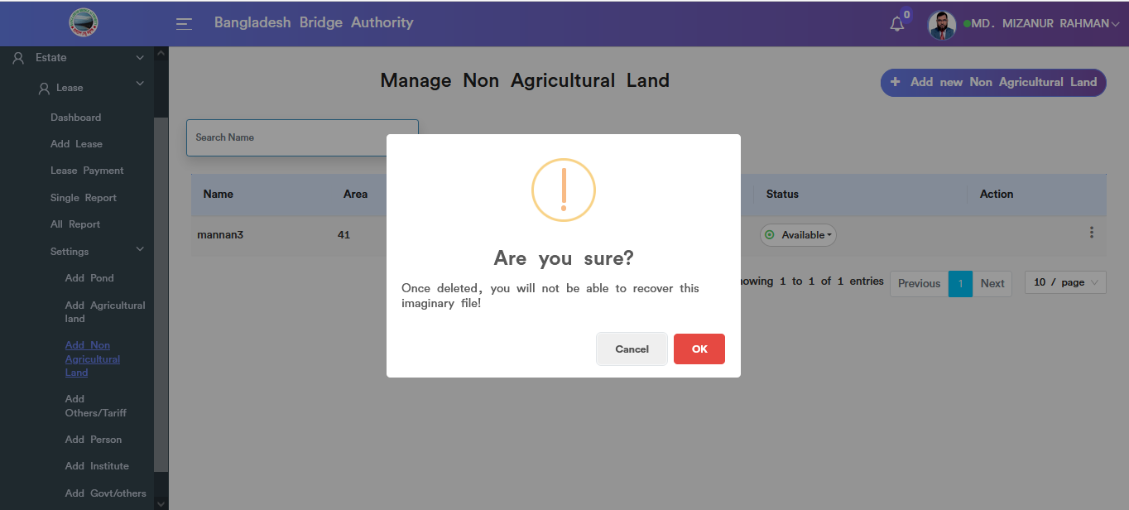

Figure 4.5.3.4: Add non agriculture land (settings) Delete

### 4.5.3.5:Add Non Agriculture land (Settings) Search

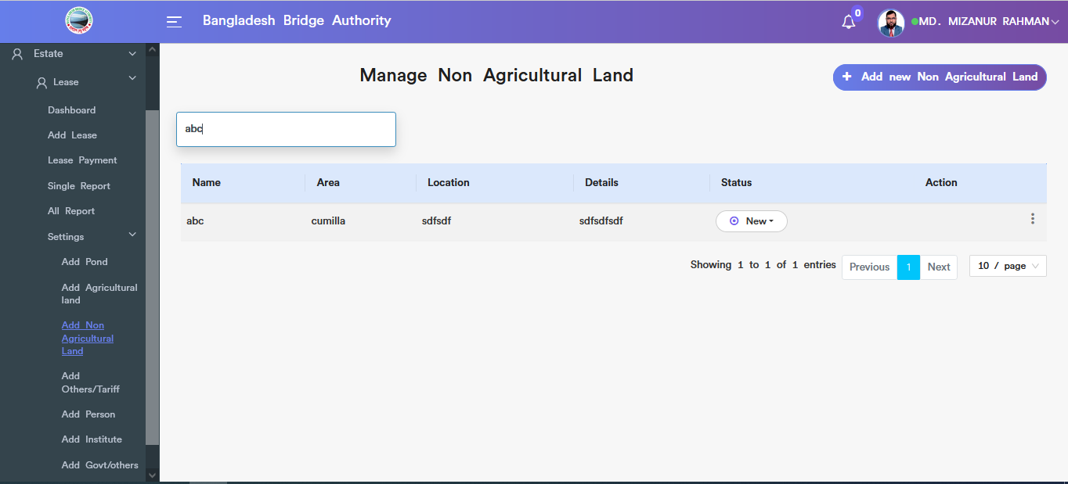

Figure 4.5.3.5: Add non agriculture land (settings) Search

### 4.5.4.1: Add Others/Tariff (Settings) Add new others/tariff input field

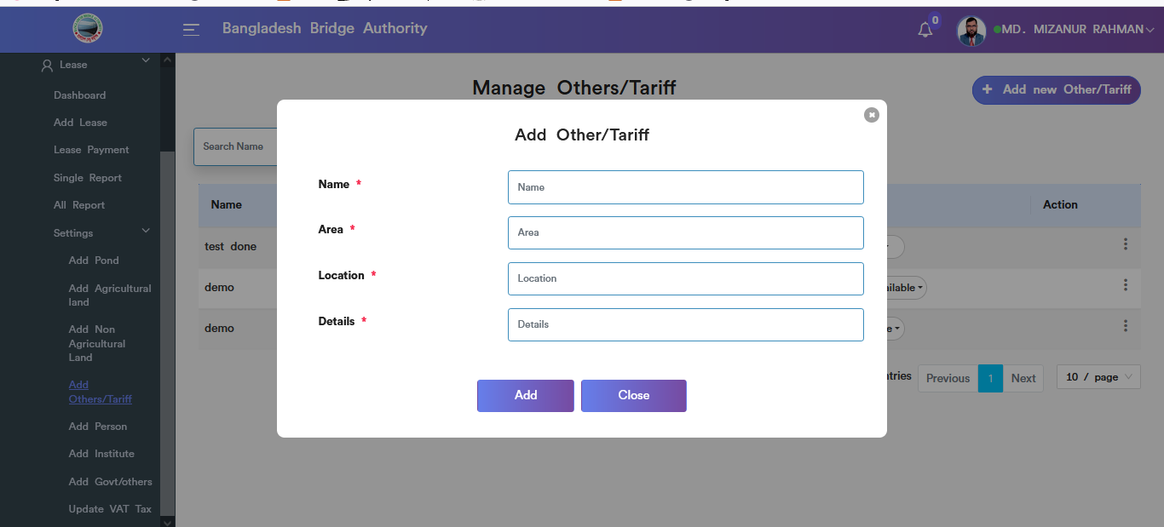

Figure 4.5.4.1: add new others/tariff input field

### 4.5.4.2: Add Others/Tariff (Settings) view details others/tariff

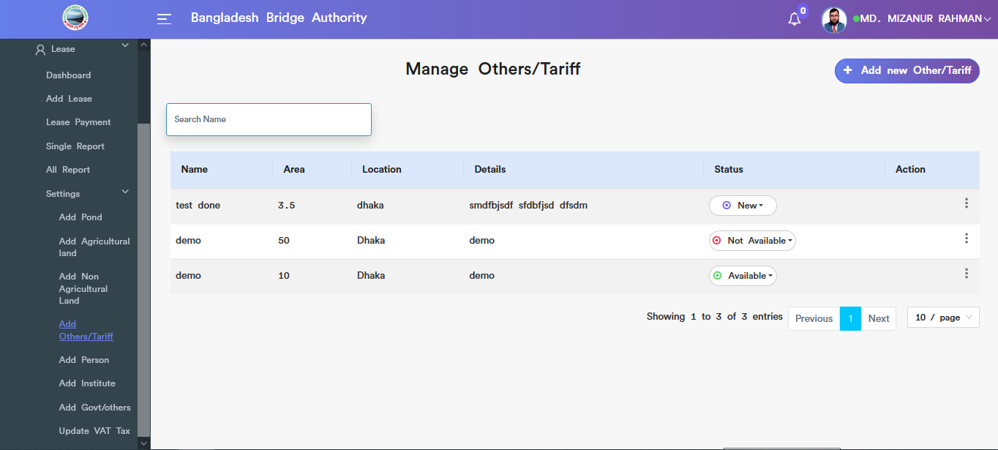

Figure 4.5.4.2: view details of others/tariff

### 4.5.4.3: Add Others/Tariff (Settings) update

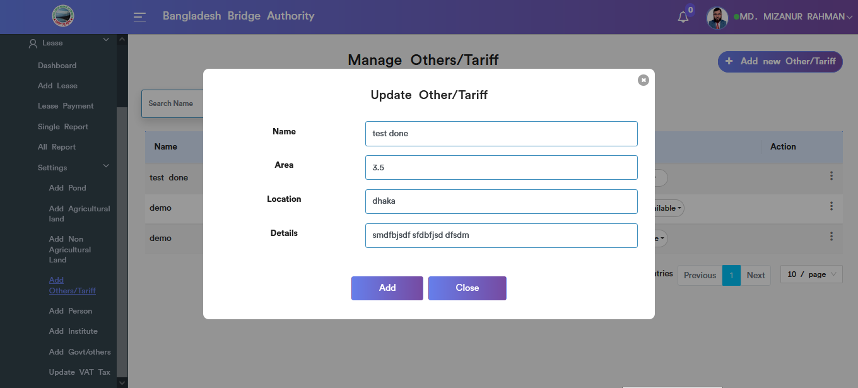

Figure 4.5.4.3: Add Other/tariff Data update input field

### 4.5.4.4: Add Others/Tariff (Settings) Delete

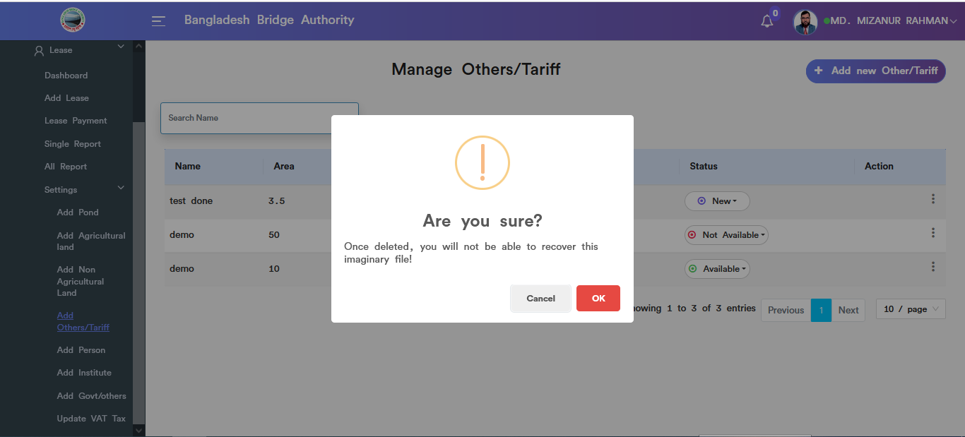

Figure 4.5.4.4: Other/tariff data Delete

### 4.5.4.5: Add Others/Tariff (Settings) Search

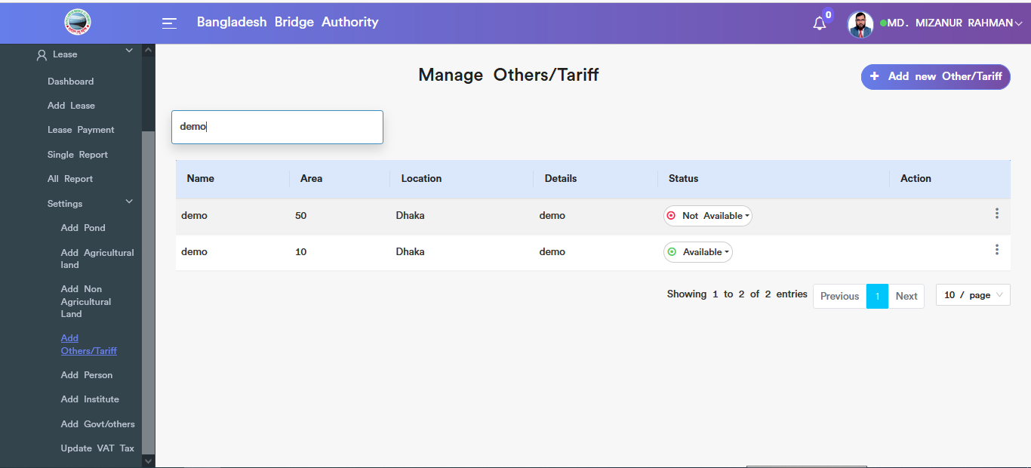

Figure 4.5.4.5: Other/tariff data search

### 4.5.5.1: Add Person (Settings) Add person input field

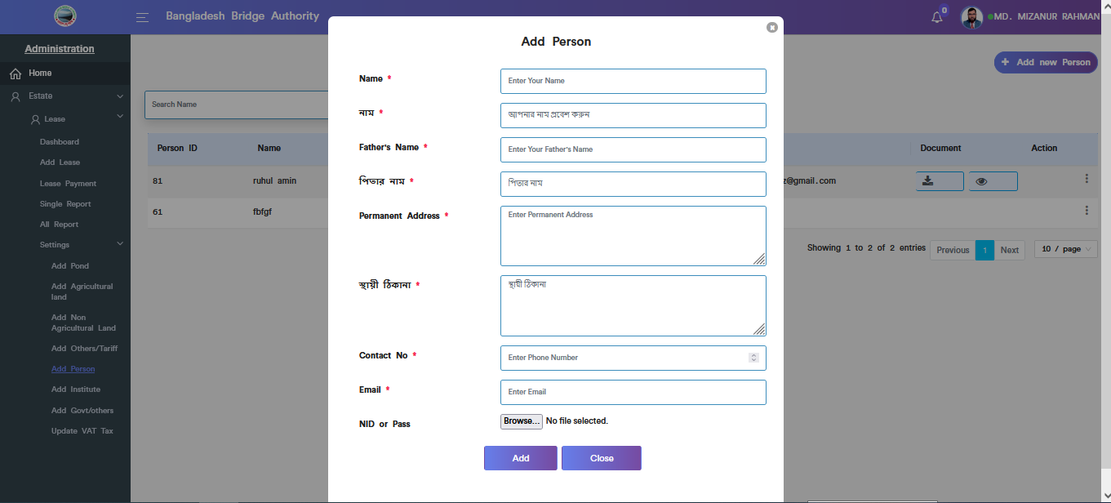

Figure 4.5.5.1: add person input field

### 4.5.5.2: Add Person (Settings) view of add person details

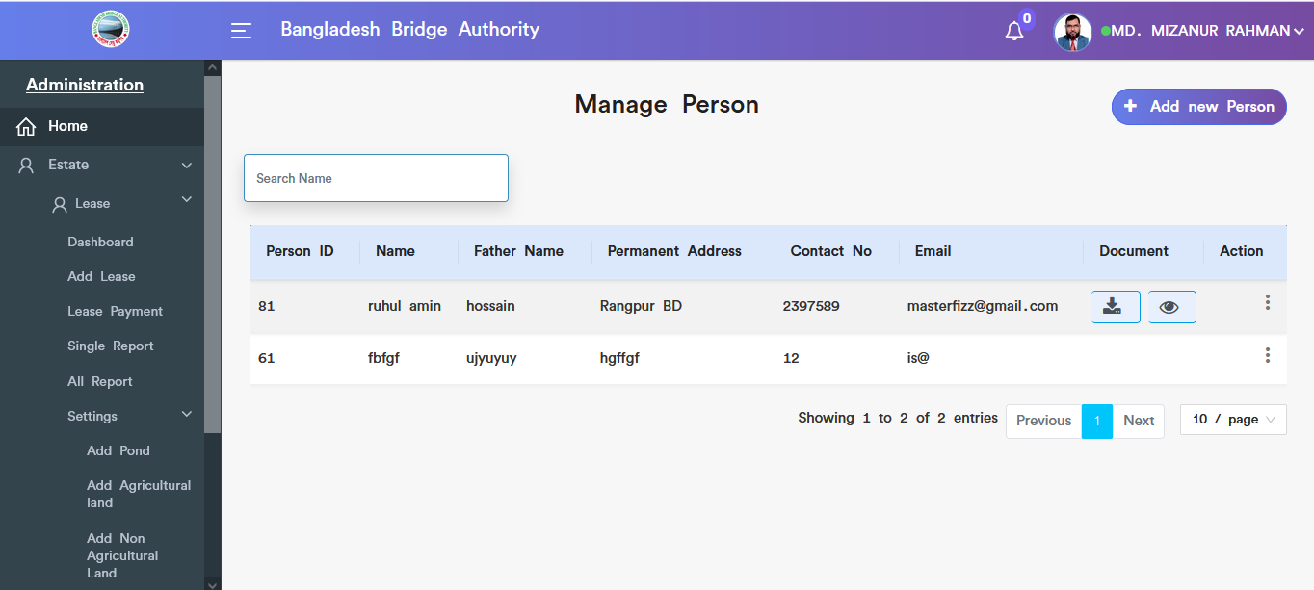

Figure 4.5.5.2: view of add person details

### 4.5.5.3: Add Person (Settings) view document

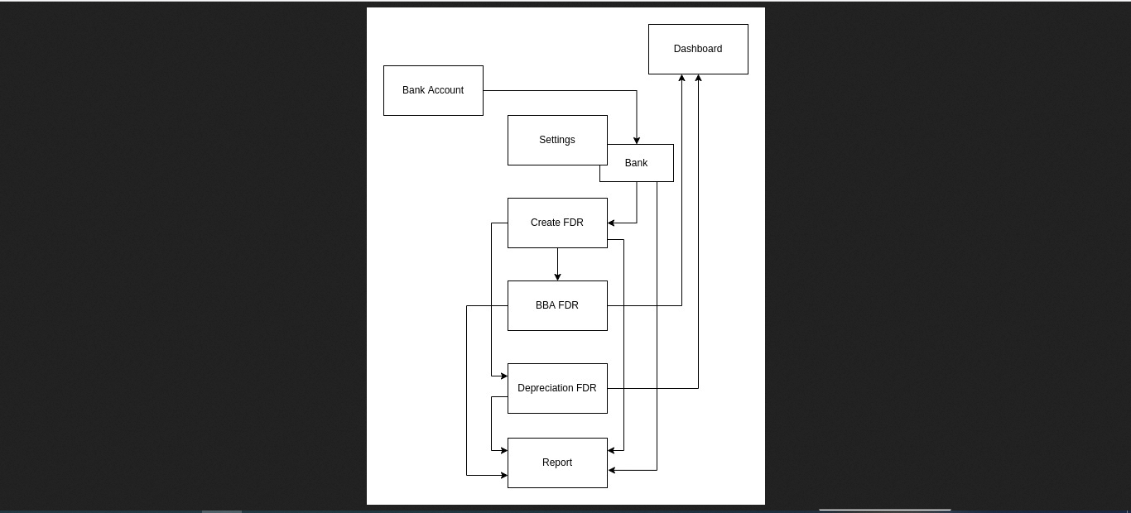

Figure 4.5.5.3: person’s view document

### 4.5.5.4: Add Person (Settings) Download document

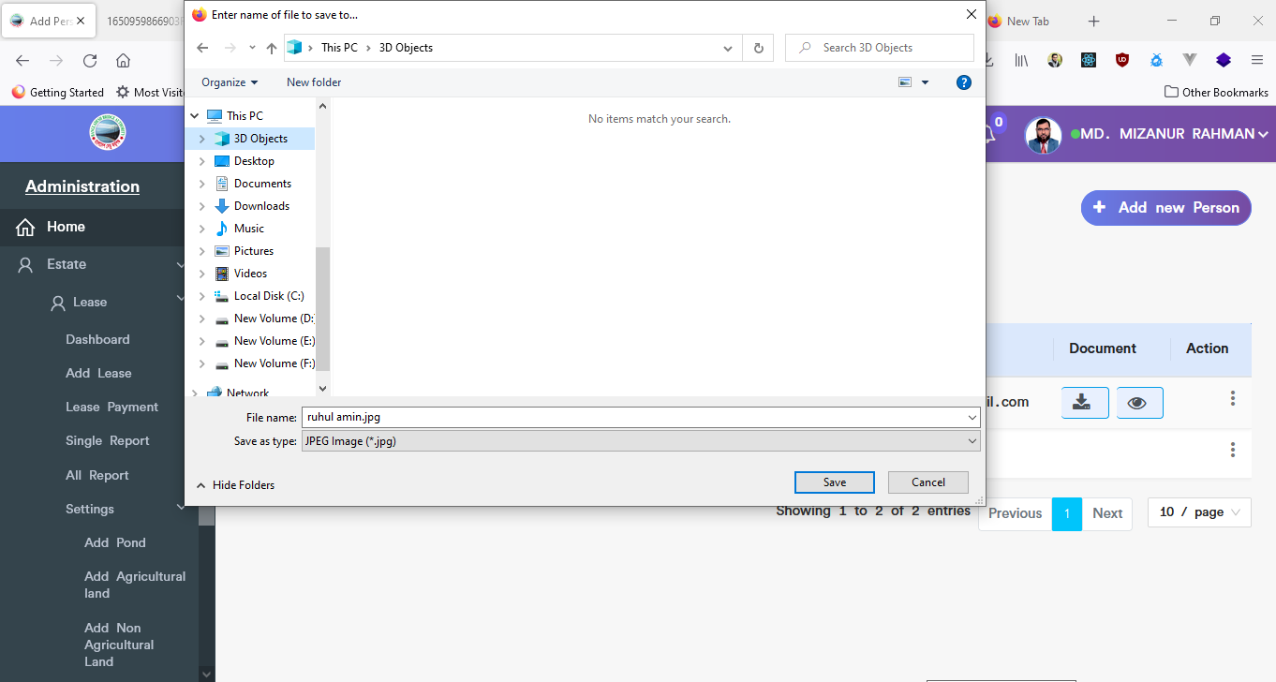

Figure 4.5.5.4: person’s download document

### 4.5.5.5: Add Person (Settings) Update

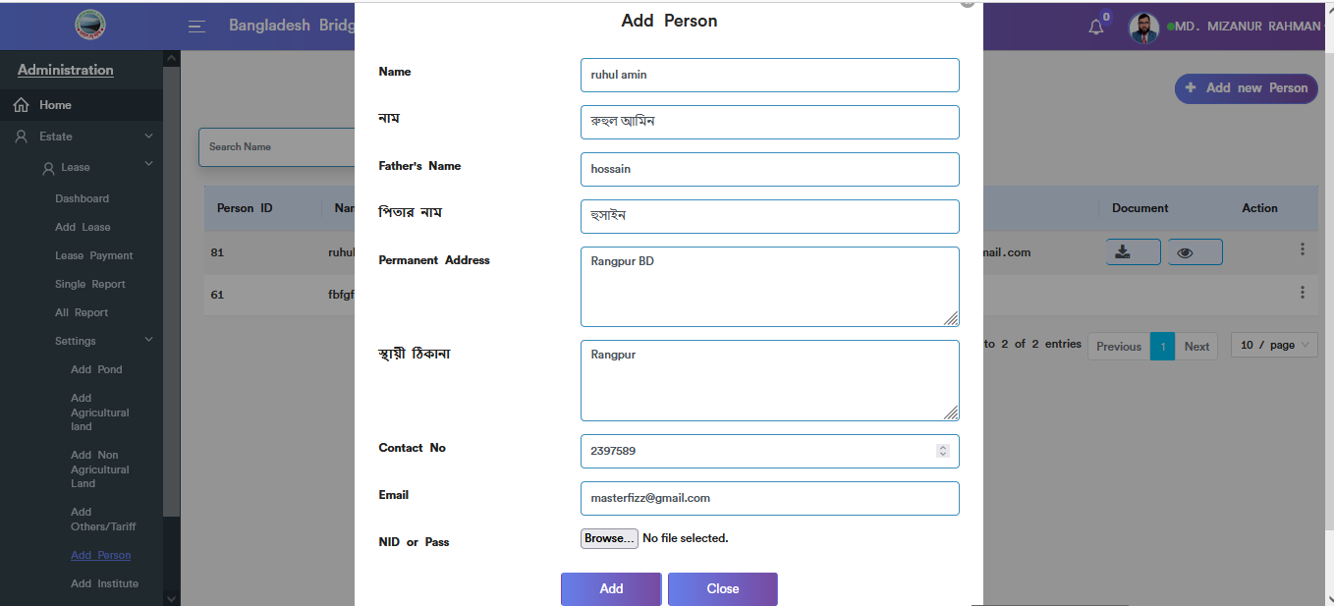

Figure 4.5.5.5: Add person (settings) update input field

### 4.5.5.6: Add Person (Settings) Delete

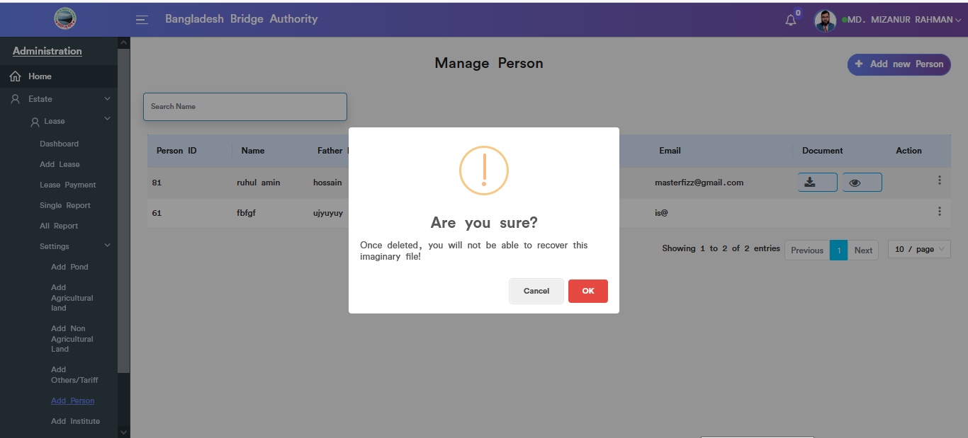

Figure 4.5.5.6: Add person (settings) Delete

### 4.5.5.7: Add Person (Settings) Search

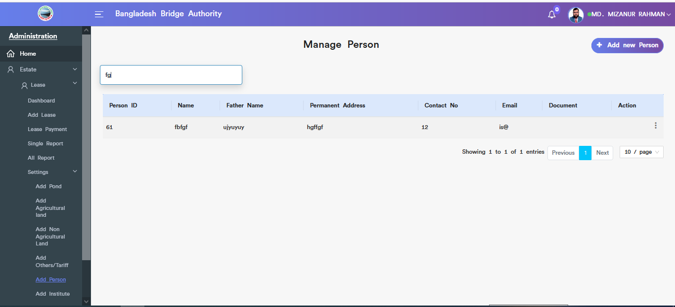

Figure 4.5.5.7: search person

### 4.5.6.1: Add Institute (Settings) add new institute input field

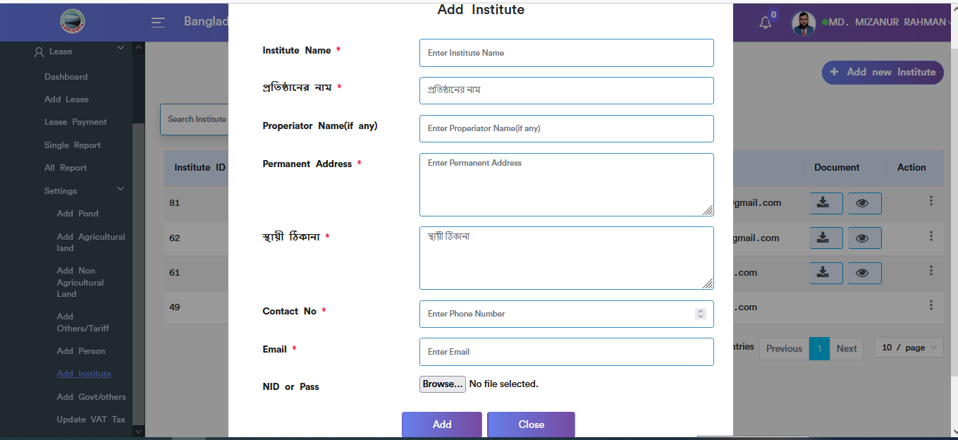

Figure 4.5.6.1: add institute input field

### 4.5.6.2: Add Institute (Settings) Add institute view details

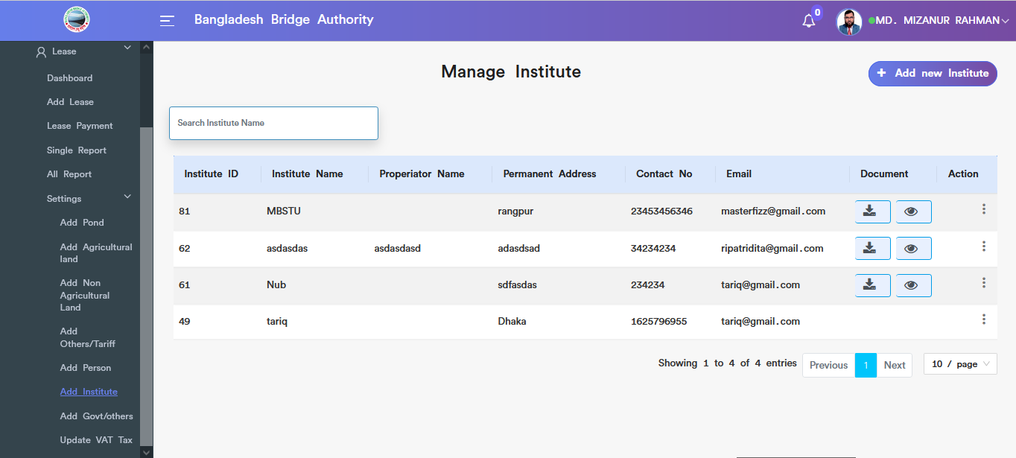

Figure 4.5.6.2: add institute view details

### 4.5.6.3: Add Institute (Settings) download document

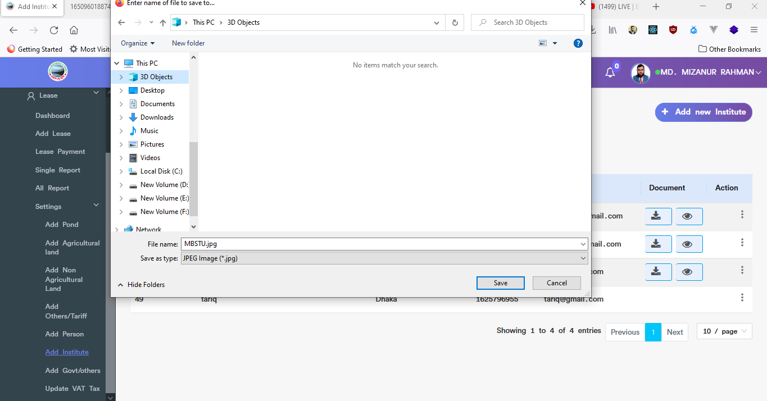

Figure 4.5.6.3: institute download document

### 4.5.6.4: Add Institute (Settings) view document

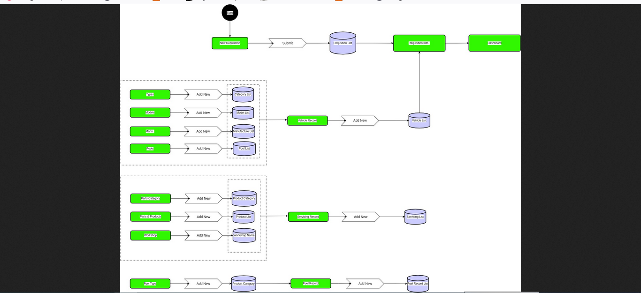

Figure 4.5.6.4: view institute document

### 4.5.6.5: Add Institute (Settings) Update

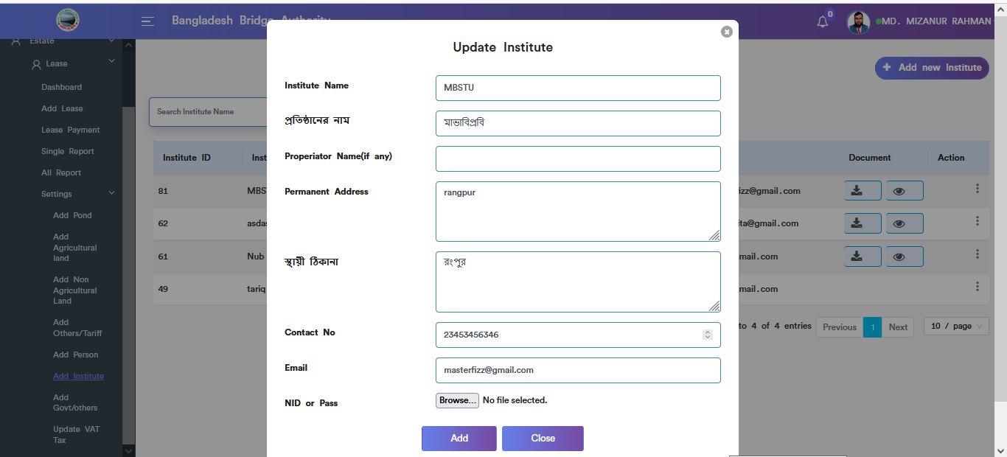

Figure 4.5.6.5: institute update input field

### 4.5.6.6: Add Institute (Settings) Delete

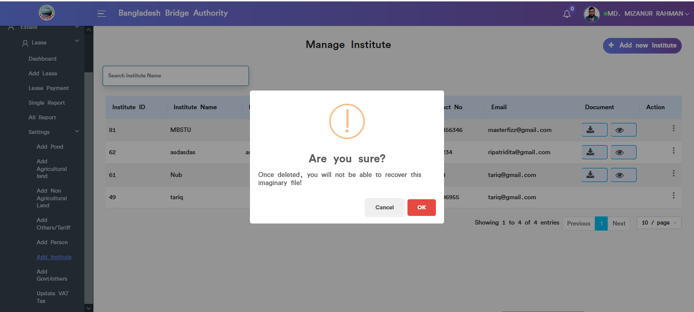

Figure 4.5.6.6: institute data delete

### 4.5.7.1: Add Govt/Others (Settings) add new govt/others input field

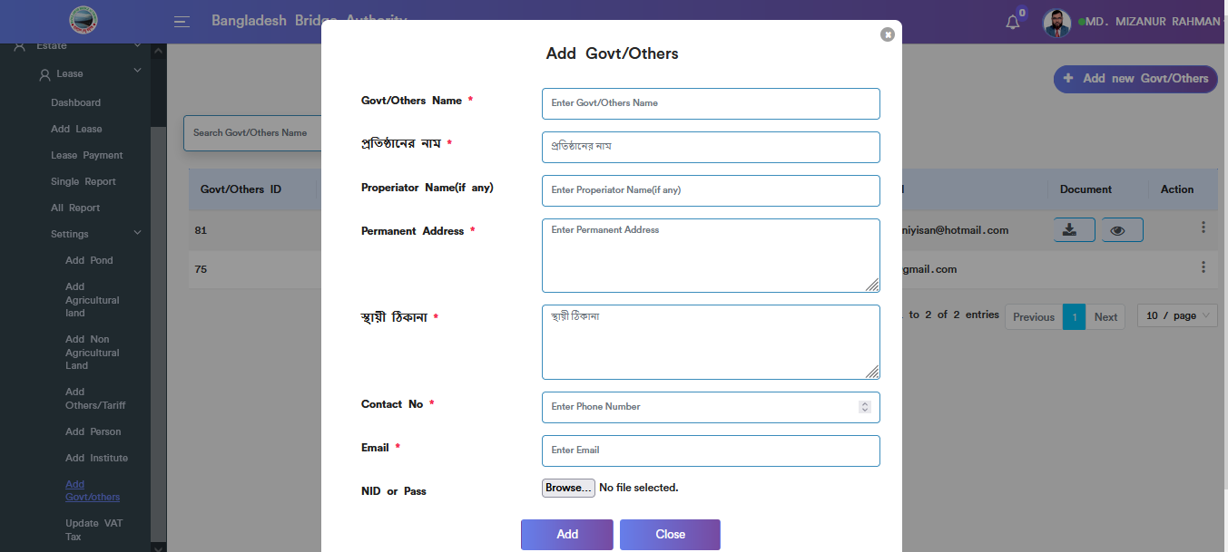

Figure 4.5.7.1: add new govt/others input field

### 4.5.7.2: Add Govt/Others (Settings) add govt/others view details

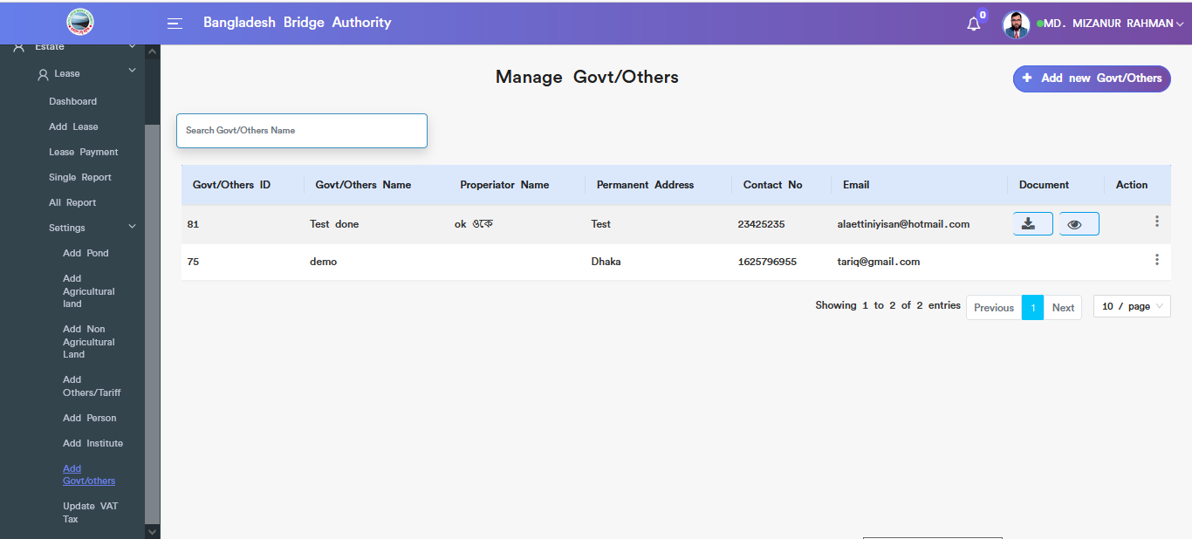

Figure 4.5.7.2: add govt/others view details

### 4.5.7.3: Add Govt/Others (Settings) download document

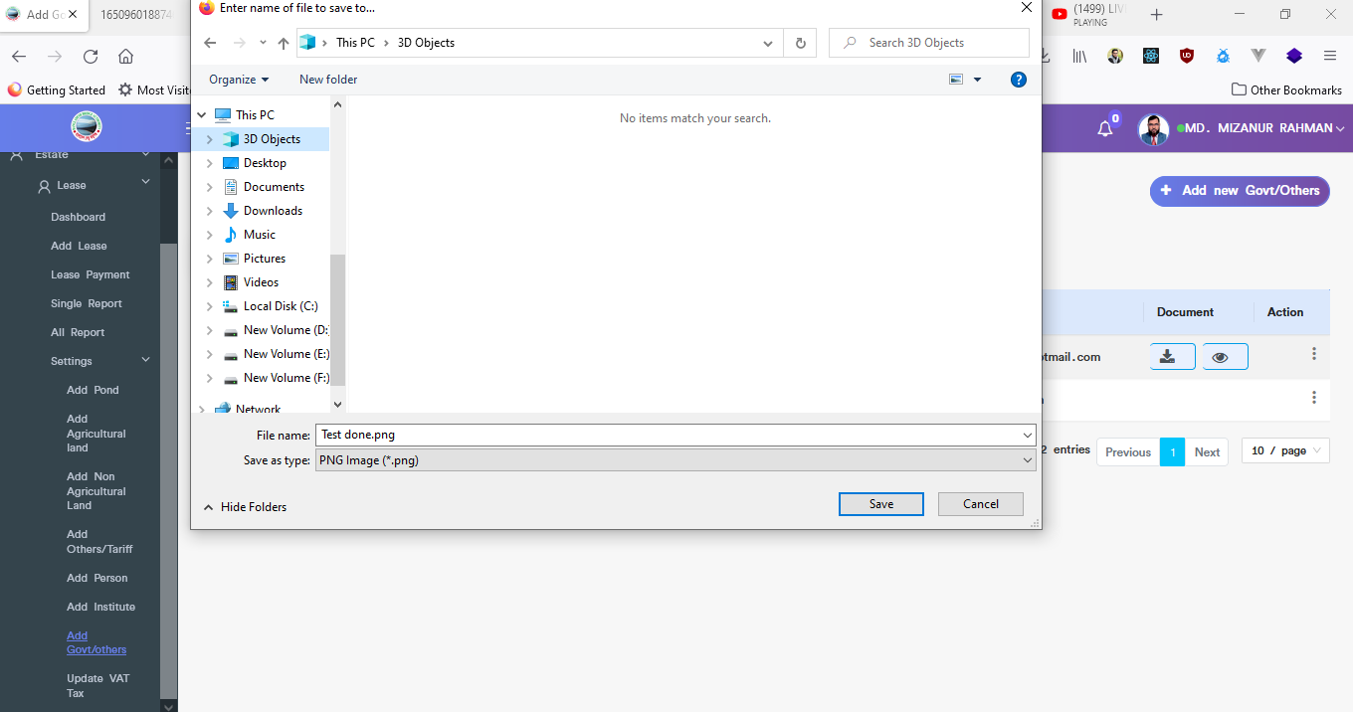

Figure 4.5.7.3: govt/others download document

### 4.5.7.4: Add Govt/Others (Settings) view document



Figure 4.5.7.4: govt/others view document

### 4.5.7.5: Add Govt/Others (Settings) Update

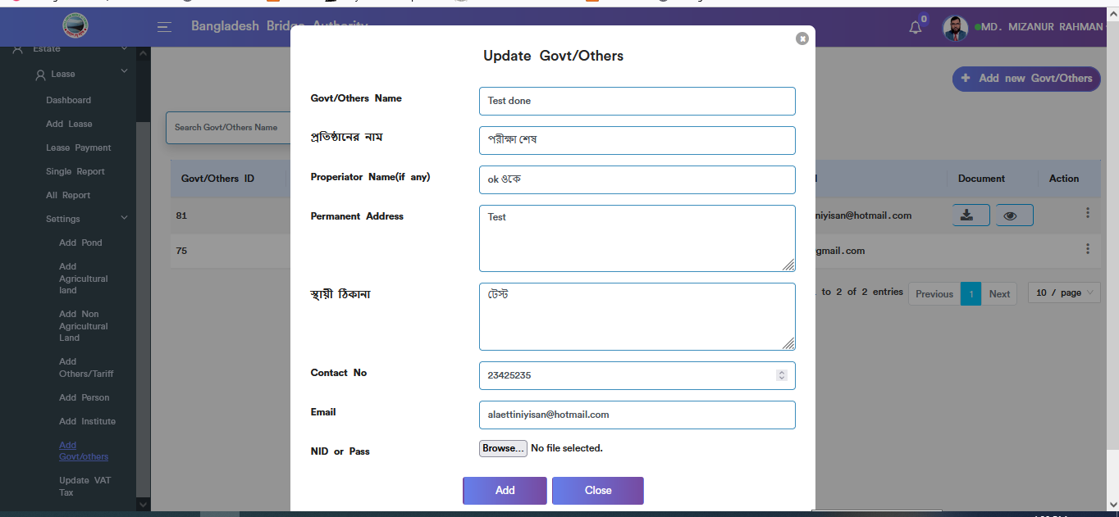

Figure 4.5.7.5: govt/others update input field

### 4.5.7.6: Add Govt/Others (Settings) Delete

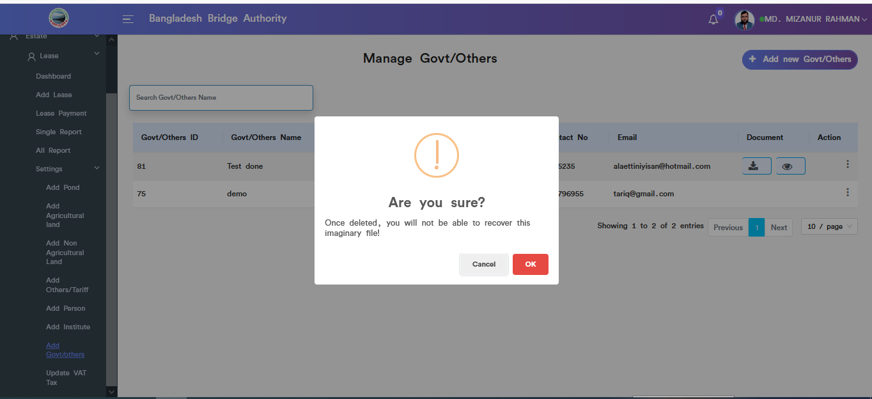

Figure 4.5.7.6: govt/others data delete

### 4.5.8.1: Update Vat/Tax (Settings) View details

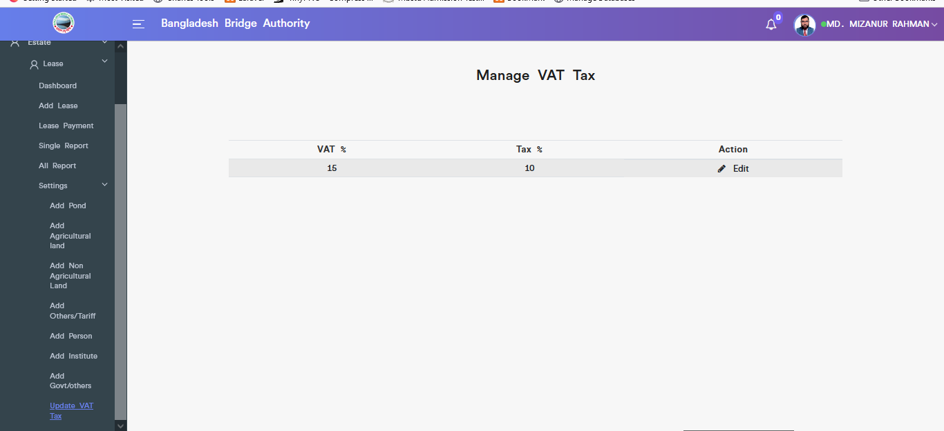

Figure 4.5.8.1: view details update vat tax

### 4.5.8.2: Update Vat/Tax (Settings) Update

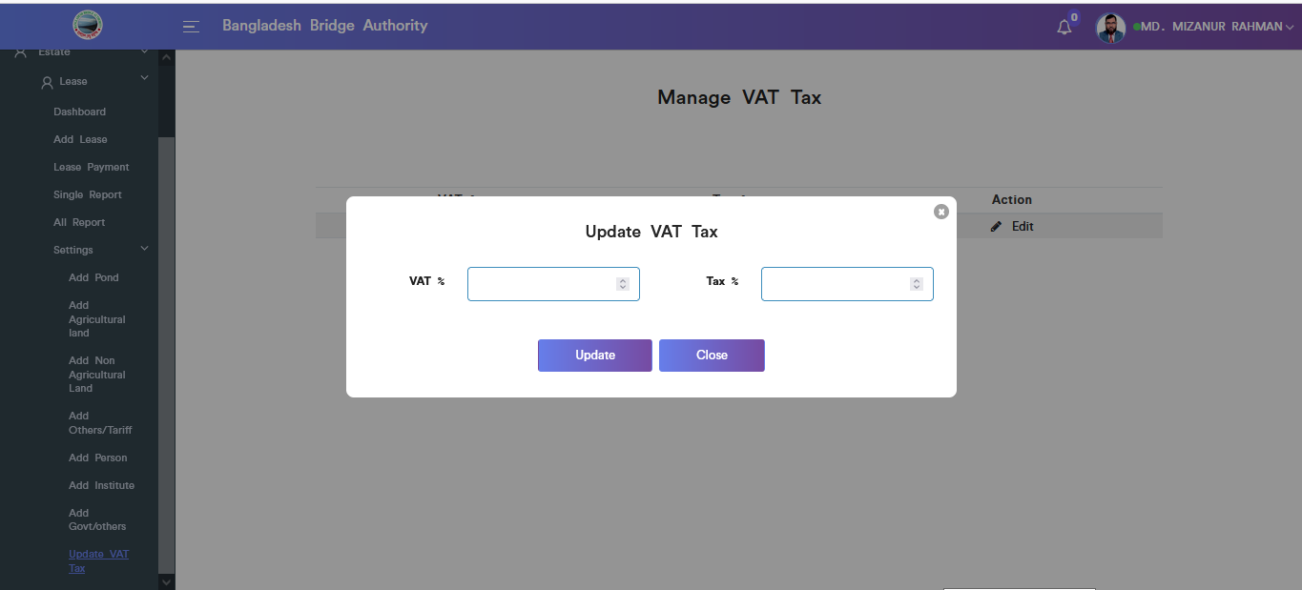

Figure 4.5.8.2: Update vat/tex (settings) update input field

# 5.TRANSPORT (SUB MODULE)

After clicking into Transport, it will redirect to the (Transport Sub Module) dashboard with some menus.

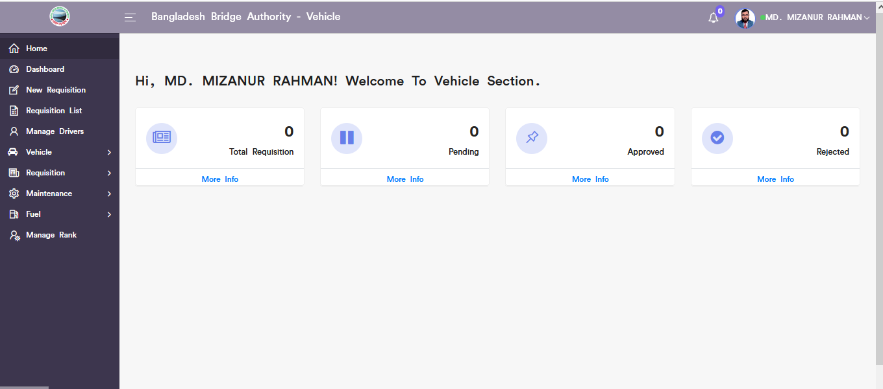

Figure 5: Dashboard of the transport (sub module).

There are four segments on the right side of the Transport Dashboard Such as **Total Requisition, Pending ,** **Approved,** And **Rejected.**

To get the details info about (**Total Requisition,Pending,Approved,Rejected**) just click on the view after that it will redirect to the relevant details info page.

# 6.TRANSPORT MENUS OVERVIEW

**Transport Menus Overview**

## 6.1: New Requisition Menu Overview

**Overview of New Requisition**

### 6.1.1: (New Requisition) Add new requisition input field

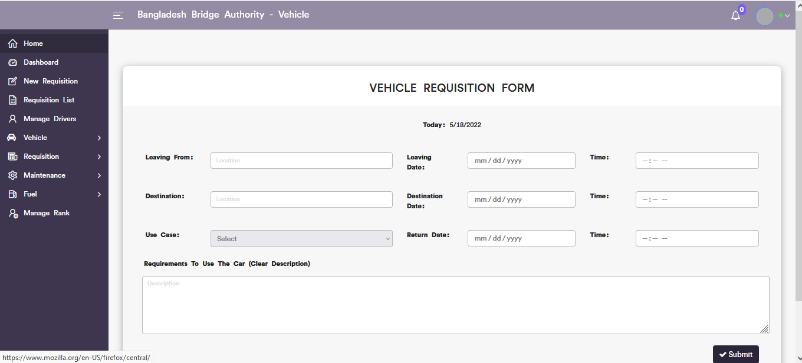

Figure 6.1.1: add new requisition input field

## 6.2: Requisition List Menu Overview

### 

### 6.2.1: ( Requisition List)View of Requisition List

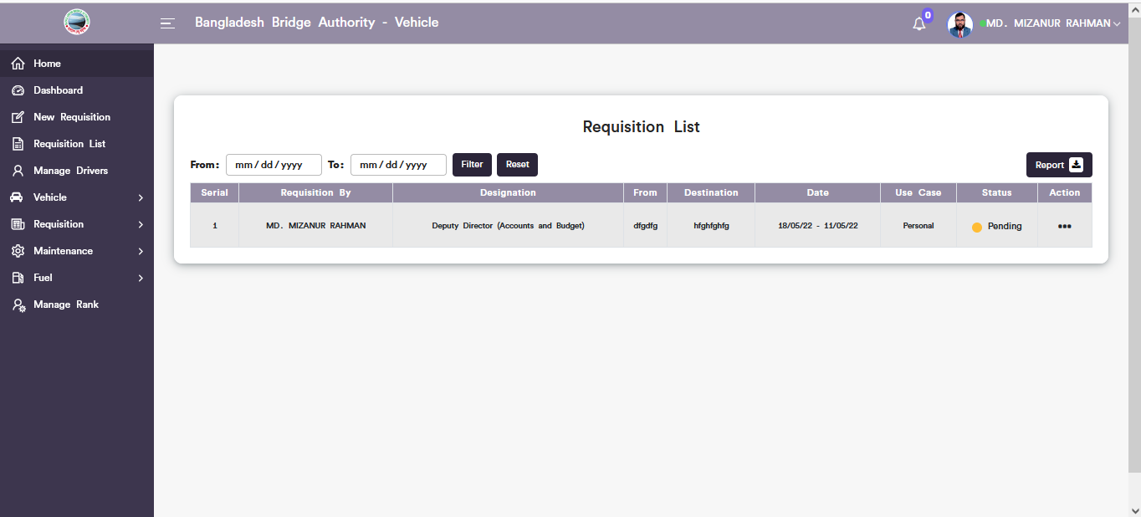

Figure 6.2.1: view of requisition list

### 6.2.2: ( Requisition List) Update

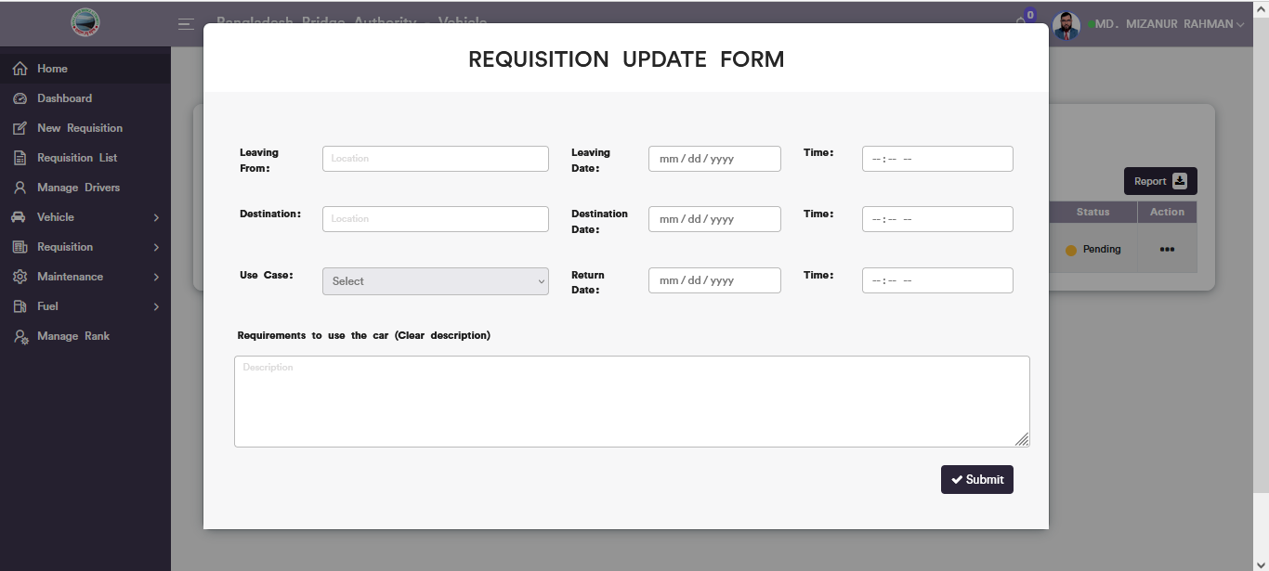

Figure 6.2.2: requisition update input field

### 6.2.3: ( Requisition List) Download Requisition list

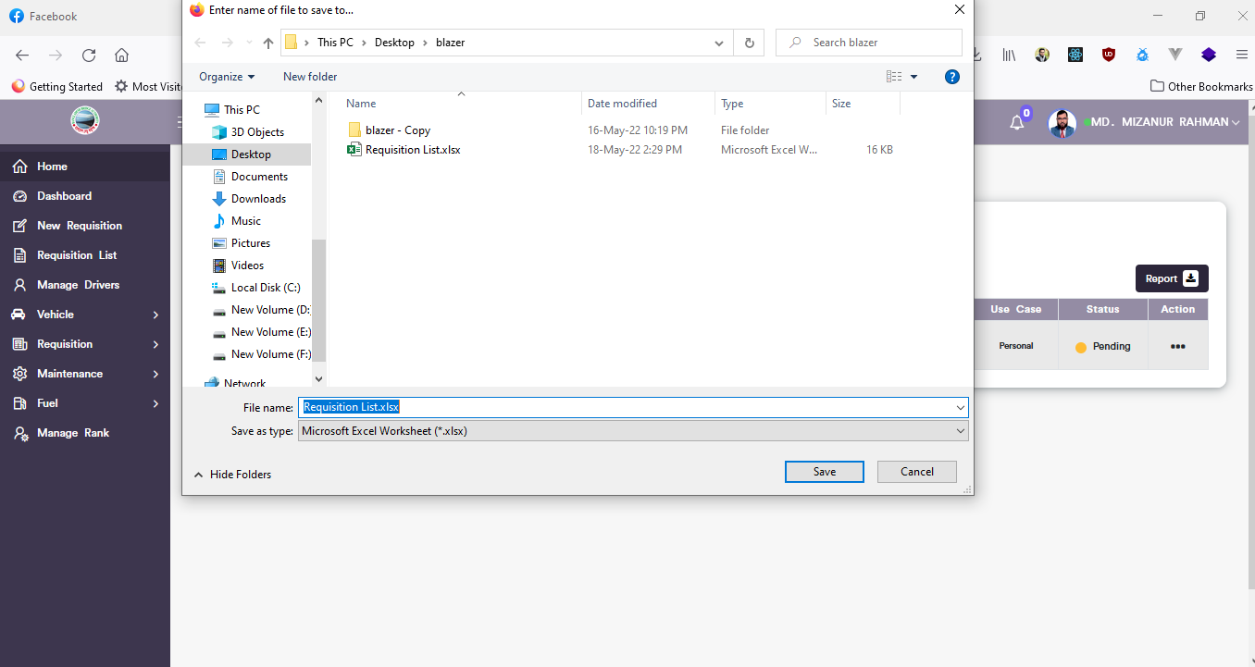

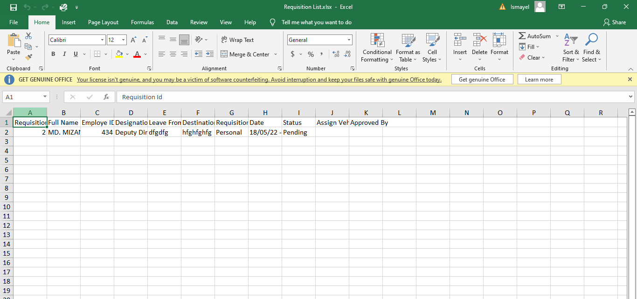

Figure 6.2.3: download requisition list

## 6.3: Manage Drivers List Menu Overview

**Overview of Manage Drivers**

### 6.3.1: ( Manage Drivers) Add new (Outsource driver record form)

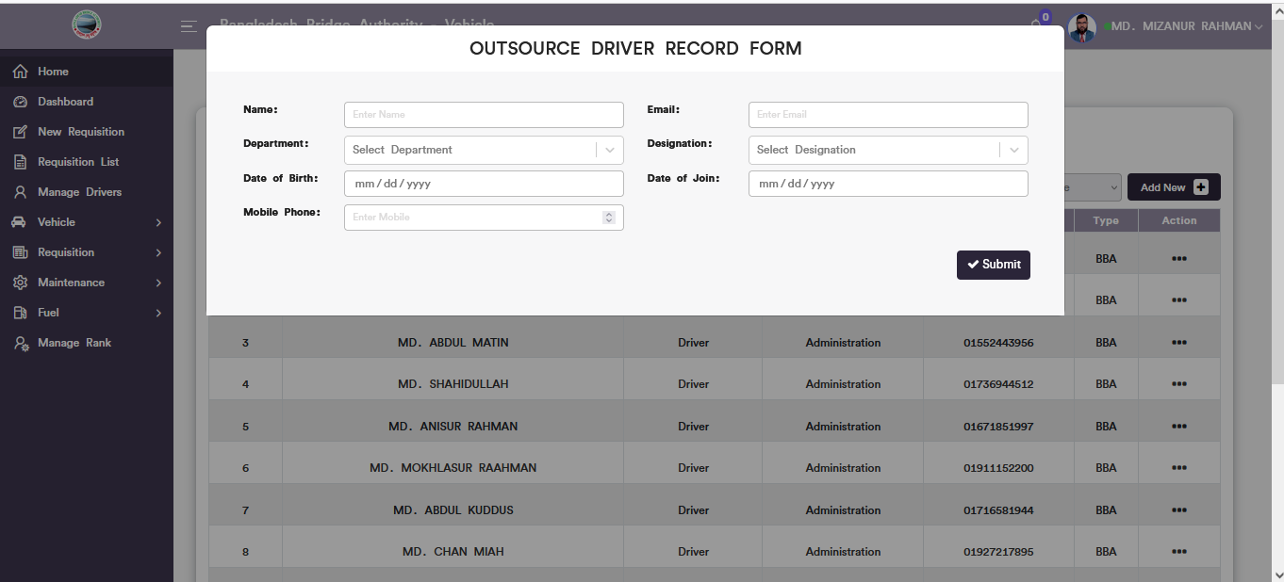

Figure 6.3.1: add new(outsource driver record form)

### 6.3.2: ( Manage Drivers)view of details

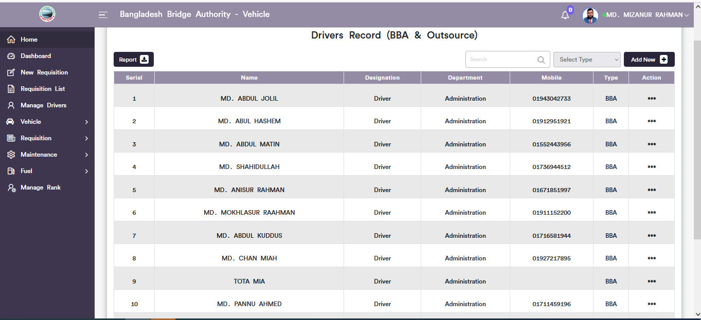

Figure 6.3.2: view details of drivers record

### 6.3.3: ( Manage Drivers) Download the report

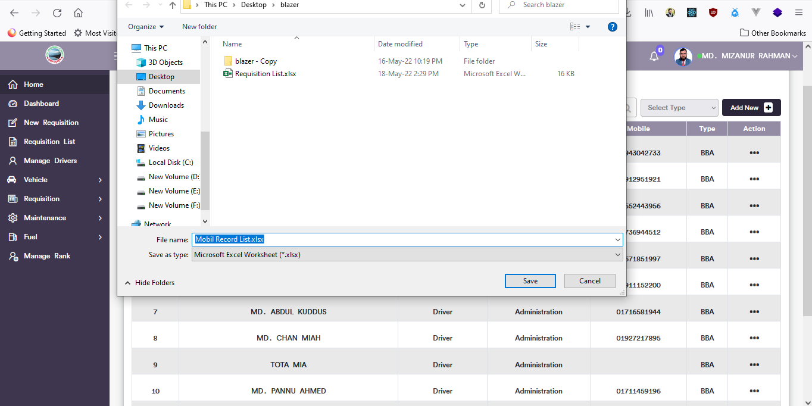

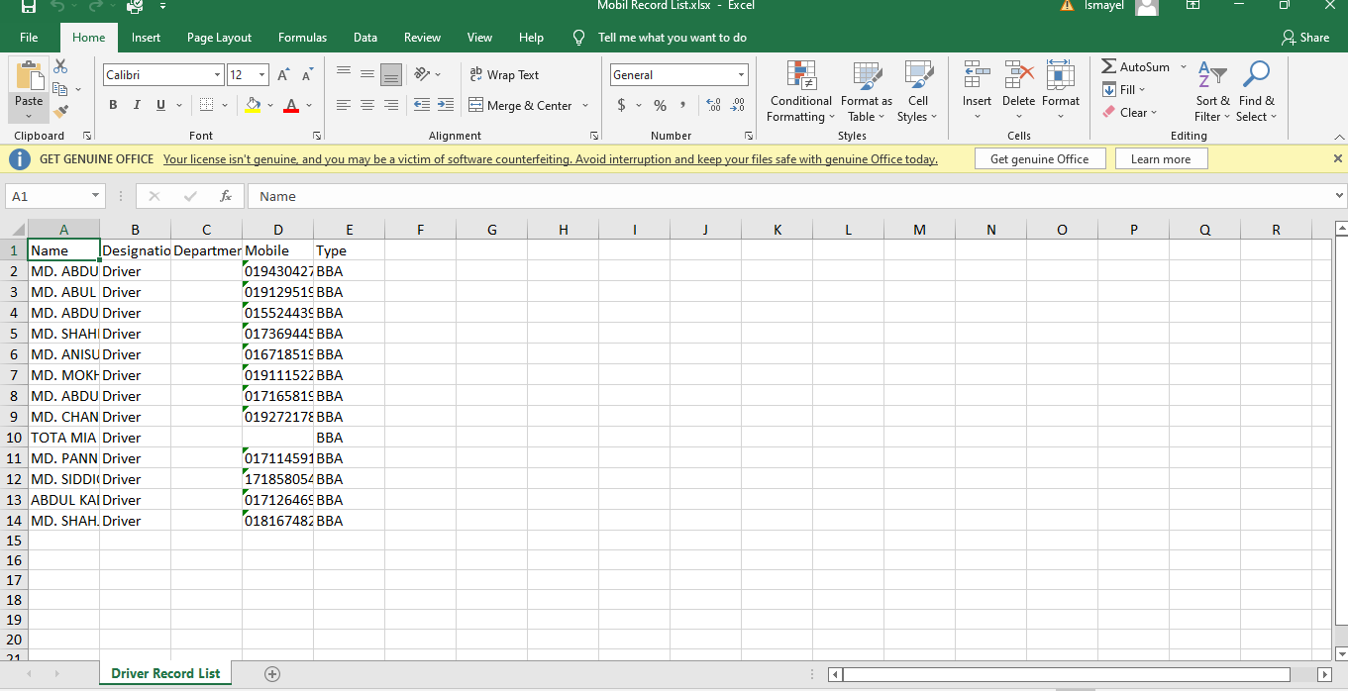

Figure 6.3.3: manage driver download reports

### 6.3.4: ( Manage Drivers)Search Driver

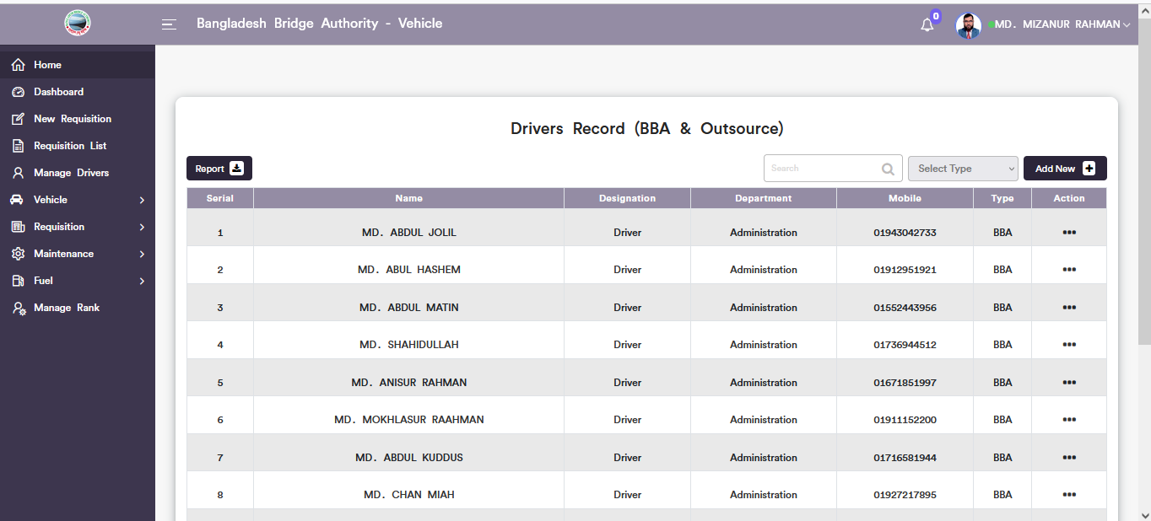

Figure 6.3.4: Search driver

## 6.4: Vehicle Menu Overview

**Overview of Vehicle**

### 6.4.1.1: Vehicle Record (Vehicle )Add vehicle

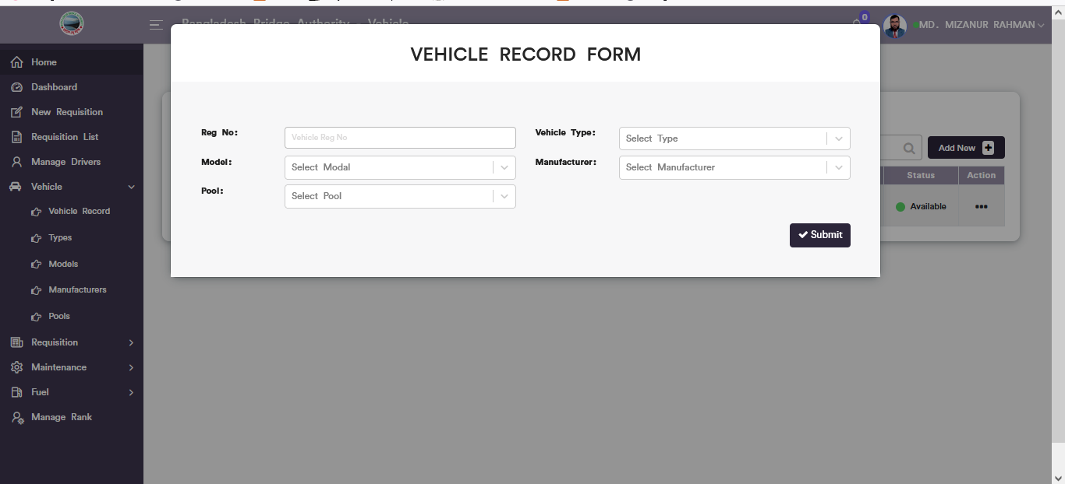

Figure 6.4.1.1: add vehicle record input from

### 6.4.1.2: Vehicle Record (Vehicle )View of Details

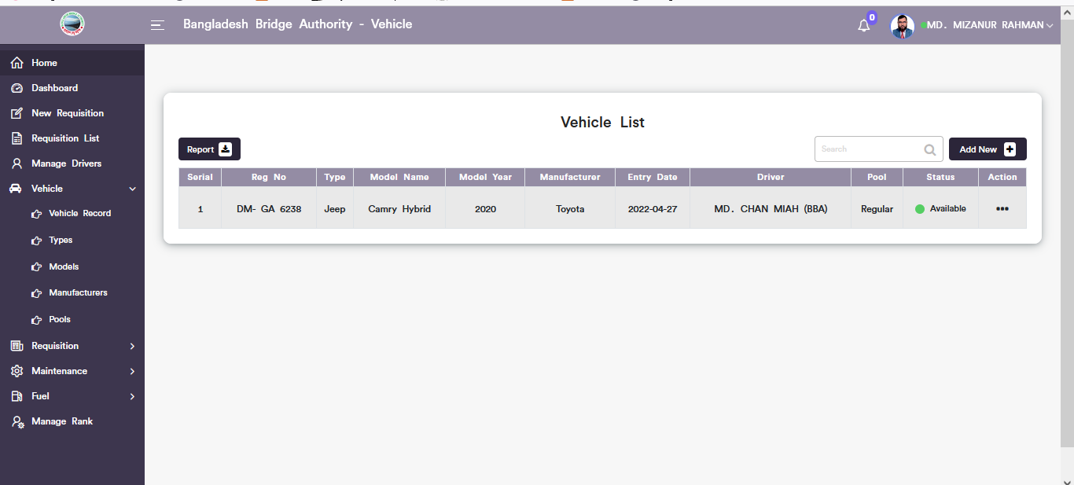

Figure 6.4.1.2: Vehicle records view details

### 6.4.1.3: Vehicle Record (Vehicle )Vehicle Update

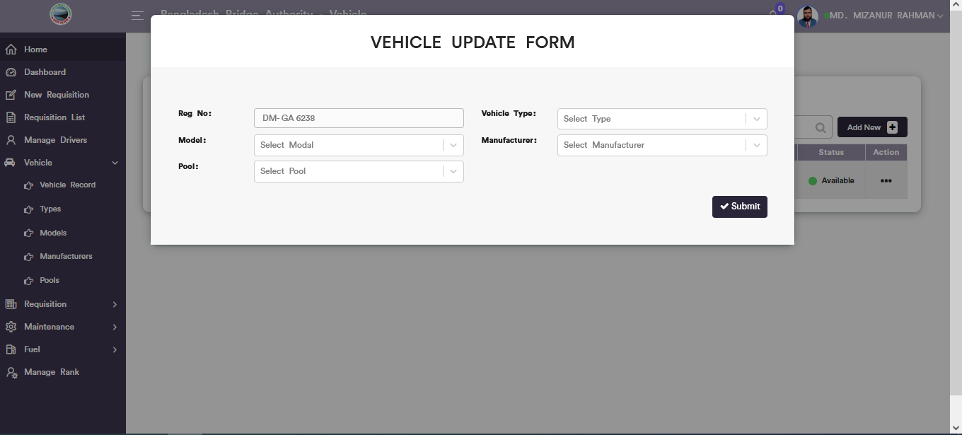

Figure 6.4.1.3: Vehicle records update form

### 6.4.1.4: Vehicle Record (Vehicle )Driver Update

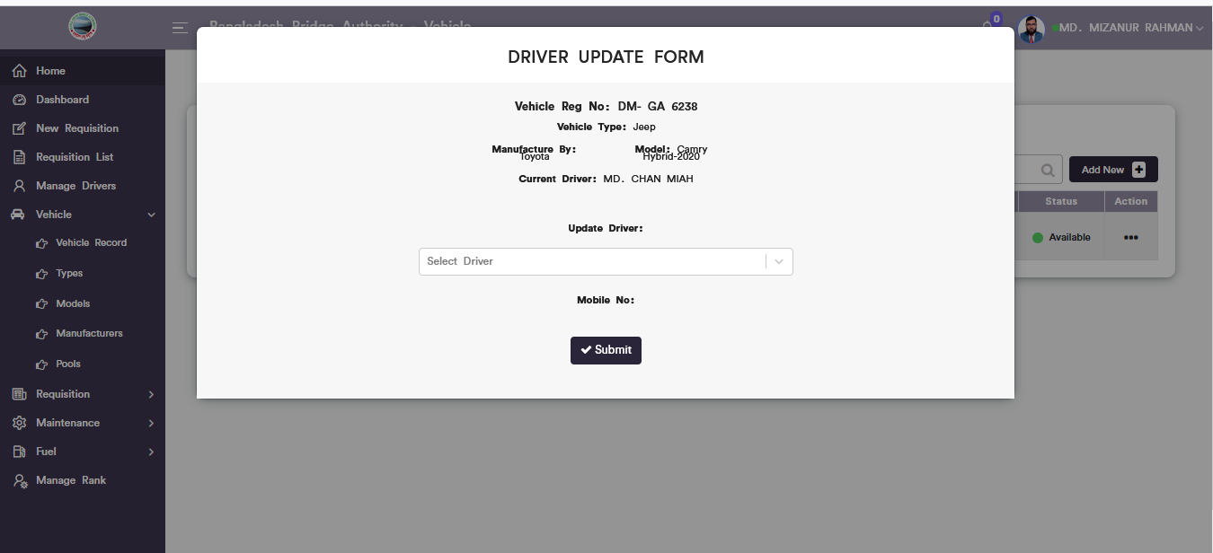

Figure 6.4.1.4: Vehicle records Driver update

### 6.4.1.5: Vehicle Record (Vehicle )Download Report

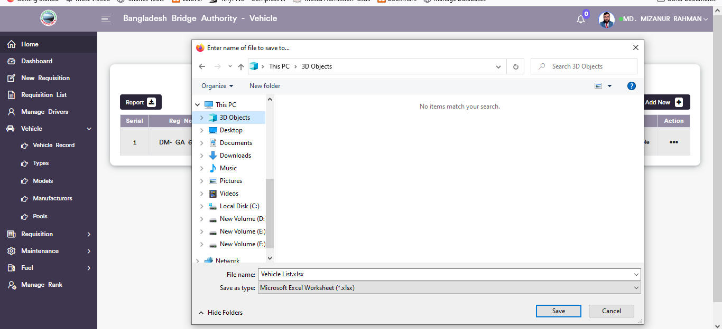

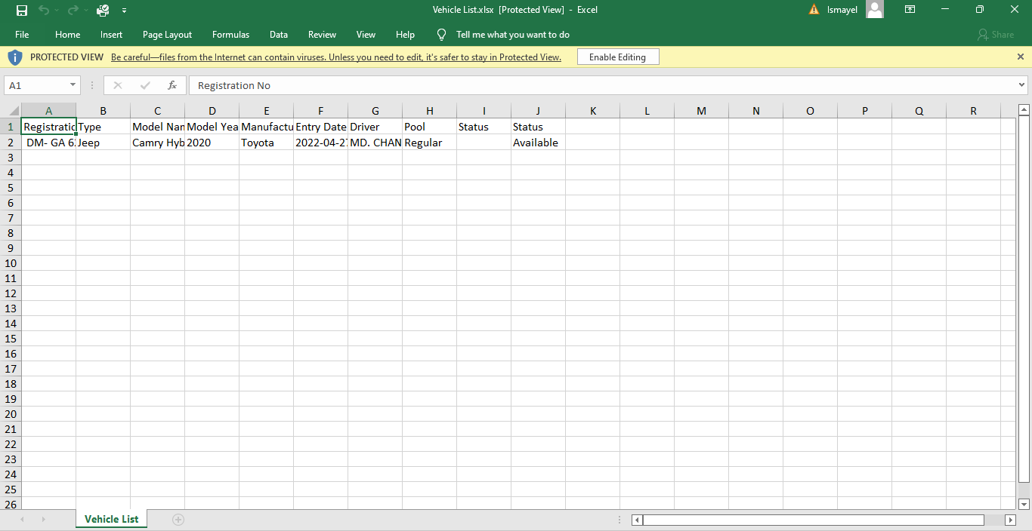

Figure 6.4.1.5: Vehicle records Download report

### 6.4.1.6: Vehicle Record (Vehicle )Search

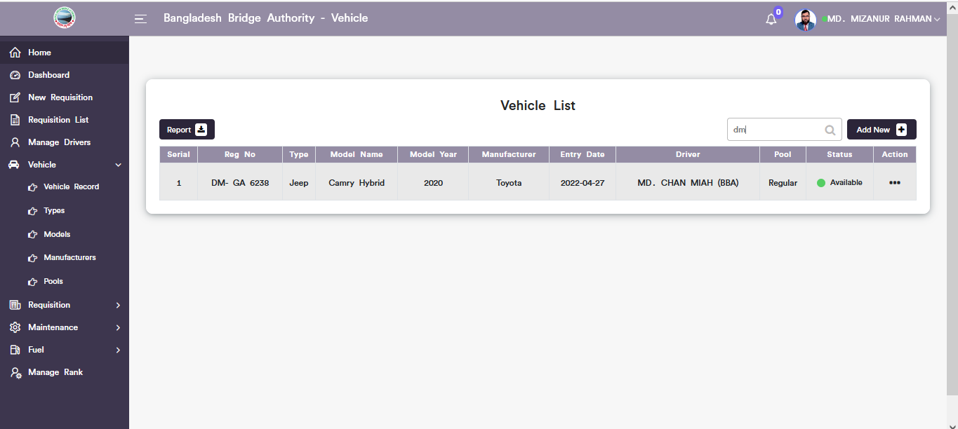

Figure 6.4.1.6: Vehicle records Search

### 6.4.2.1: Types (Vehicle )Add New(Vehicle Category Record form)

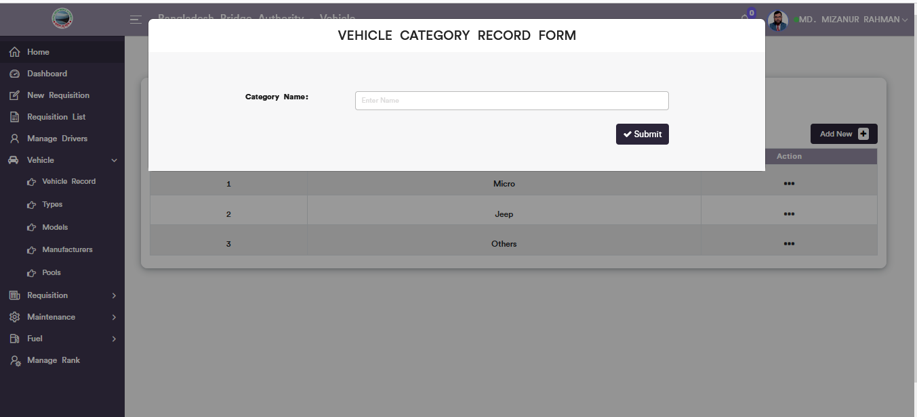

Figure 6.4.2.1: vehicle category record form

### 6.4.2.2: Types (Vehicle )View of details

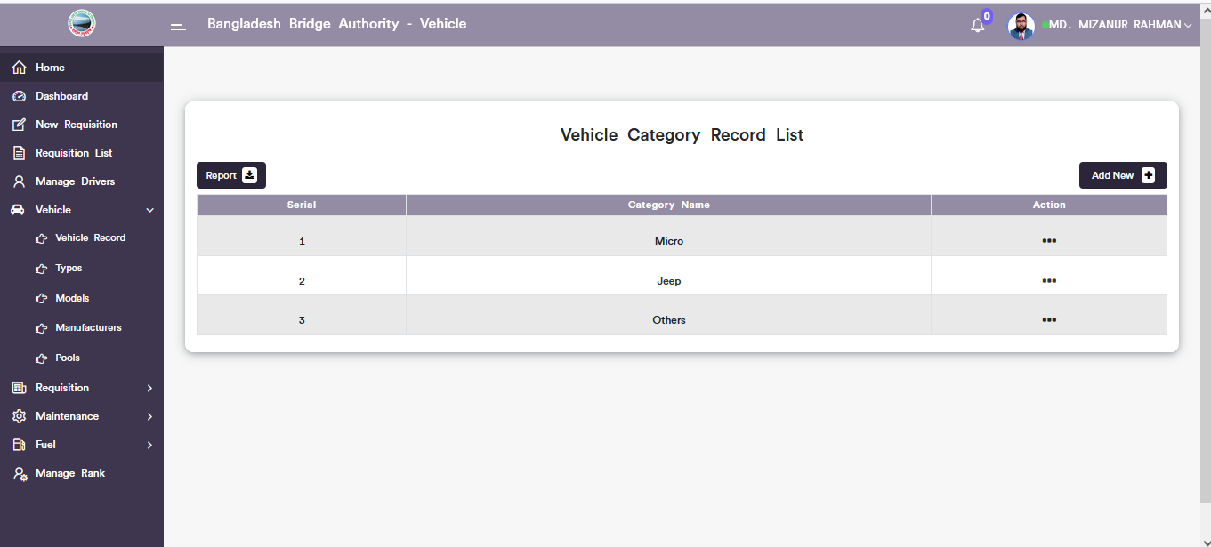

Figure 6.4.2.2: View of vehicle type list

### 6.4.2.3: Types (Vehicle )Download Report

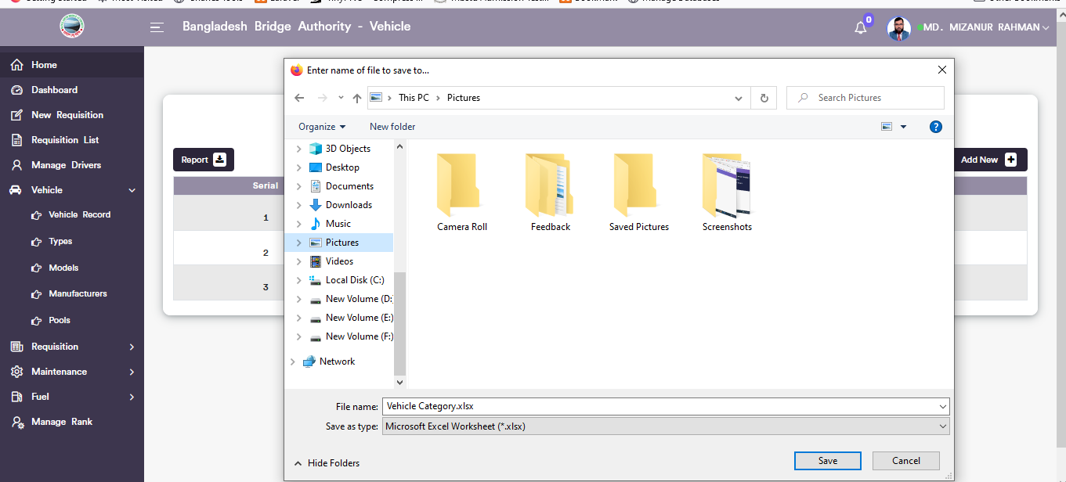

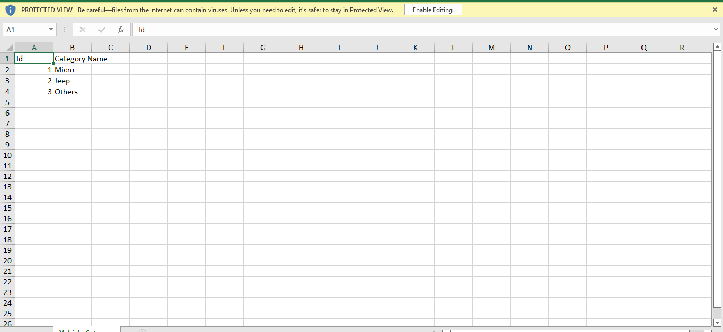

Figure 6.4.2.3: vehicle category record list download

### 6.4.2.4: Types (Vehicle ) Vehicle Category Update

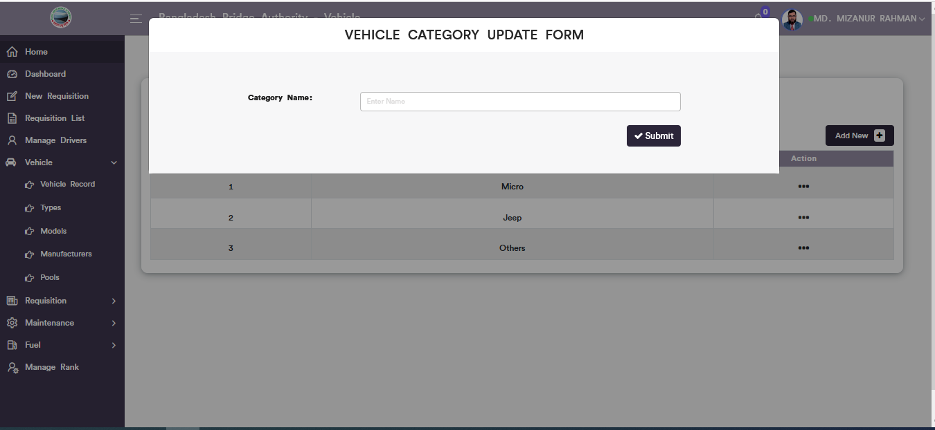

Figure 6.4.2.4: Types ( vehicle)vehicle category Update

### 6.4.3.1: Models (Vehicle )Vehicle Model record from

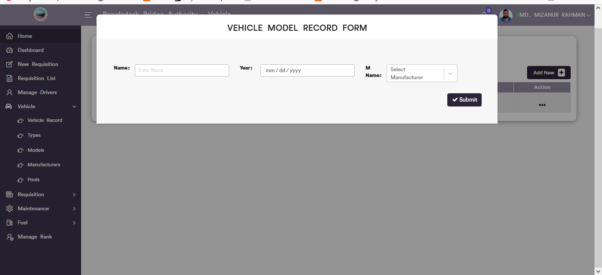

Figure 6.4.3.1: vehicle Model record form

### 6.4.3.2: Models (Vehicle )View of models details list

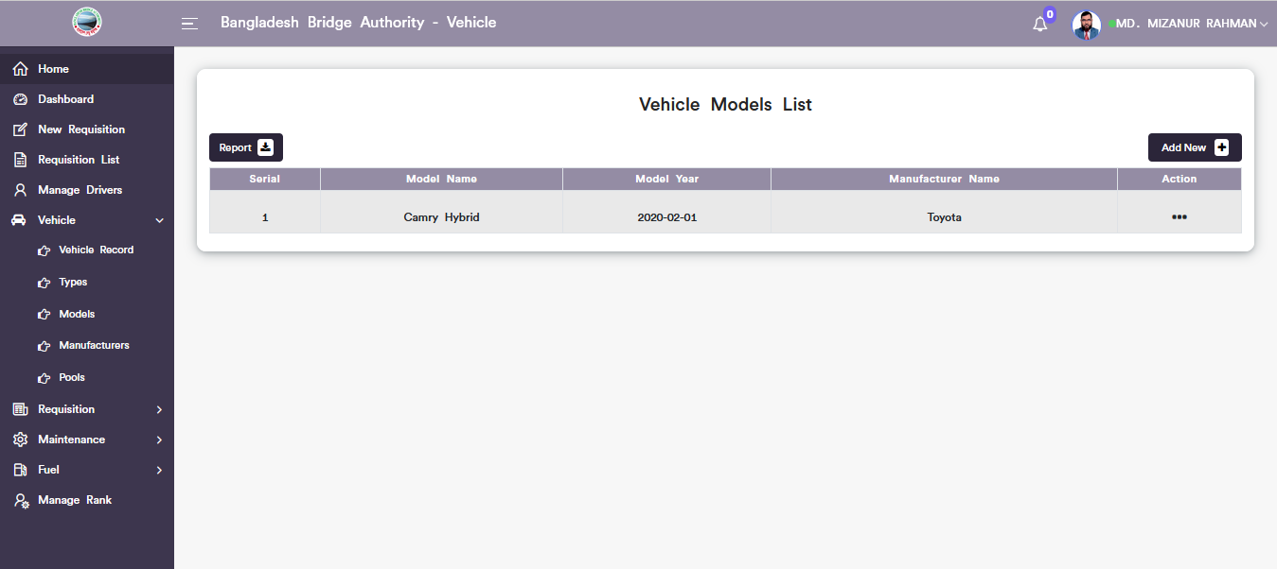

Figure 6.4.3.2: Vehicle models list

### 6.4.3.3: Vehicle Model Update Form

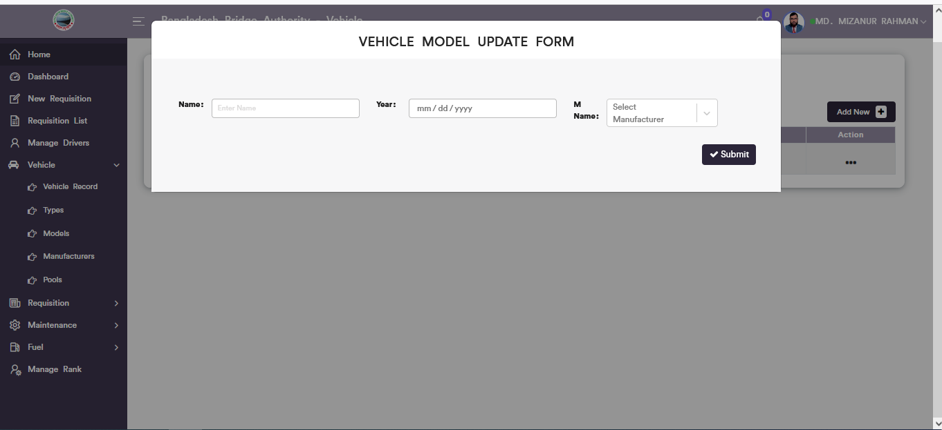

Figure 6.4.3.3: vehicle model update form

### 6.4.3.4: Models (Vehicle ) Download Model list Report

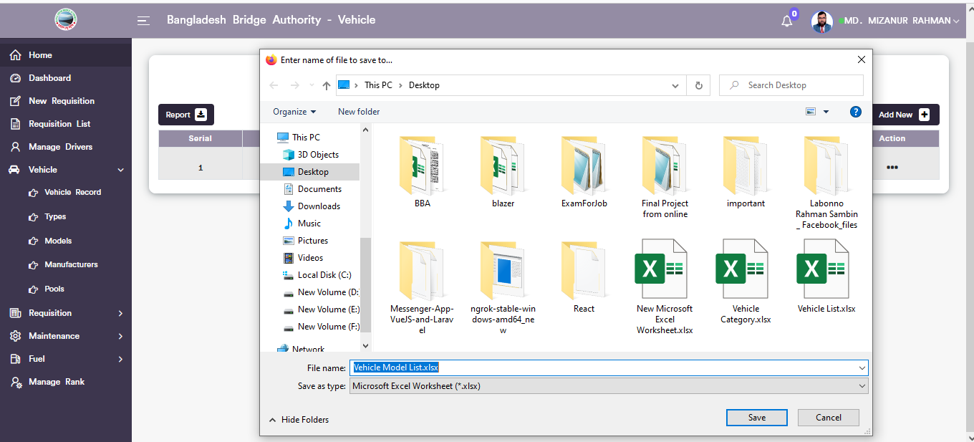

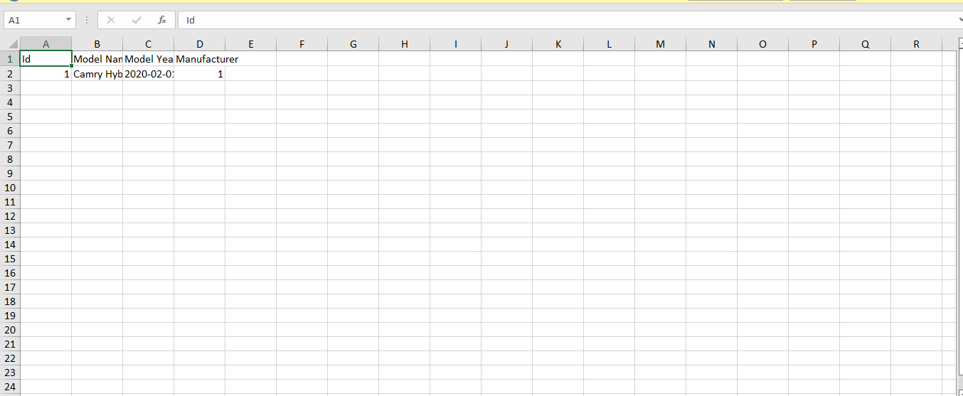

Figure 6.4.3.4:vehicle model list Download report

### 6.4.4.1: Manufacturers (Vehicle )Vehicle Manufacturer record from

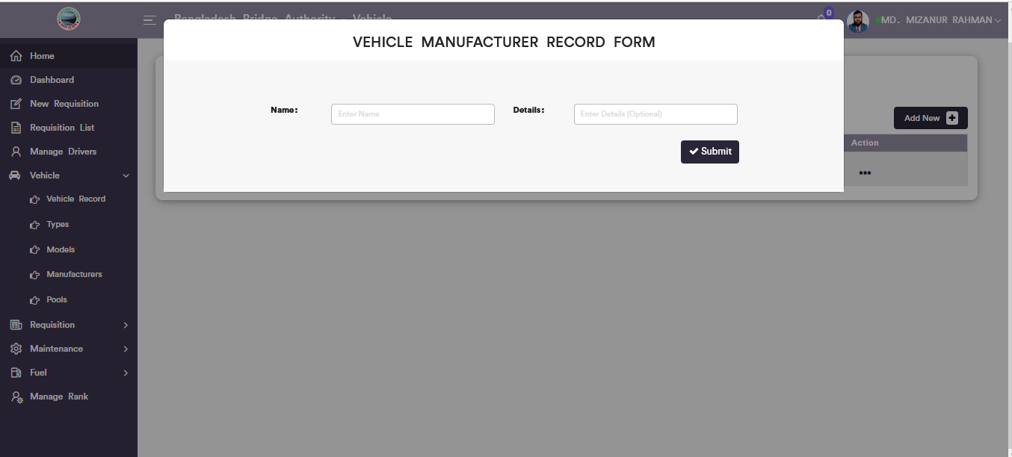

Figure 6.4.4.1: vehicle manufacturer record form

### 6.4.4.2: Manufacturers (Vehicle )View of manufacturers details list

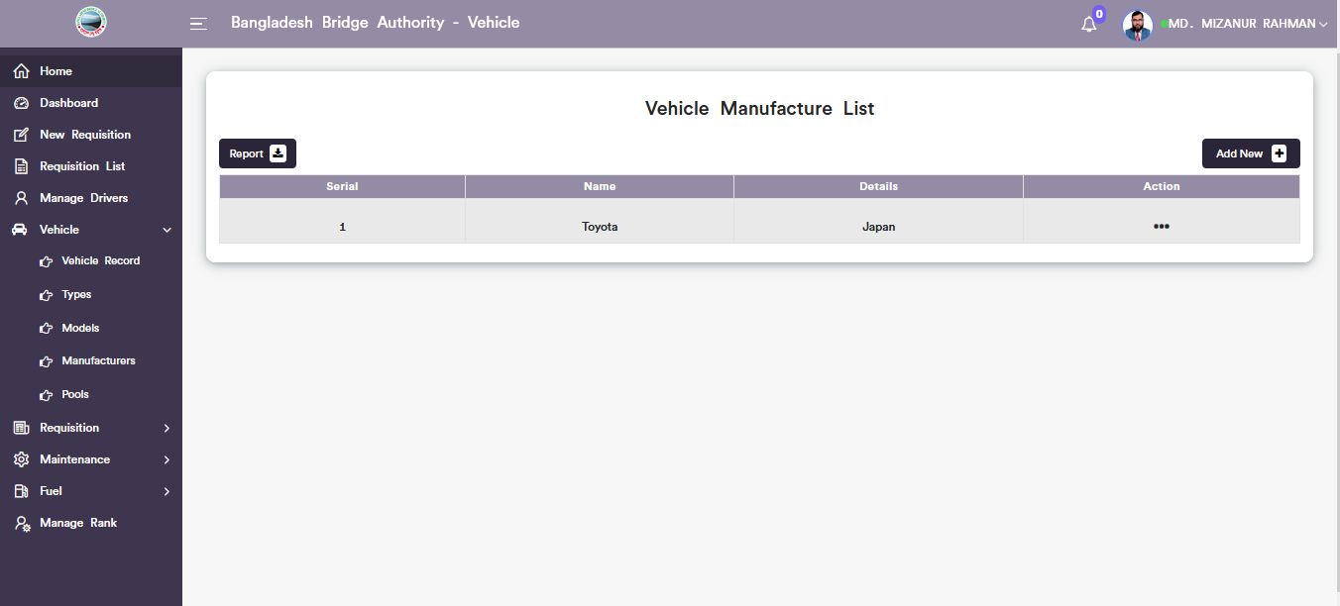

Figure 6.4.4.2: vehicle manufacturer list

### 6.4.4.3: Manufacturers (Vehicle )Download Report

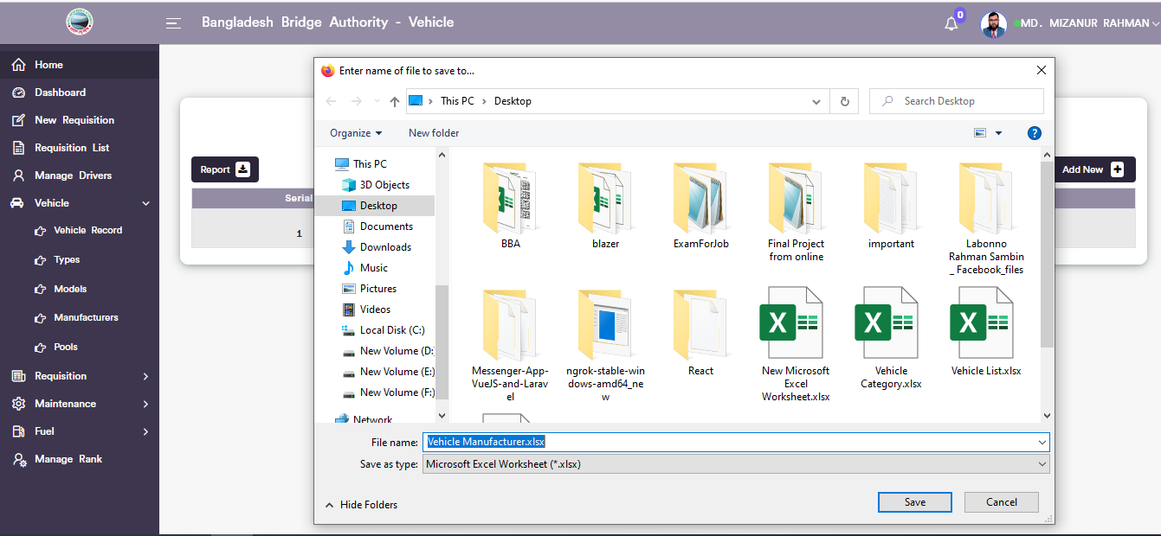

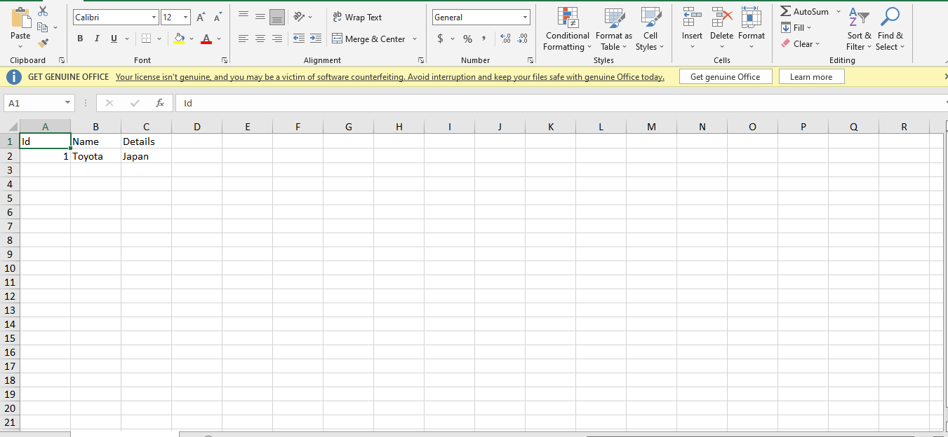

Figure 6.4.4.3: vehicle manufacturers Download report

### 6.4.5.1: Pools (Vehicle )Vehicle pool record form

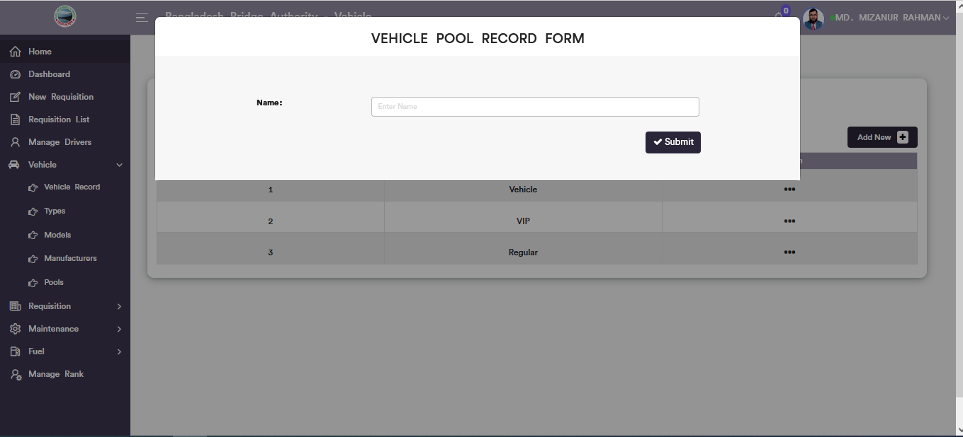

Figure 6.4.5.1: vehicle pool record form

### 6.4.5.2: Pools (Vehicle )View of details vehicle pool list

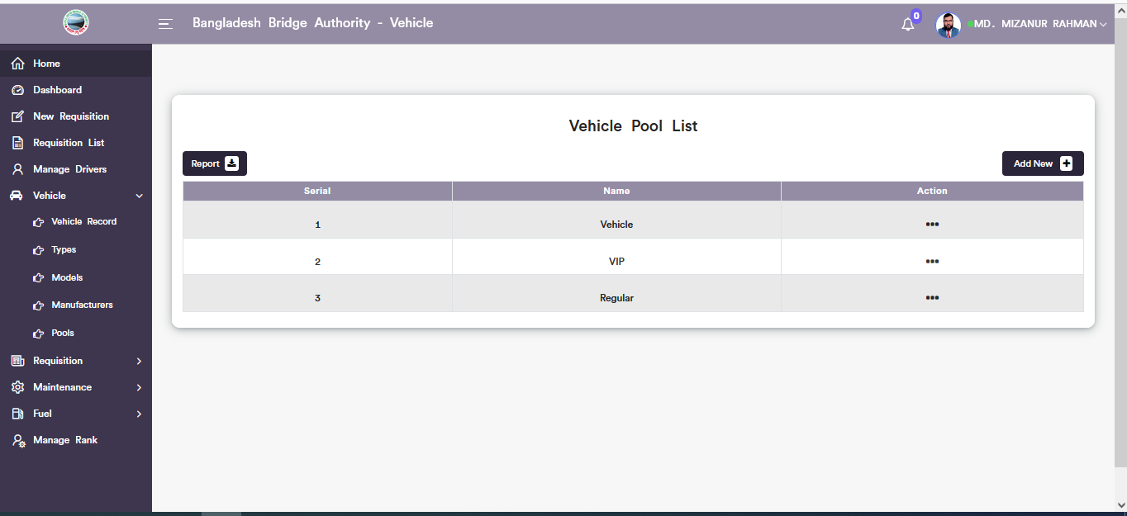

Figure 6.4.5.2: vehicle pool record form list

### 6.4.5.3: Vehicle Pool Update Form

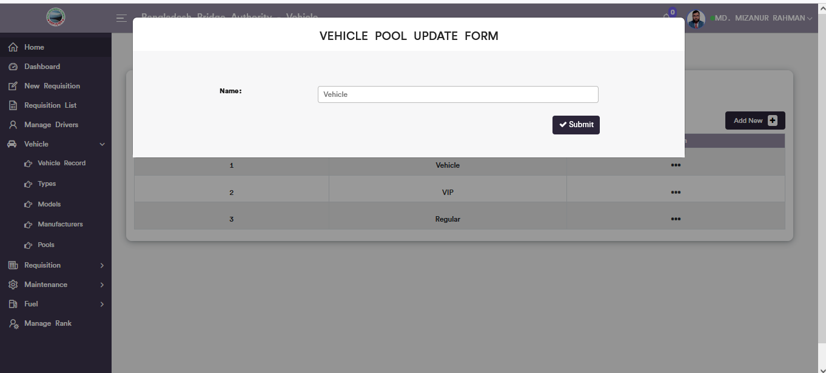

Figure 6.4.5.3: vehicle pool update form

### 6.4.5.4: Pools (Vehicle )Download Report

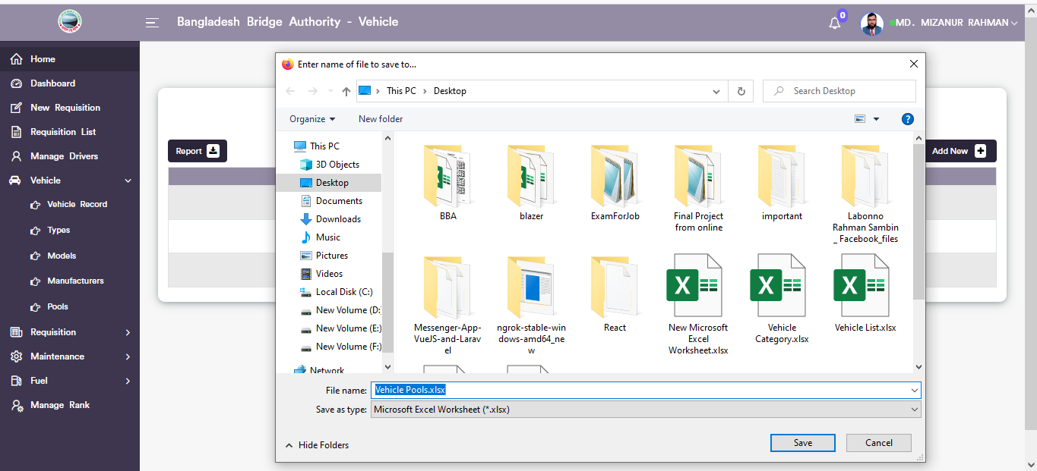

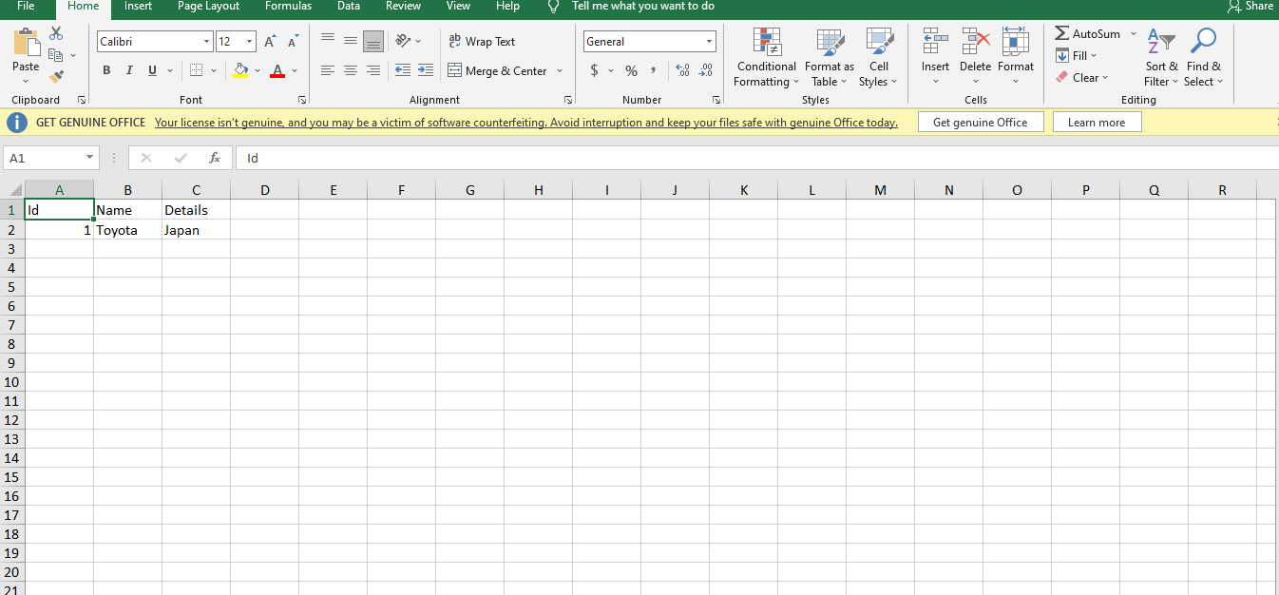

Figure 6.4.5. vehicle pools list download report

### 6.4.6: Settings (Vehicle )

In the settings sub menu there are two options and they are **1. Vehicle user**,and **2.Vehicle routes.**

### 6.4.6.1: Settings (Vehicle )Vehicle common user add form, vehicle common user list, edit and download report.

**1.Vehicle User**

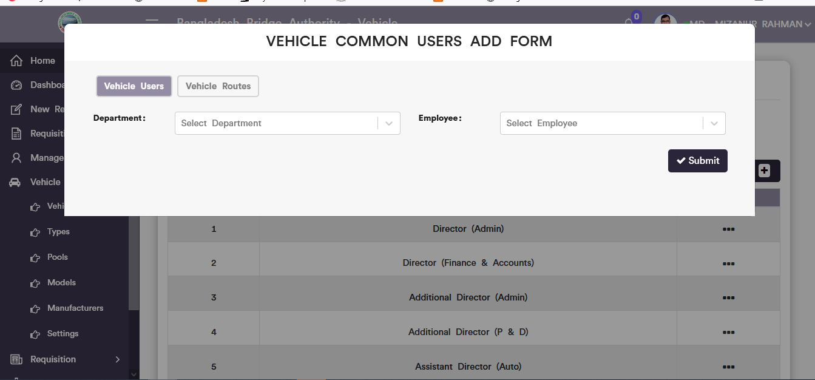

Figure 6.4.6.1.1. vehicle common users add form

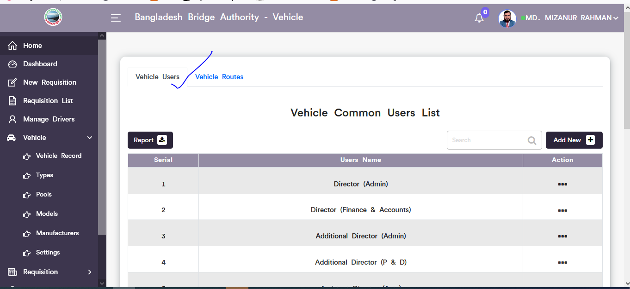

Figure 6.4.6.1.2. vehicle common users list

Click on the dotted button then choose update option after that looks like pop-up vehicle common user update modal will display. User can update input field data as user required.

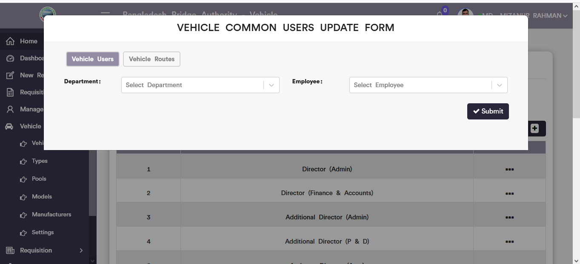

Figure 6.4.6.1.3. vehicle common users update form

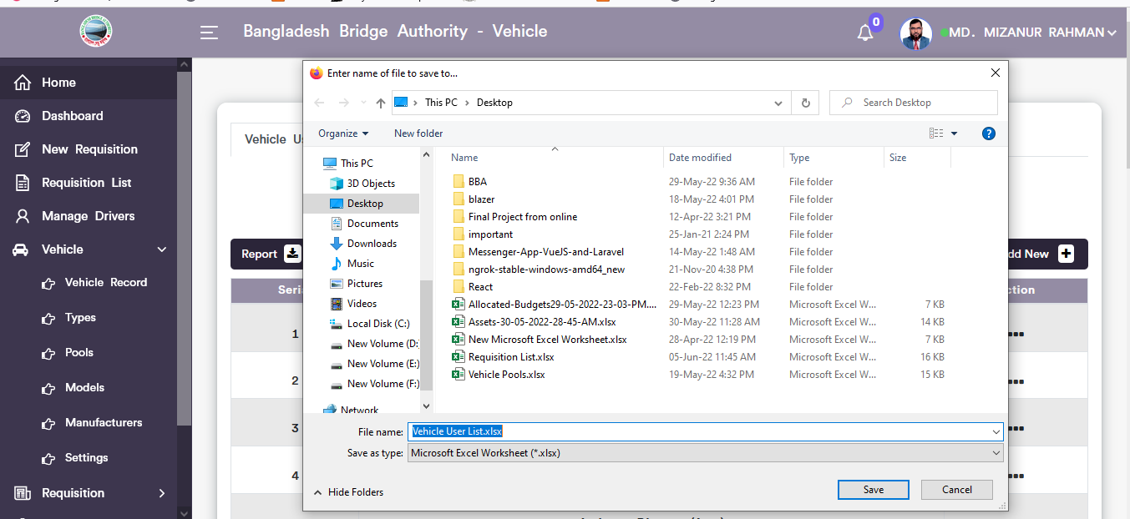

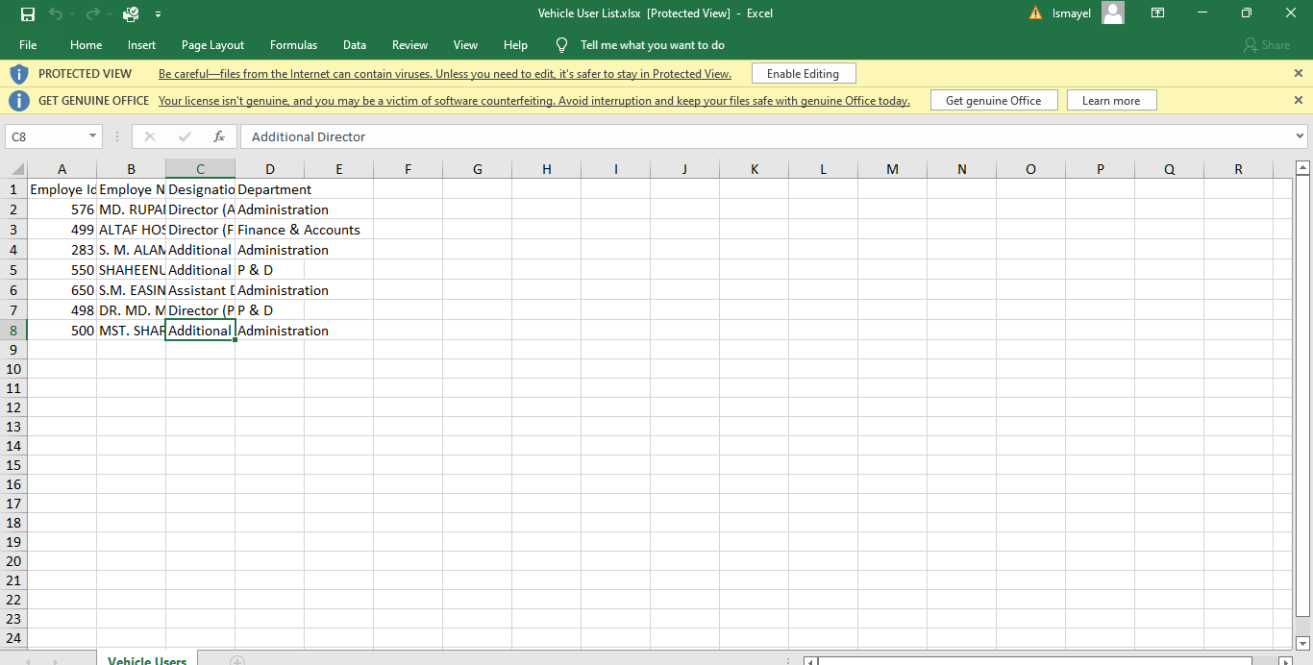

Figure 6.4.6.1.4. vehicle common users report download

### 6.4.6.2: Settings (Vehicle )Vehicle common Route add form, vehicle route list, edit and download report.

**1.Vehicle Route List**

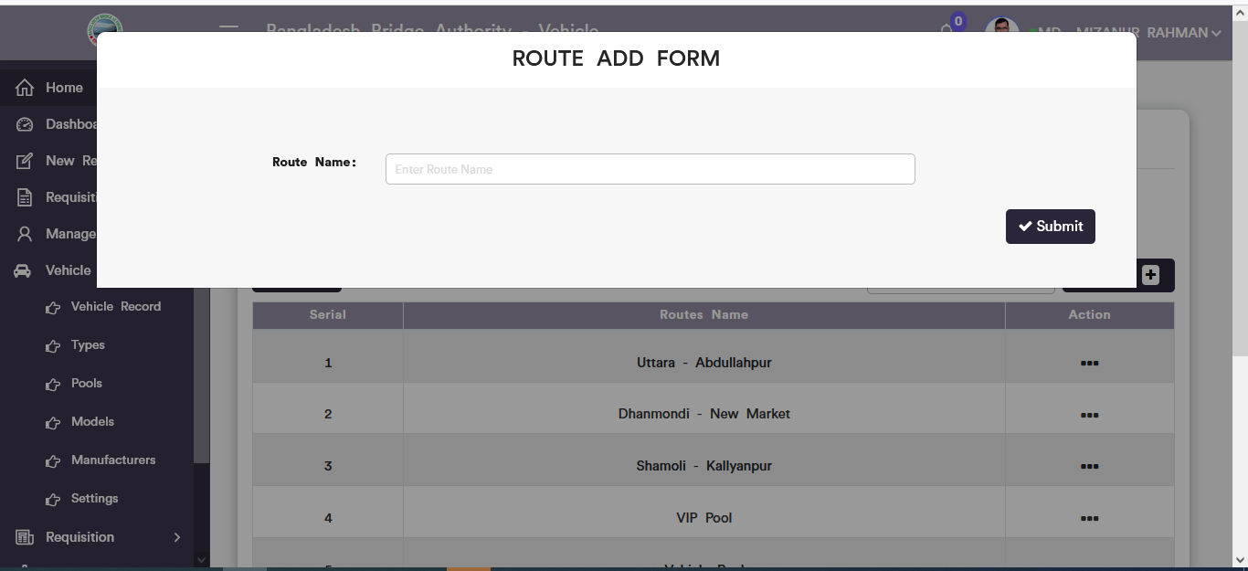

Figure 6.4.6.2.1 vehicle routes add form

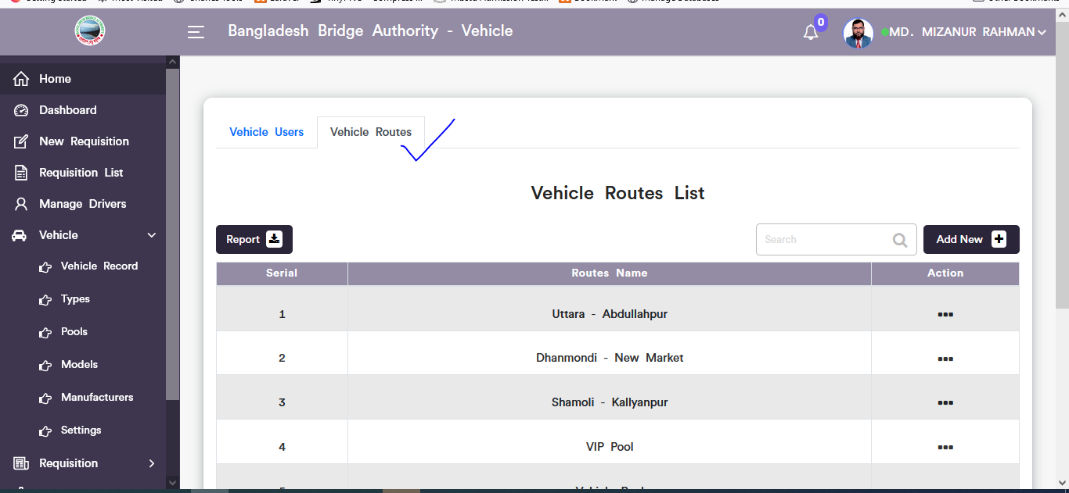

Figure 6.4.6.2.2. vehicle routes list

Click on the dotted button then choose update option after that looks like pop-up route update modal will display. User can update input field data as user required.

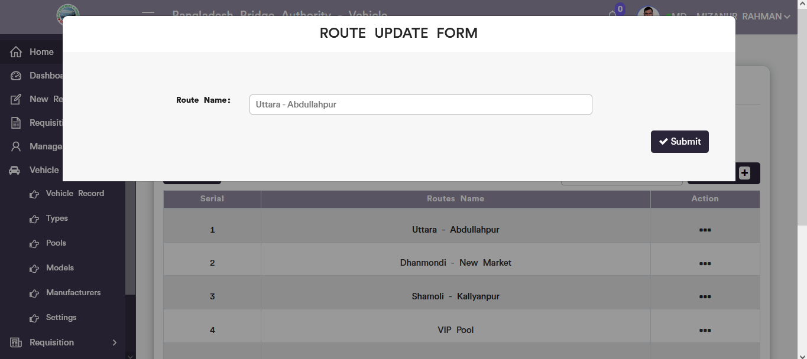

Figure 6.4.6.2.3. vehicle route update form

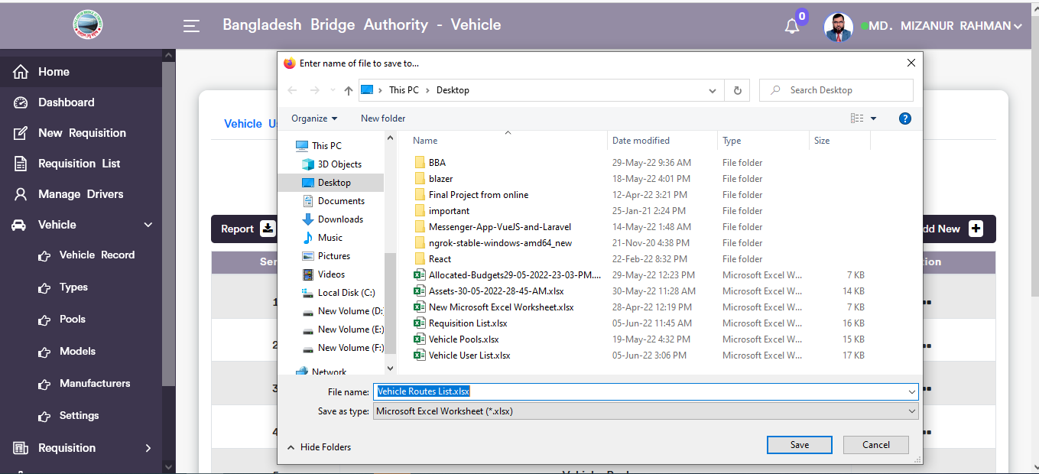

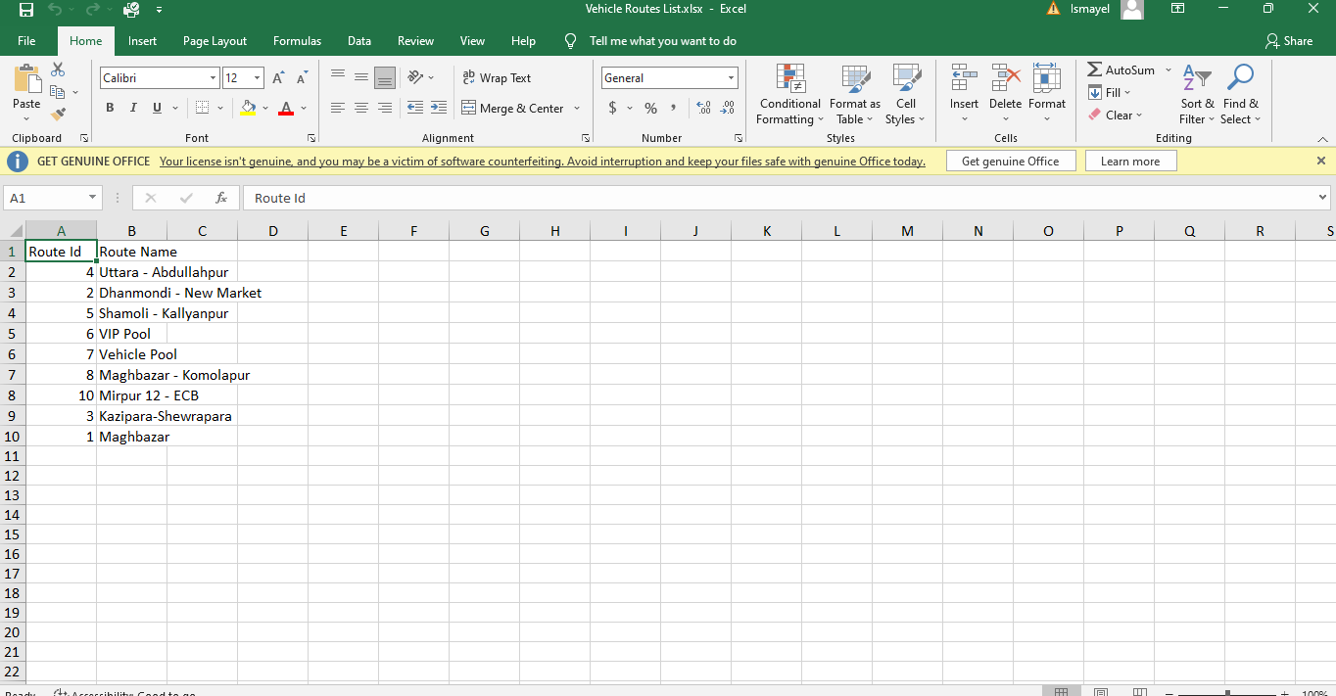

Figure 6.4.6.2.4. vehicle route list report download

## 6.5: Requisition Menu Overview

**Overview of Requisition**

### 6.5.1.1: Requisition Record (Requisition)View of all requisition list

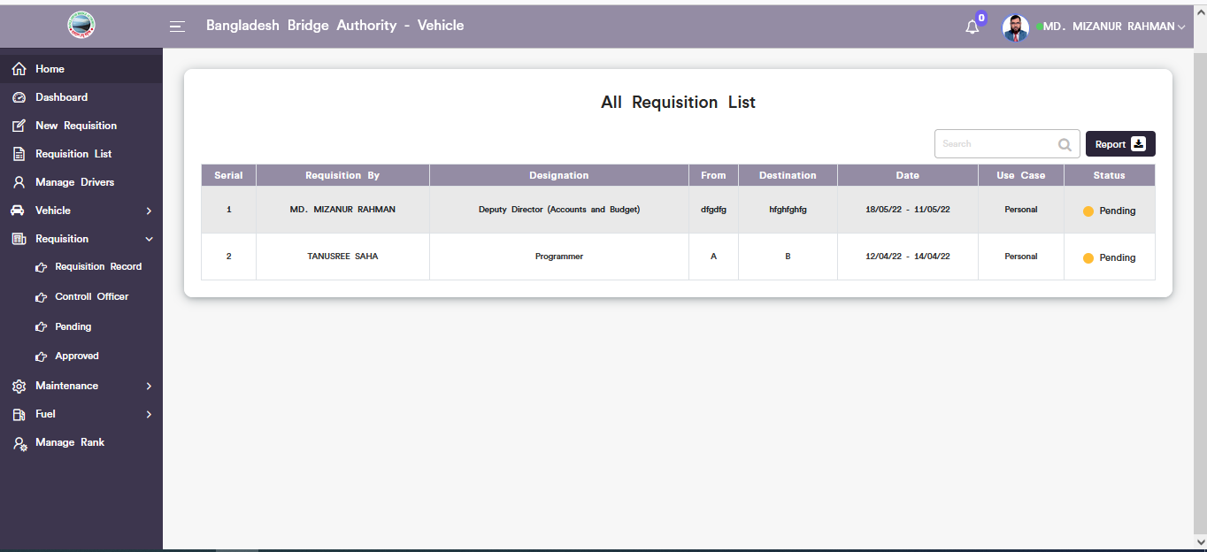

Figure 6.5.1.1: View of all requisition list

### 6.5.1.2: Requisition Record (Requisition)Report download

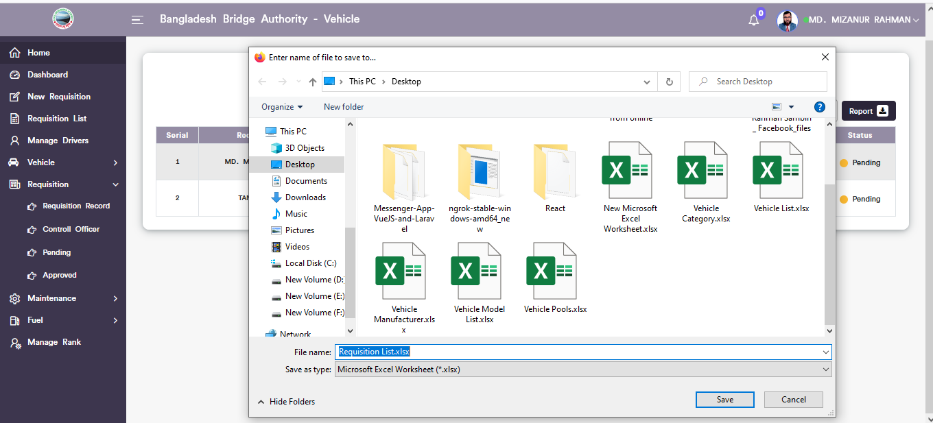

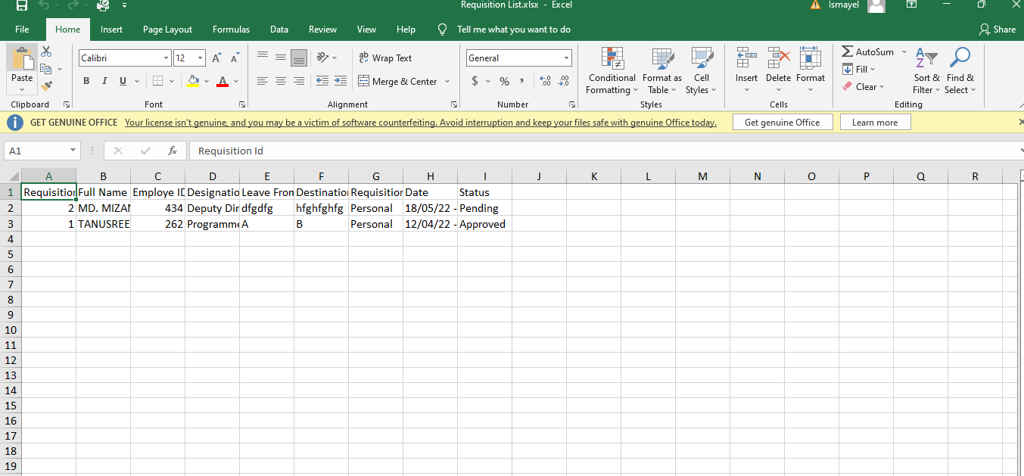

Figure 6.5.1.2: all requisition list report download

### 6.5.1.3: Requisition Record (Requisition)Search

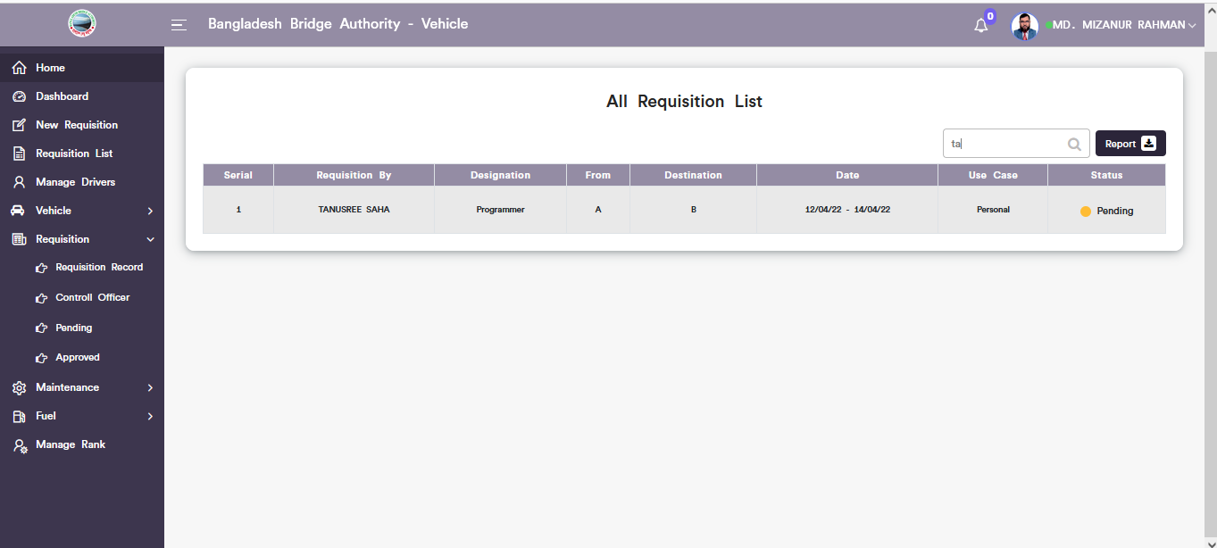

Figure 6.5.1.3: search data from all requisition list

### 6.5.2.1: Control Officer (Requisition)View of pending requestion for controller officer.

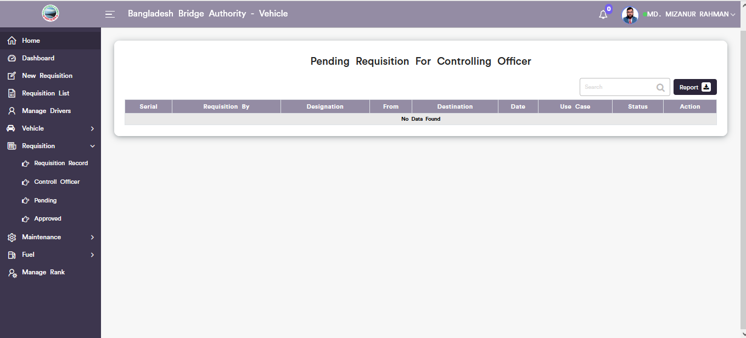

Figure 6.5.2.1: pending Requisition for controlling officer

### 6.5.2.2: Control Officer (Requisition)Download report.

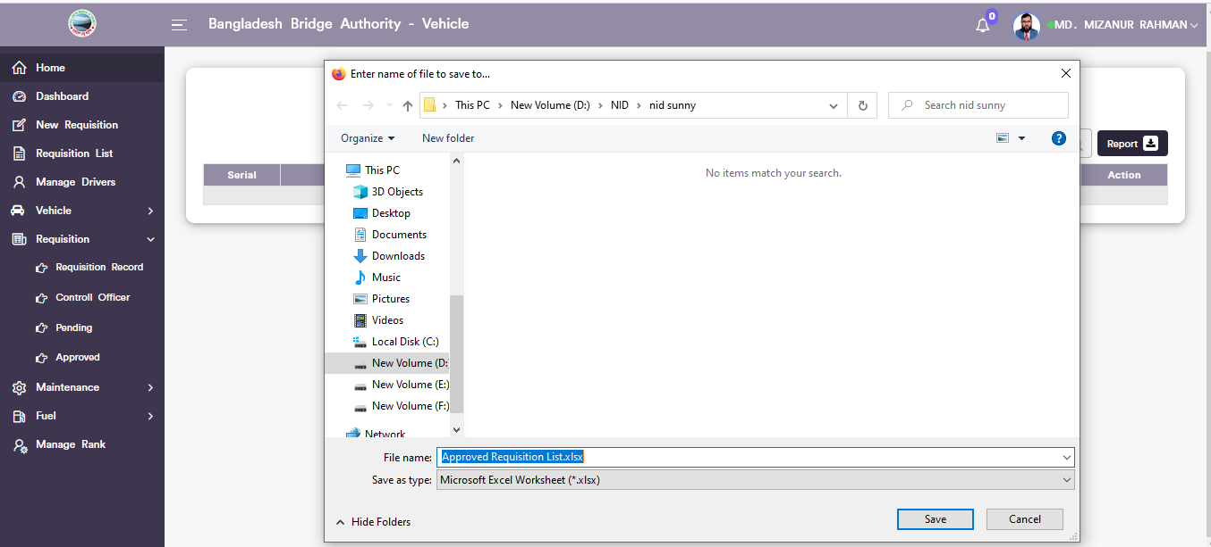

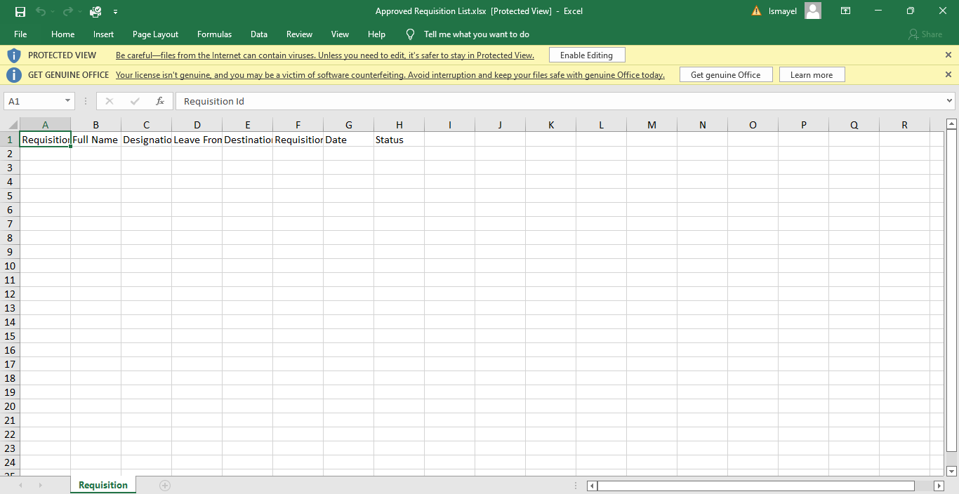

Figure 6.5.2.2: Control officer pending requisition Download report

### 6.5.3.1: Pending (Requisition)View of pending requisition list.

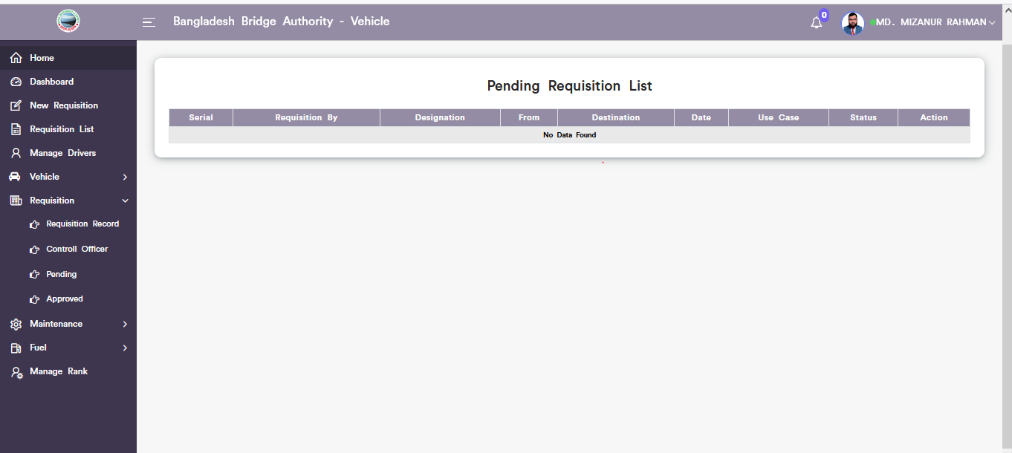

Figure 6.5.3.1: pending requisition list

### 6.5.4.1: Approved(Requisition)Approved requisition list.

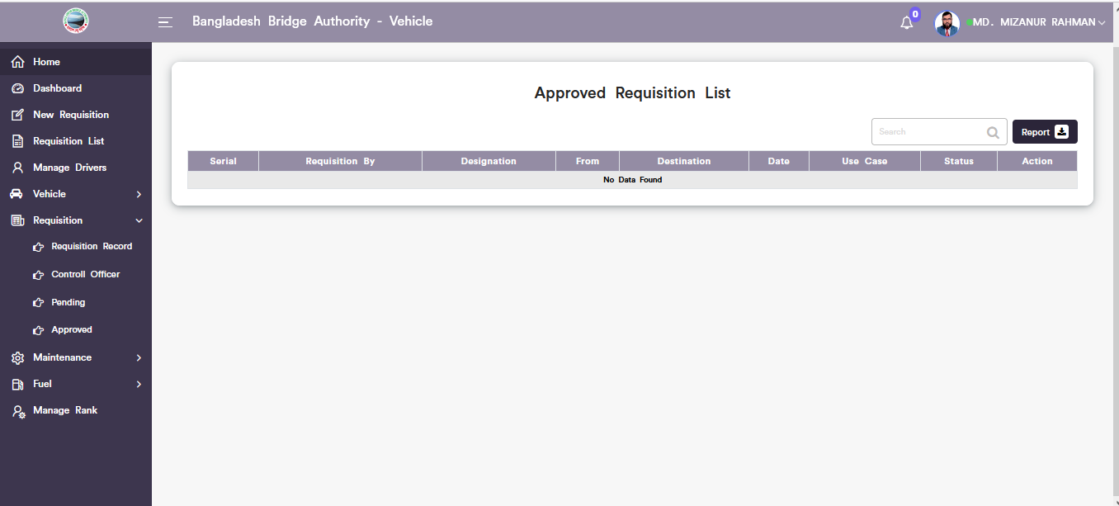

Figure 6.5.4.1: approved requisition list

## 6.6: Maintenance Menu Overview

**Overview of Maintenance**

### 6.6.1.1: Maintenance Record(Maintenance)Add new vehicle servicing

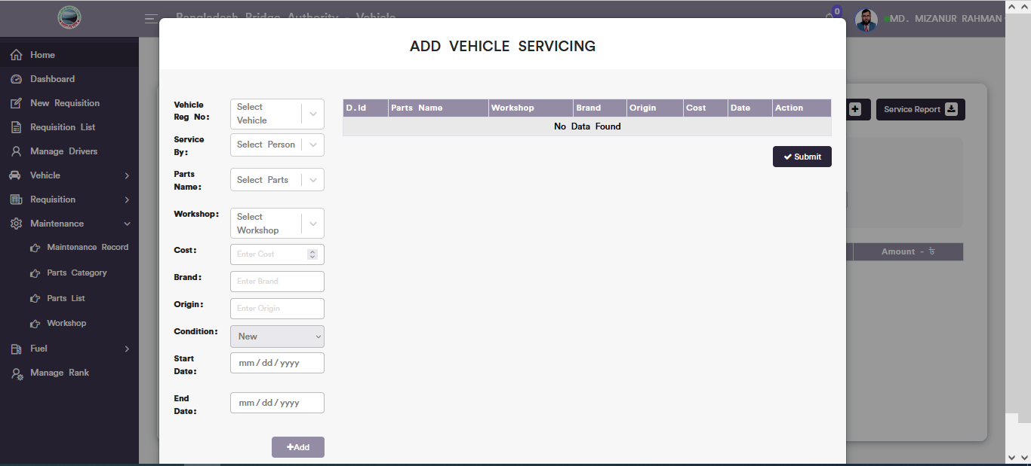

Figure 6.6.1.1: add new vehicle servicing

### 6.6.1.2: Maintenance Record(Maintenance)View of servicing list

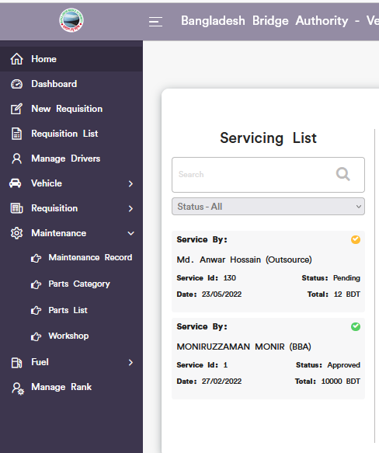

Figure 6.6.1.2: view of servicing list

### 6.6.1.3: Maintenance Record(Maintenance)Single Details servicing

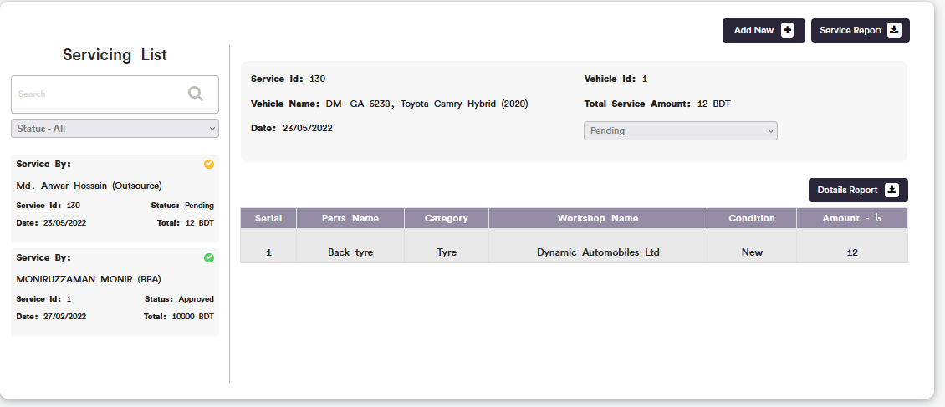

Figure 6.6.1.3: single details servicing information

### 6.6.1.4: Maintenance Record(Maintenance)Search

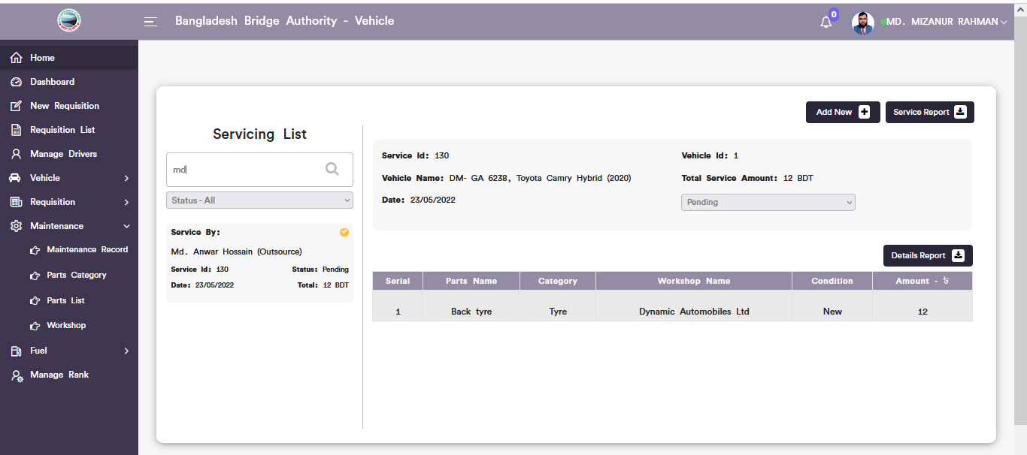

Figure 6.6.1.4: Maintenance record search from servicing list

### 6.6.1.5: Maintenance Record(Maintenance)Service report download

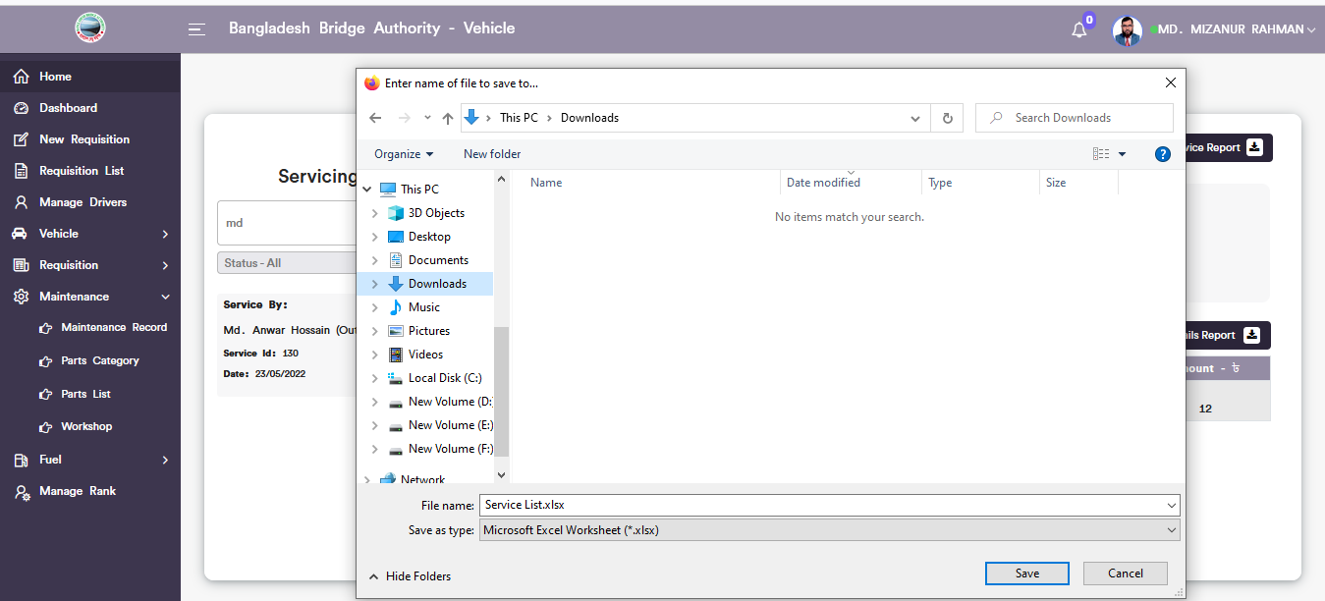

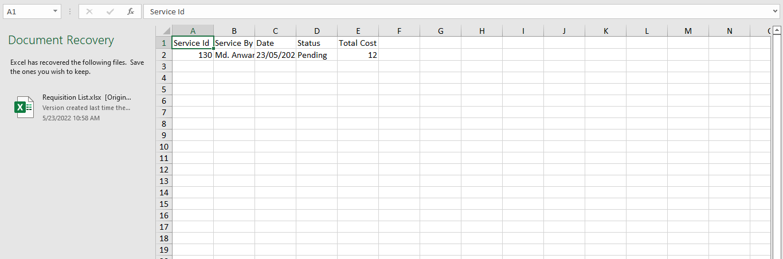

Figure 6.6.1.5: service list report download

### 6.6.1.6: Maintenance Record(Maintenance)Details report download

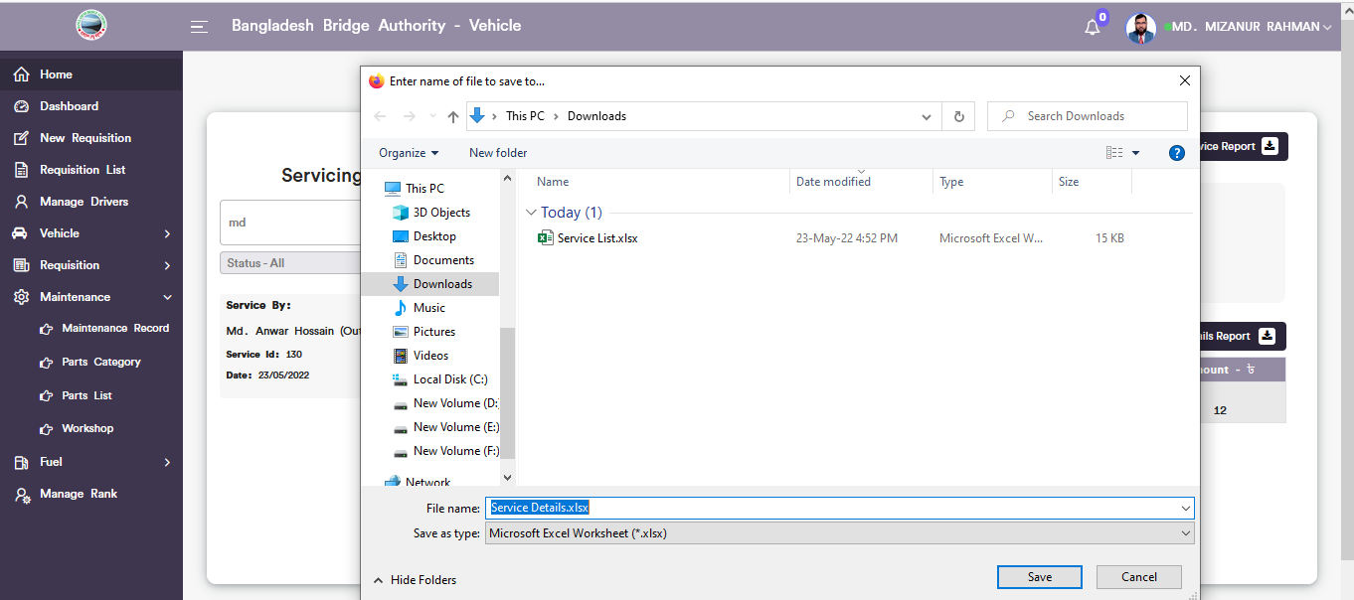

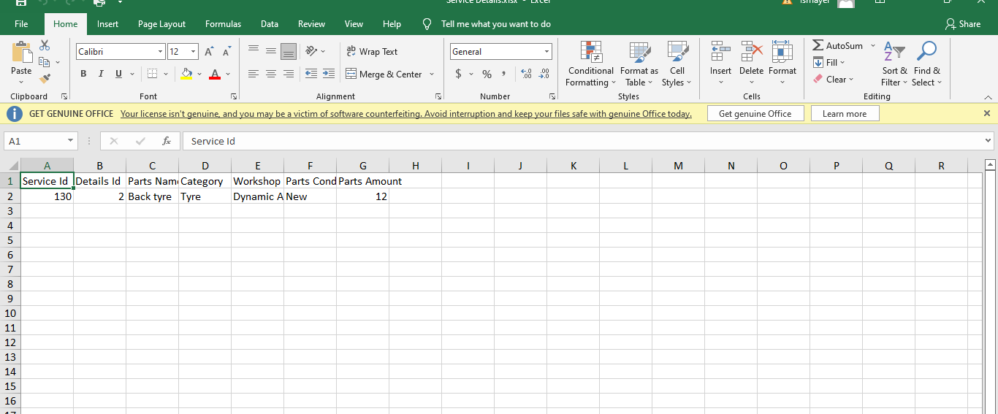

Figure 6.6.1.6: details service report download

### 6.6.2.1: Product Category(Maintenance)Add new Category

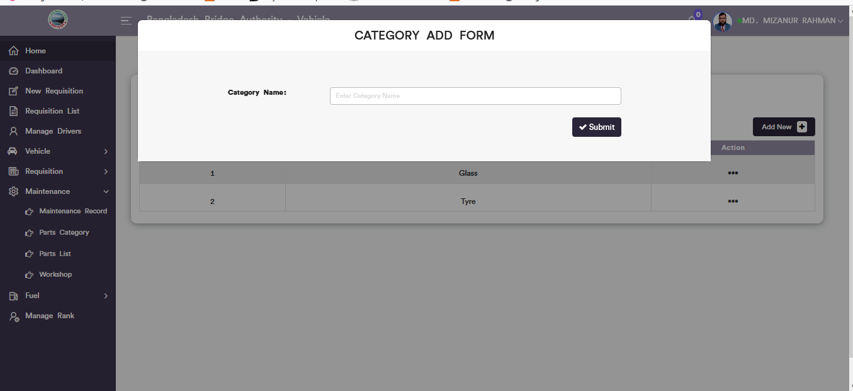

Figure 6.6.2.1: Product category add form

### 6.6.2.2: Product Category(Maintenance)Update category data



Figure 6.6.2.2: update Product category data

### 6.6.2.2: Product Category(Maintenance)Download Report

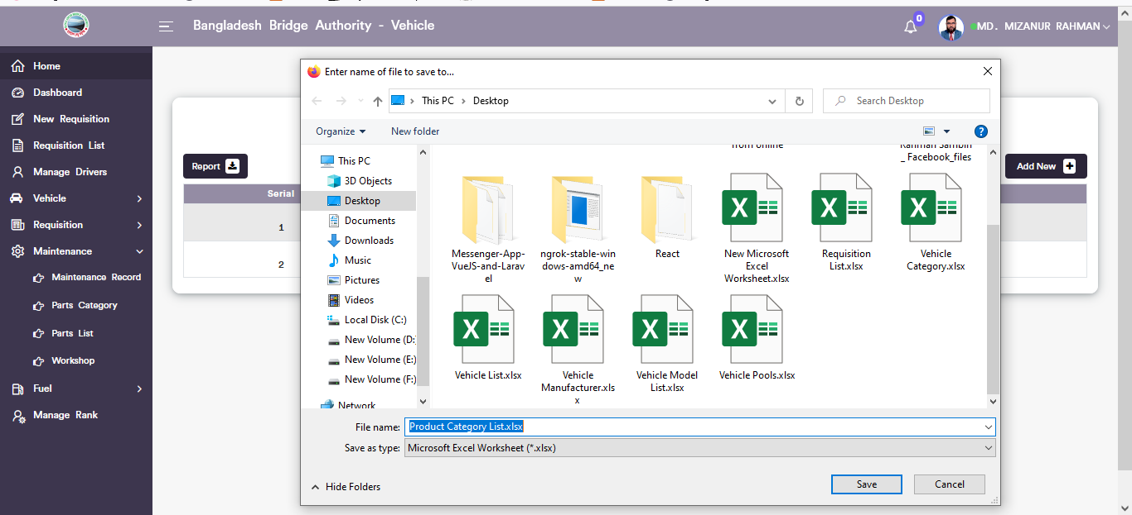

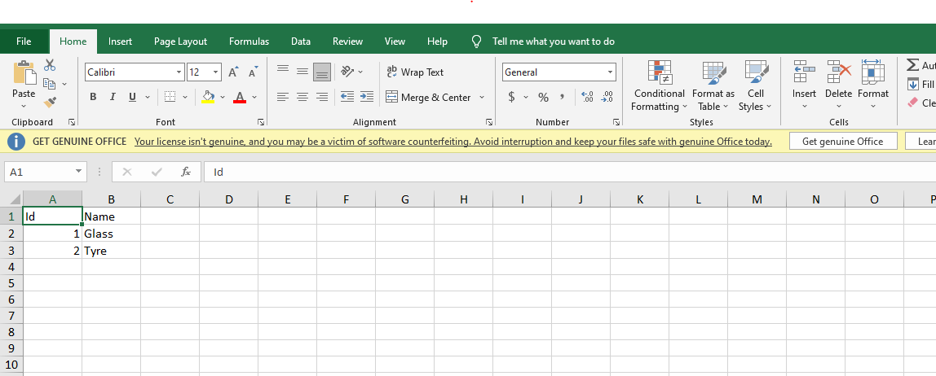

Figure 6.6.2.3: Product category Report Download

### 6.6.3.1: Product List(Maintenance)Add new product

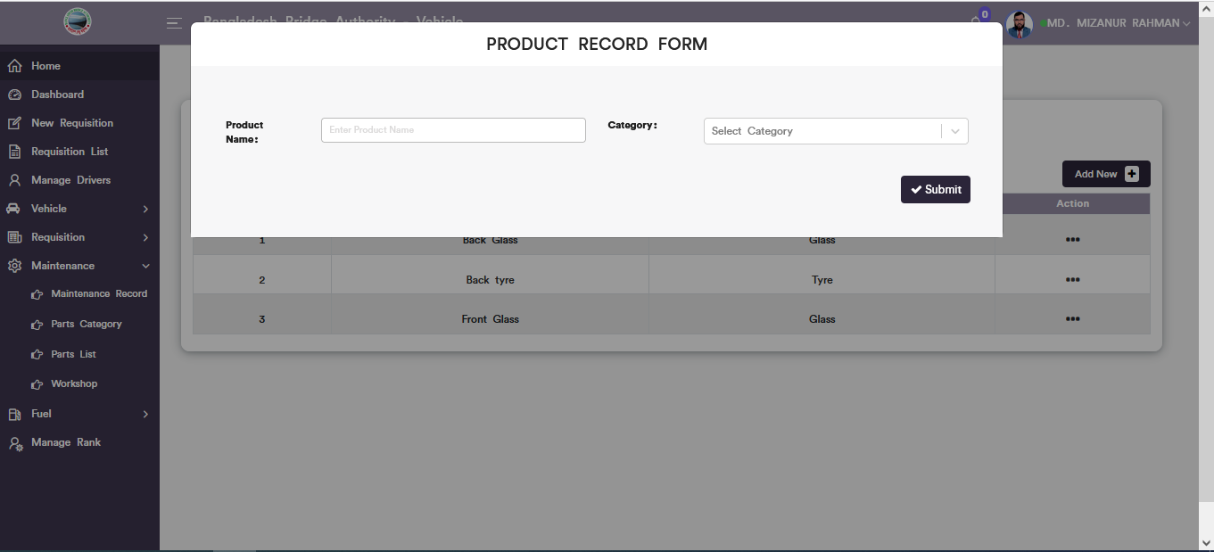

Figure 6.6.3.1: new product record form

### 6.6.3.2: Product List(Maintenance)Product Update

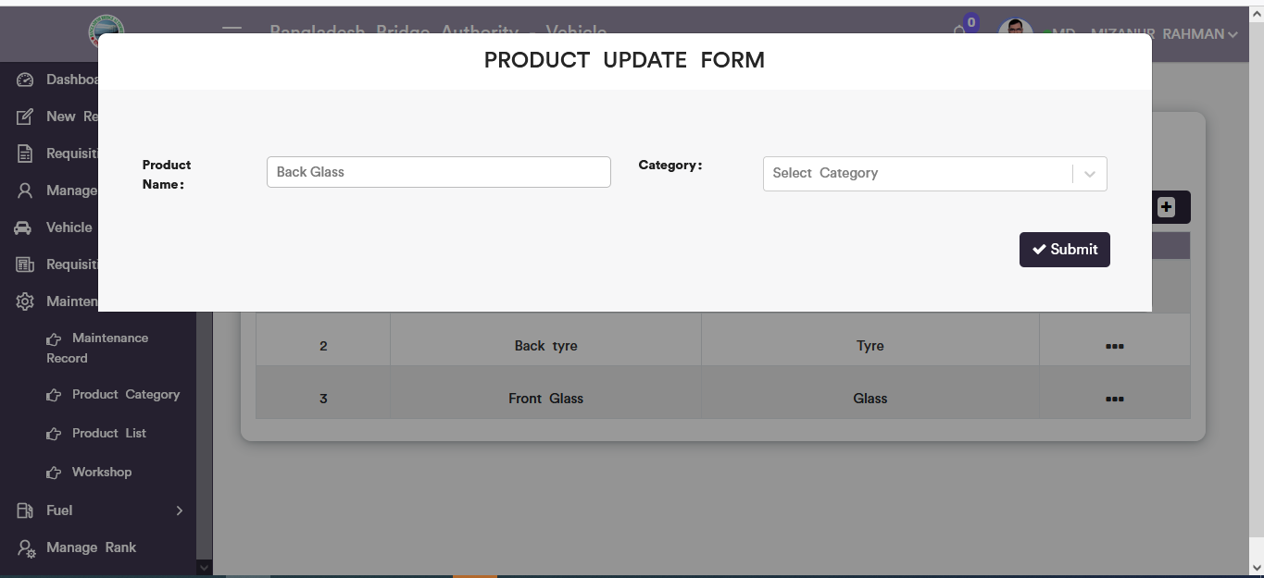

Figure 6.6.3.2: Product Update form

### 6.6.3.3: Product Lists(Maintenance)Download Report



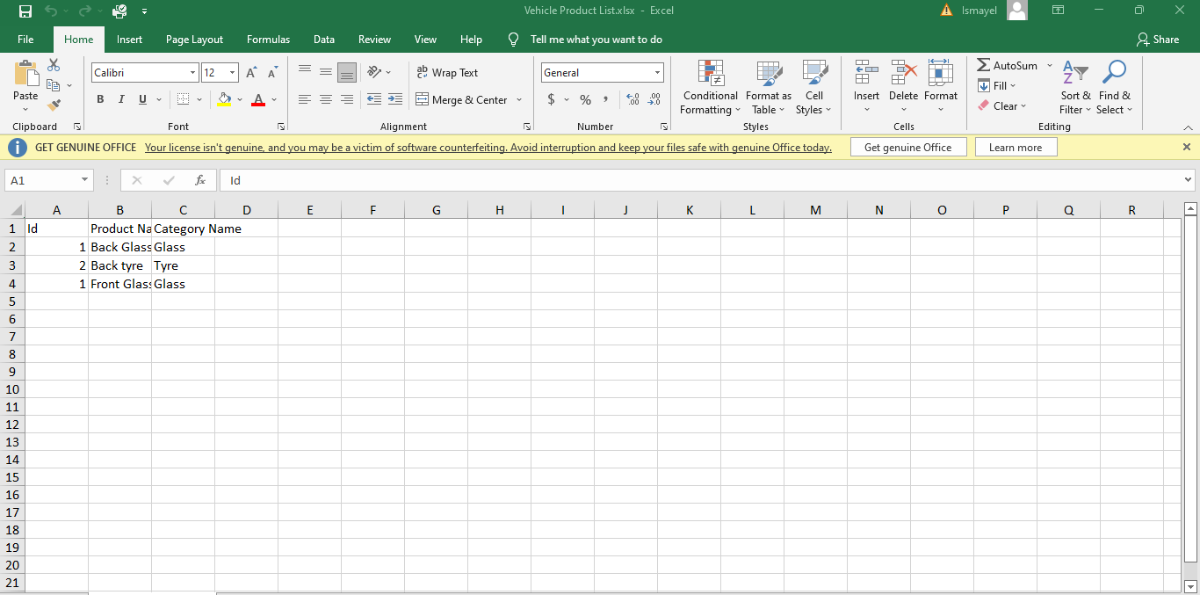

Figure 6.6.3.3: Product Lists Report Download

### 6.6.4.1: Workshop(Maintenance)Add workshop

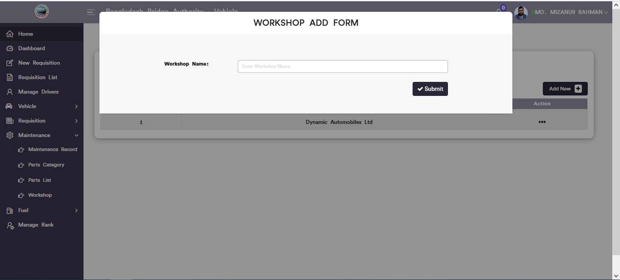

Figure 6.6.4.1: add new workshop input form

### 6.6.4.2: Workshop(Maintenance)Update workshop data

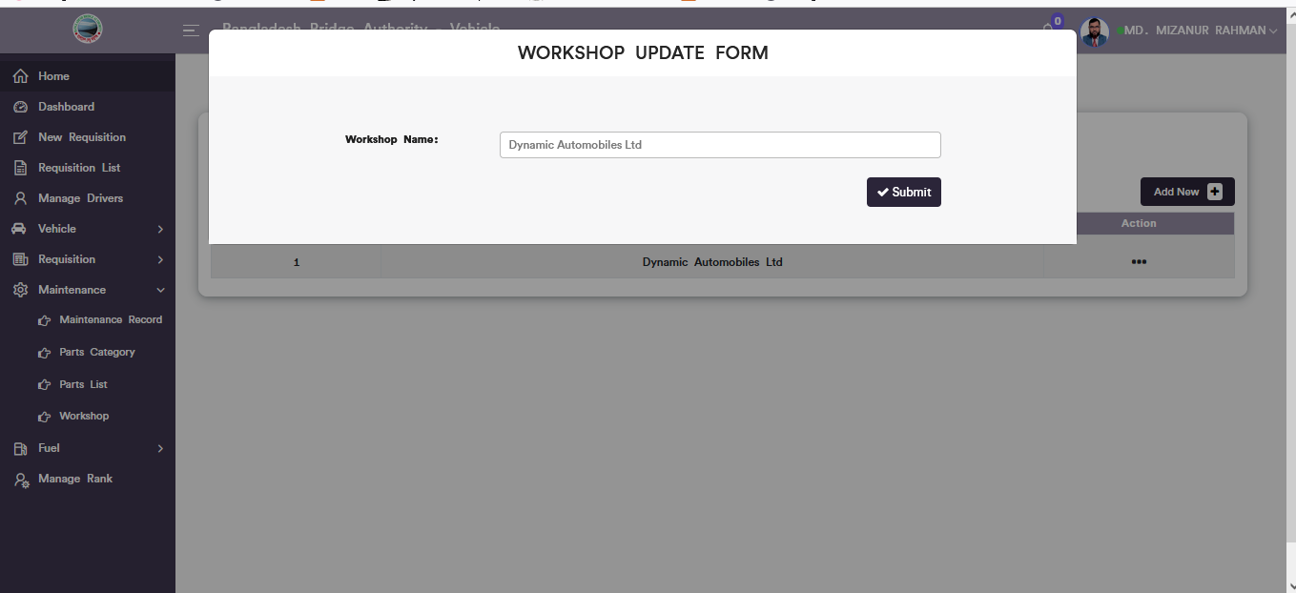

Figure 6.6.3.2: Workshop Update form

### 6.6.4.3: Workshop(Maintenance)Download Report

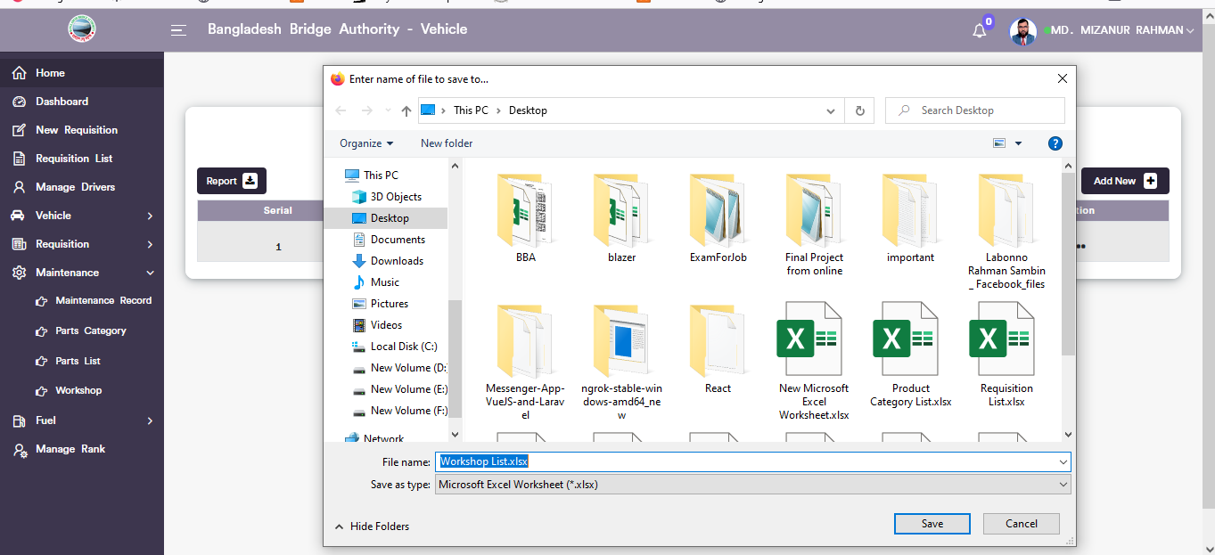

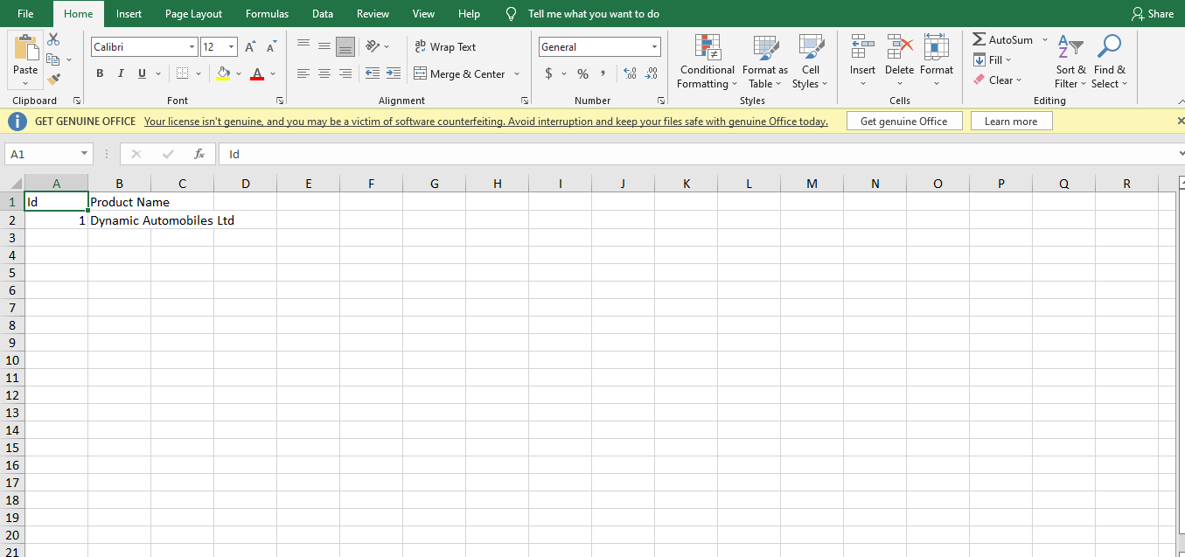

Figure 6.6.4.3: Workshop report Download

## 6.6: Fuel Menu Overview

**Overview of Fuel**

### 6.7.1.1: Fuel Record(Fuel)Add new fuel record form

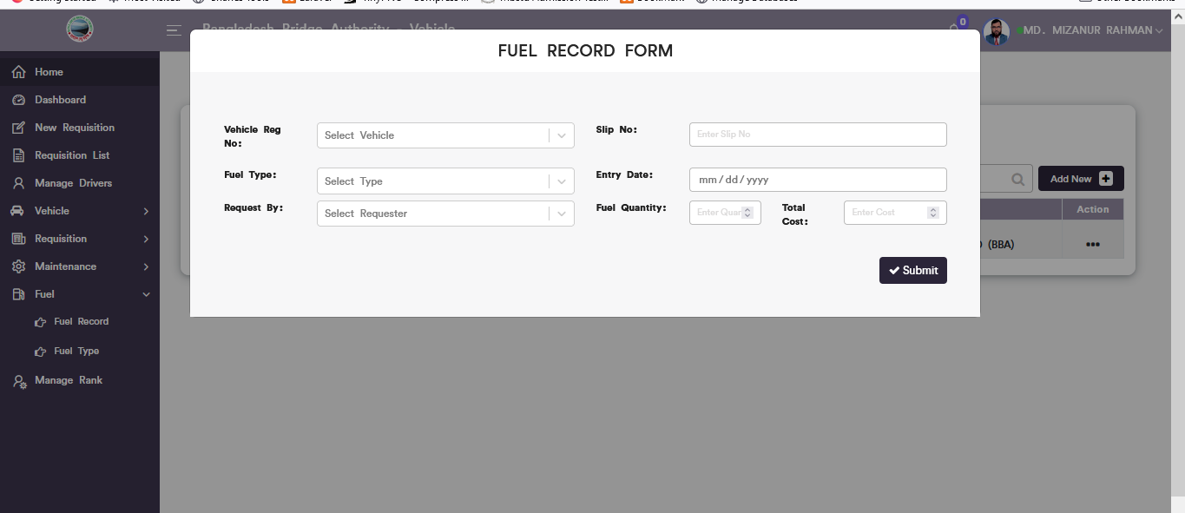

Figure 6.7.1.1: add new fuel record input form

### 6.7.1.2: Fuel record(Fuel)View of fuel record list

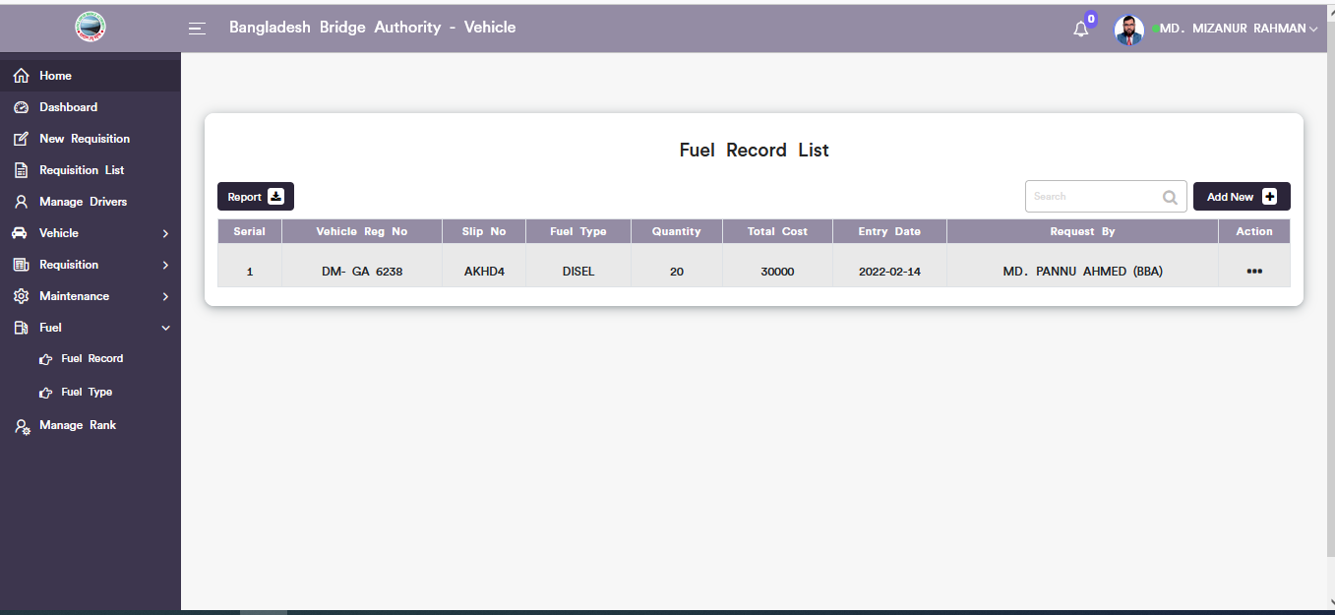

Figure 6.7.1.2: Fuel record list

### 6.7.1.3: Fuel Record(Fuel)Update fuel record data

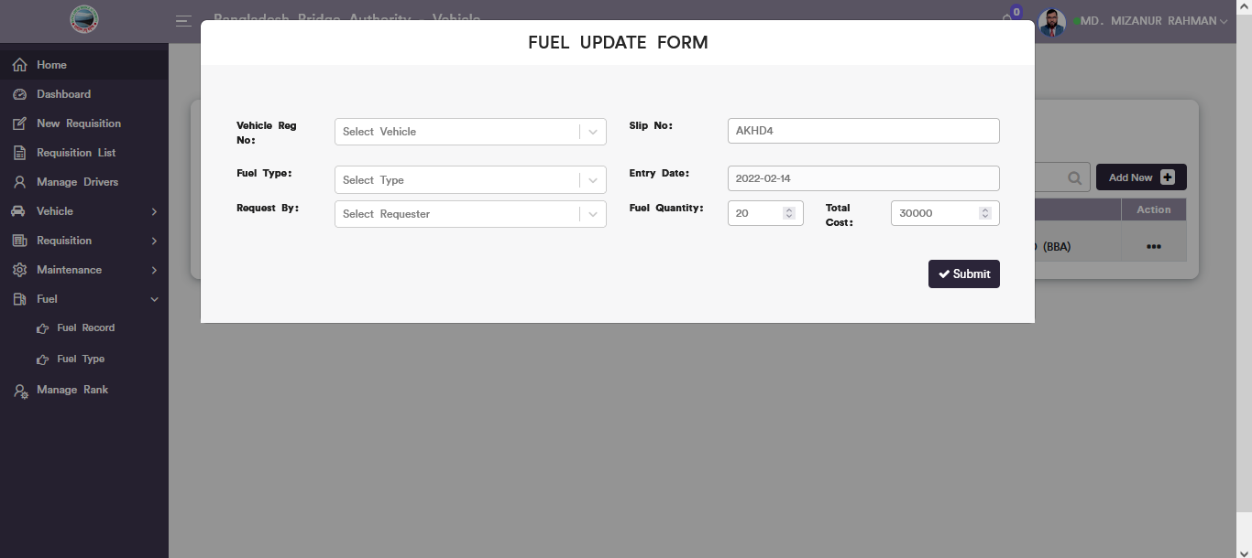

Figure 6.7.1.3: Update fuel record

### 6.7.1.4: Fuel Record(Fuel)Download Report

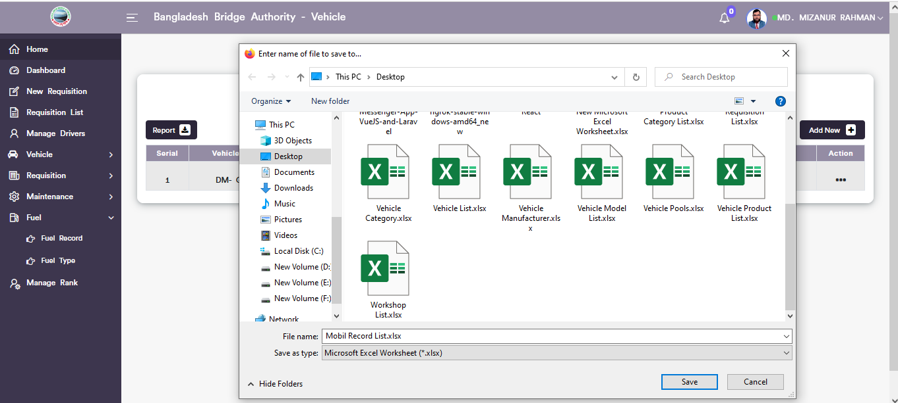

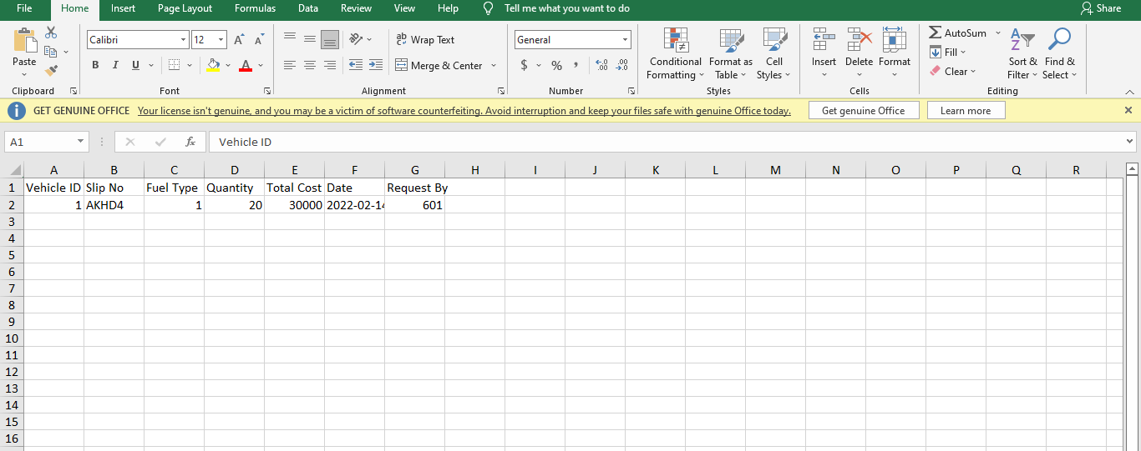

Figure 6.7.1.4: Download fuel record list

### 6.7.1.5: Fuel Record(Fuel)Search

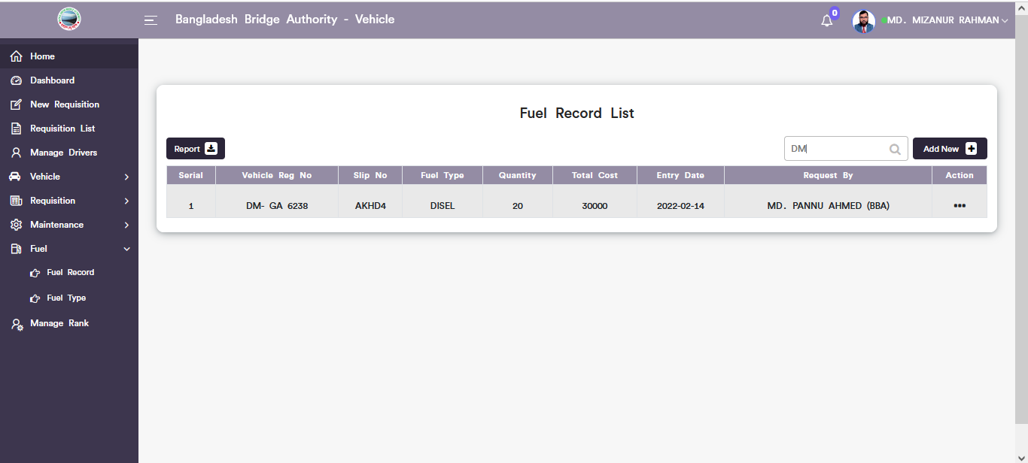

Figure 6.7.1.5: Search data from fuel record list

### 6.7.2.1: Fuel Type(Fuel)Add new fuel type form

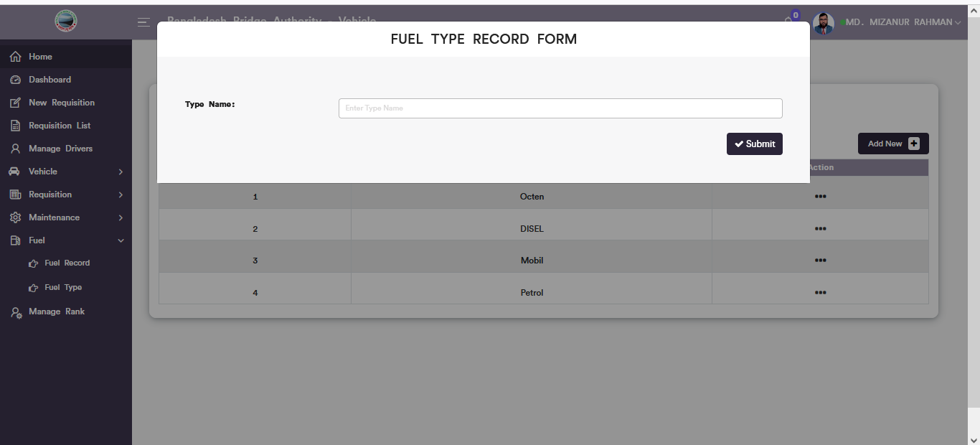

Figure 6.7.2.1: add new Fuel type input form

### 6.7.2.2: Fuel Type(Fuel)View of fuel type list

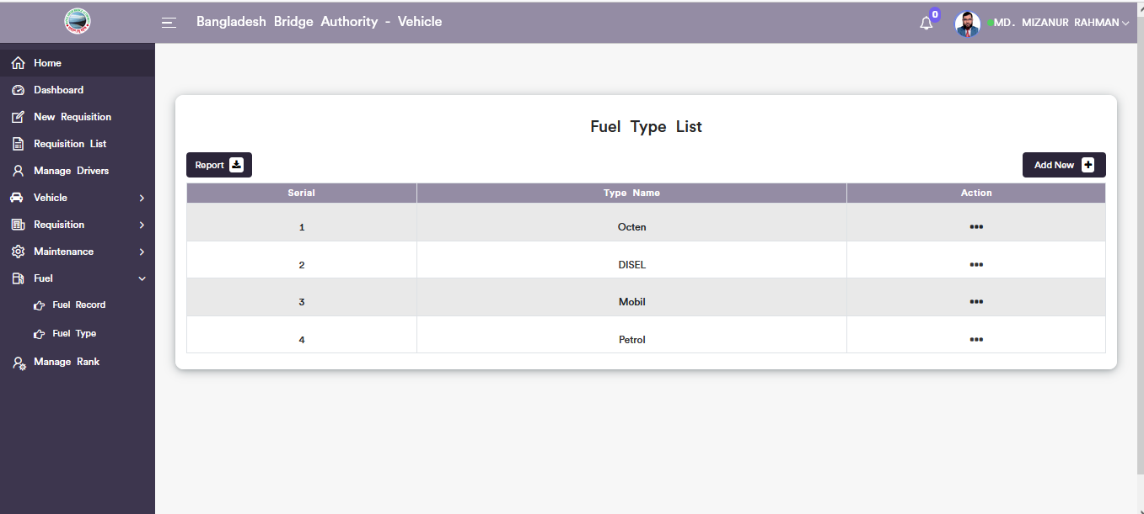

Figure 6.7.2.2: Fuel type list

### 6.7.2.3: Fuel Type(Fuel)Update fuel type data

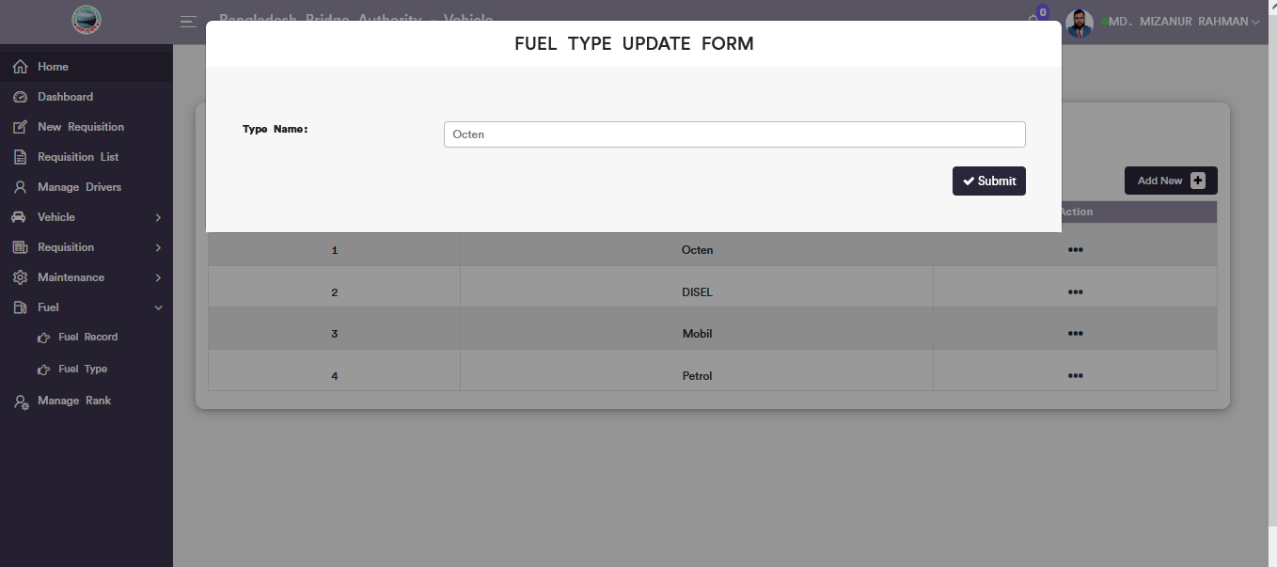

Figure 6.7.1.3: update fuel type data

### 6.7.2.4: Fuel Type(Fuel)Download Report

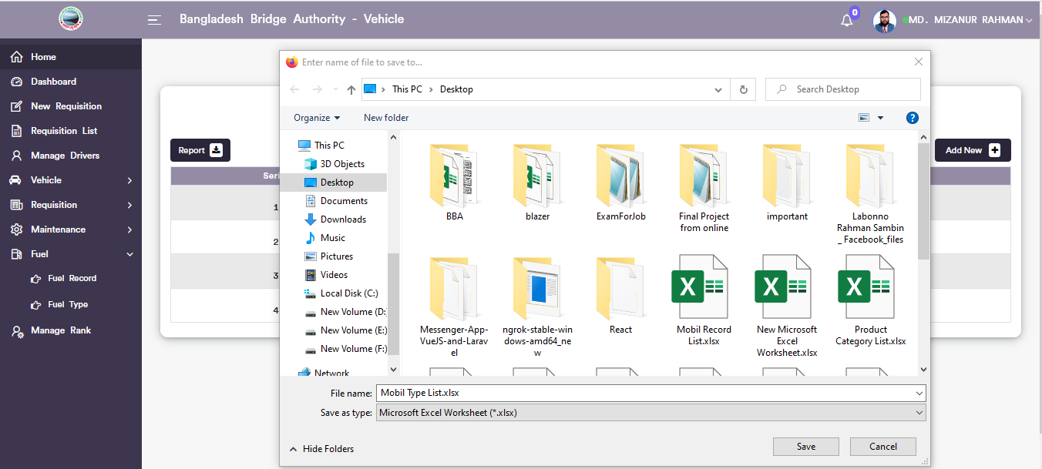

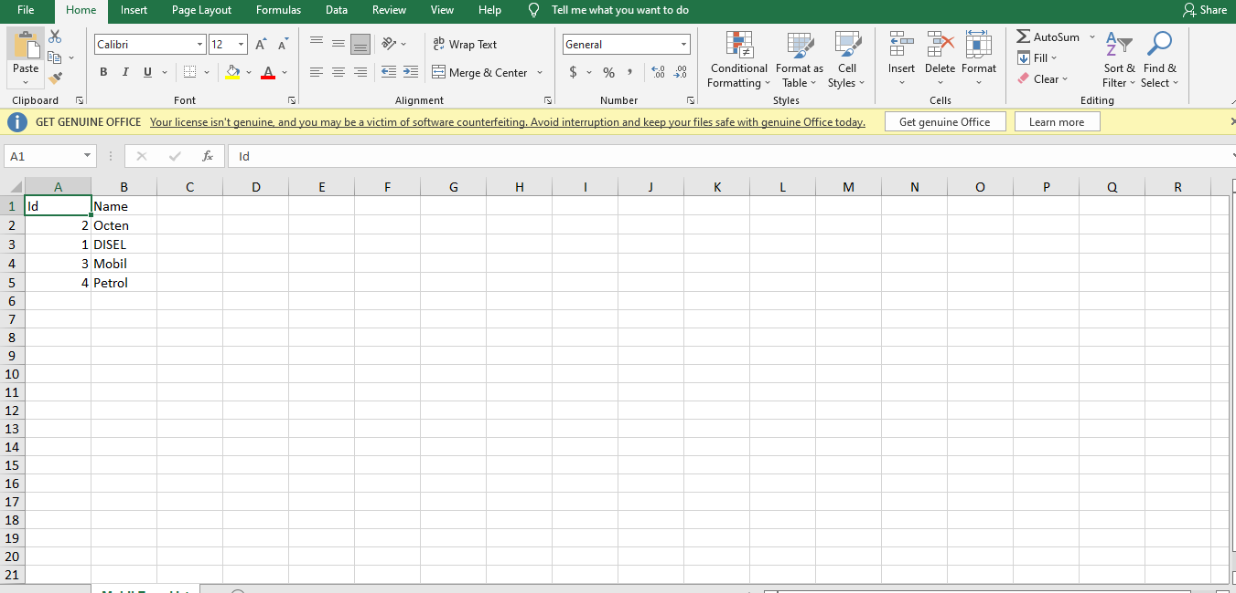

Figure 6.7.2.4: Download fuel type Report

## 6.8: Manage Rank Menu Overview

**Overview of Manage Rank**

### 6.8.1: (Manage Rank)View of requisition hierarchy rank list

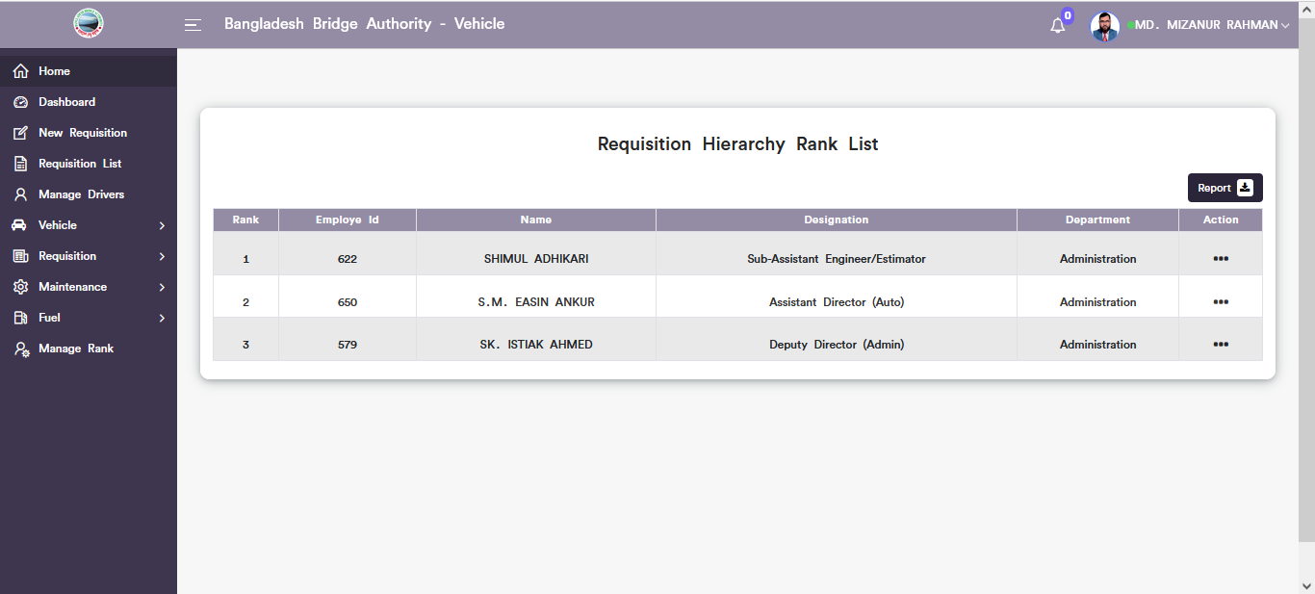

Figure 6.8.1: requisition hierarchy rank list

### 6.8.2: (Manage Rank)Update Requisition hierarchy

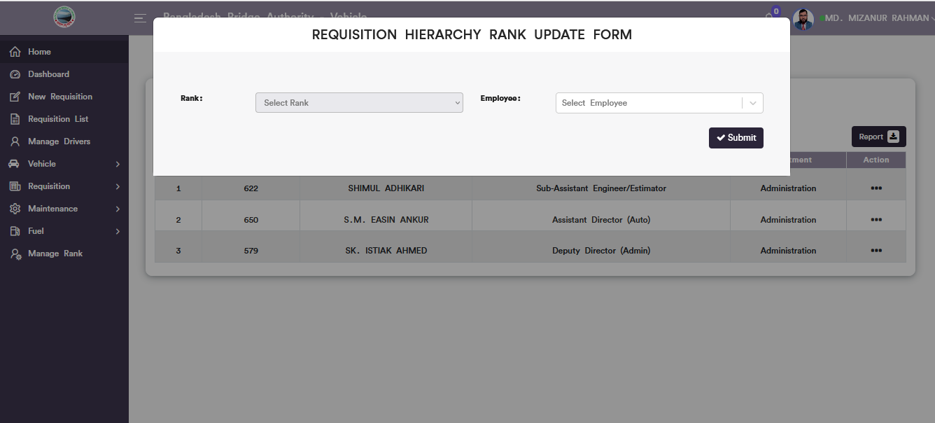

Figure 6.8.2: requisition hierarchy rank update form

### 6.8.3: (Manage Rank)Report download

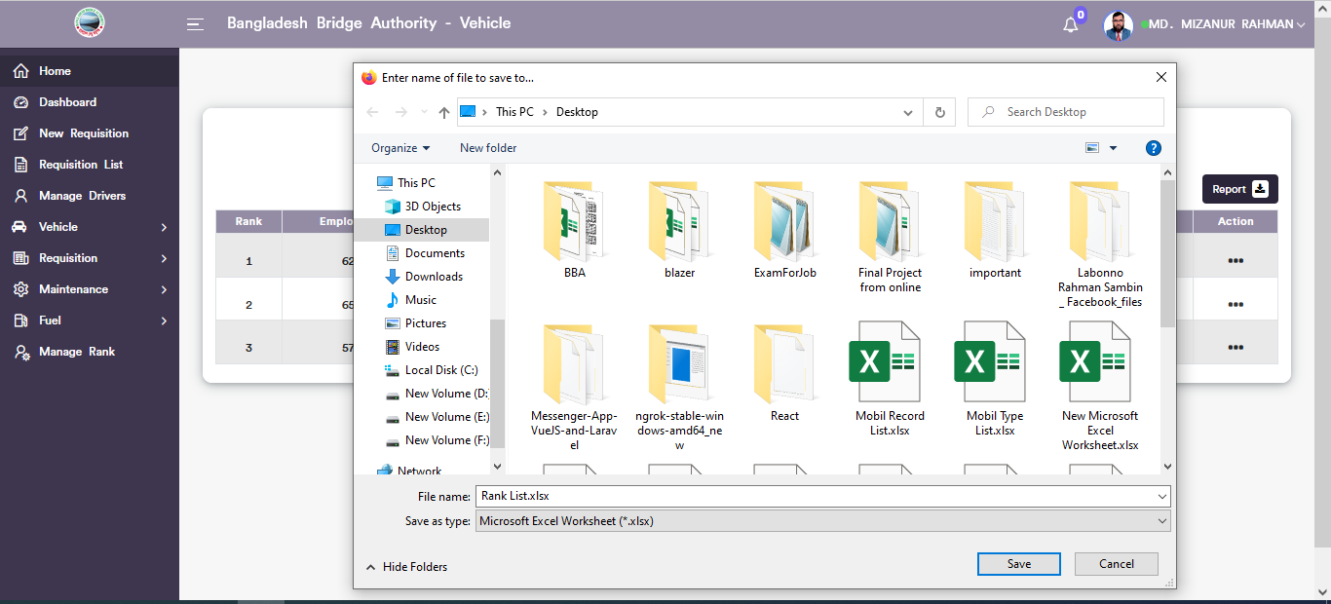

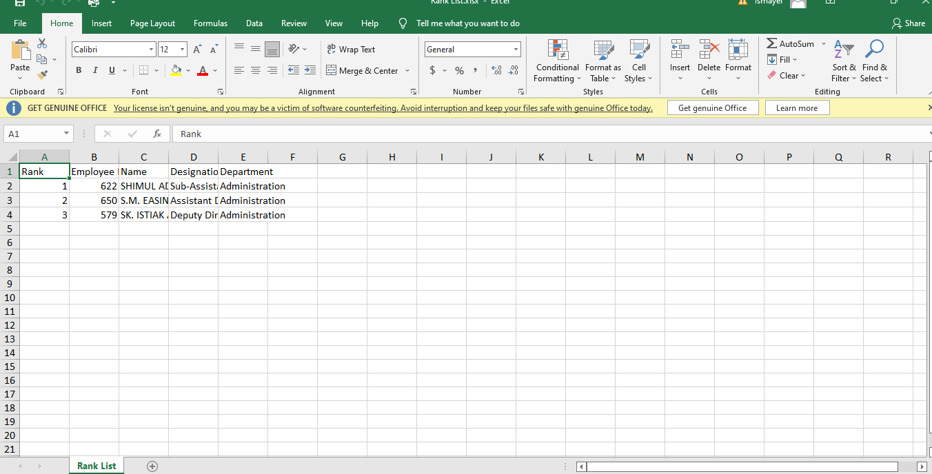

Figure 6.8.3: Requisition hierarchy rank Report download

# 7.IT (SUB MODULE)

After clicking into IT, it will redirect to the (IT Sub Module) dashboard with some menus.

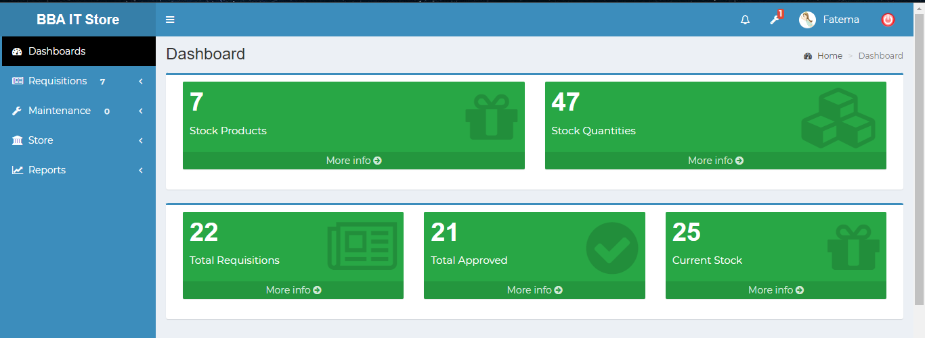

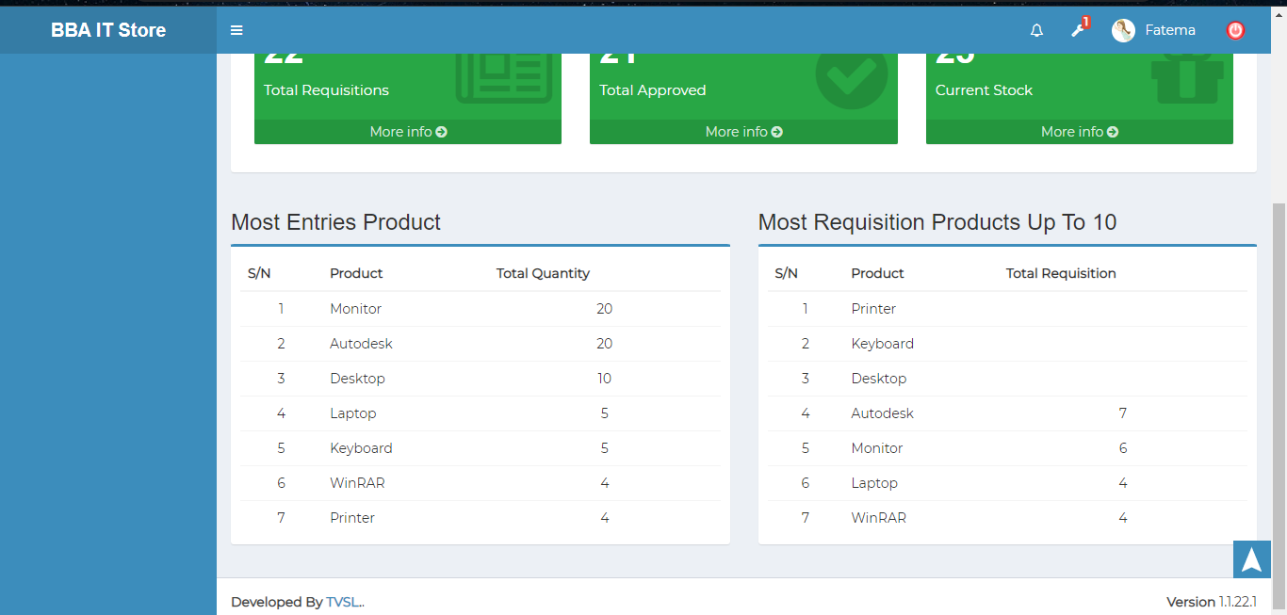

Figure 7: Dashboard of the IT (sub module).

There are five segments on the top right side of the IT Dashboard Such **Stock Products, Stock Quantities , otal Requisitions,Tota l Approved,and Current Stock.**

To get the details info about ( **Stock Products, Stock Quantities, Total Requisitions,Total Approved, Cand urrent Stock**) just click on the view after that it will redirect to the relevant details info page.

Bottom of the right side of he dashboard there are two tables and they are the **most Entries product table, and the most requisition products table.**

# 8.IT MENUS OVERVIEW

## 8.1: Requisitions Menu Overview

## 

**Overview of Requisitions**

### 8.1.1:Pending(Requisitions) View the pending all requisitions list

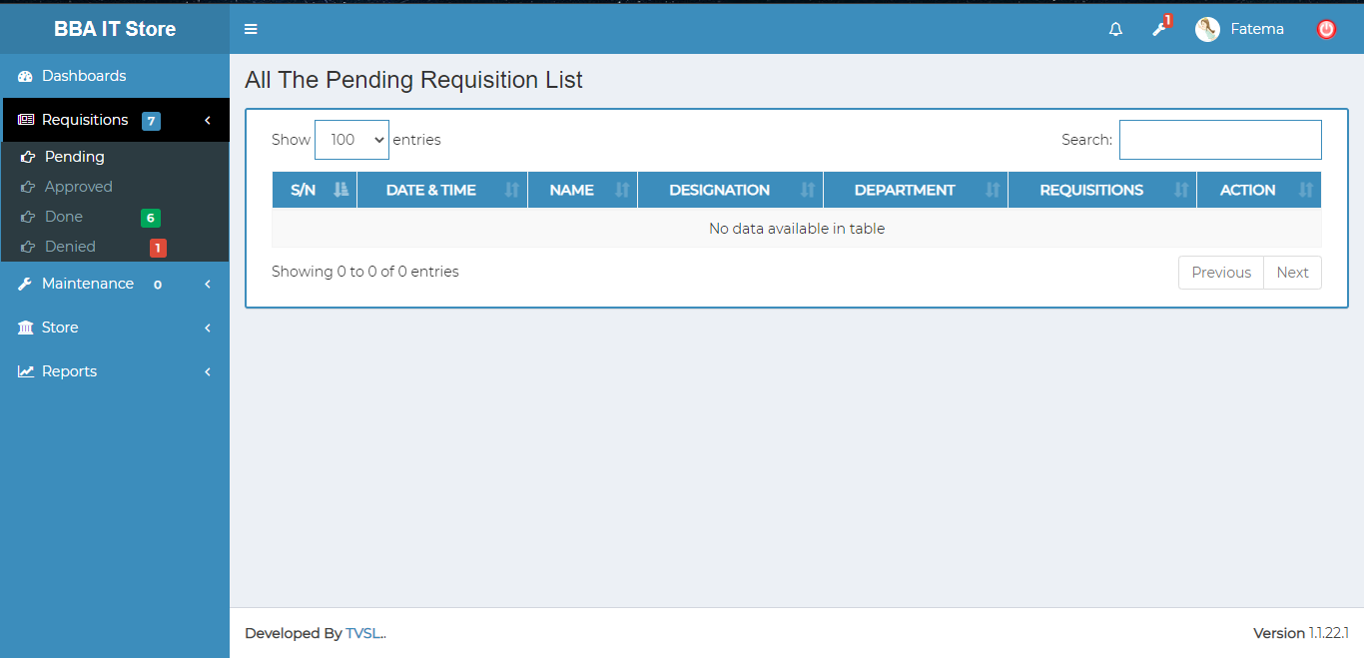

Figure 8.1.1: view the pending requisition list

### 8.1.2:Approved(Requisitions) View approved all requisitions list

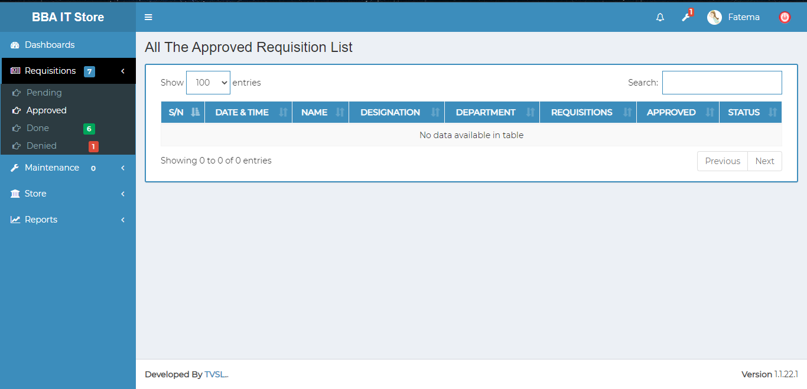

Figure 8.1.2: view Approved requisition list

### 8.1.3:Done(Requisitions) Complete all requisitions list view

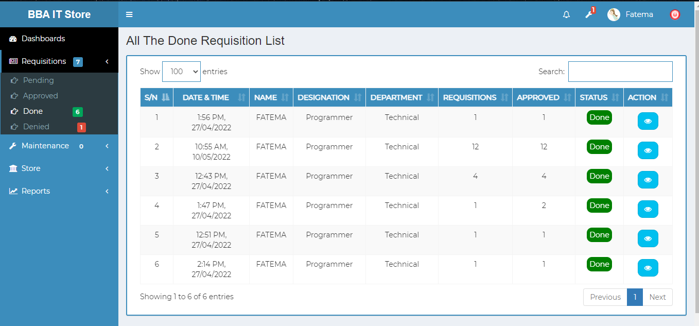

Figure 8.1.3: complete all requisitions list view

Complete single requisition details view: Click on the view button after that it will redirect to what looks like below scenario page.

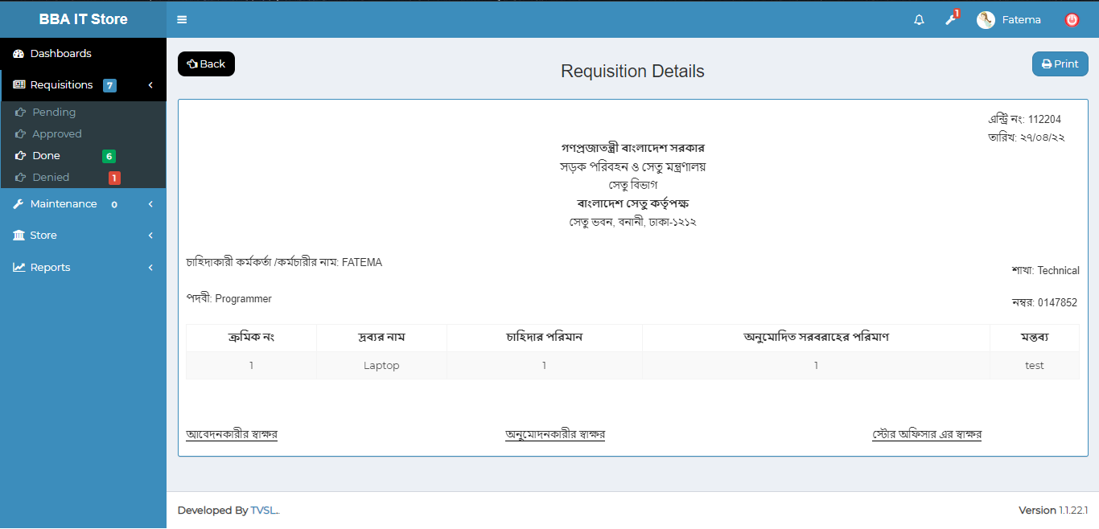

Figure 8.1.3.1: complete single requisition details view

Complete single requisition details print: Click on the print button after that looks like printing functionality will display.

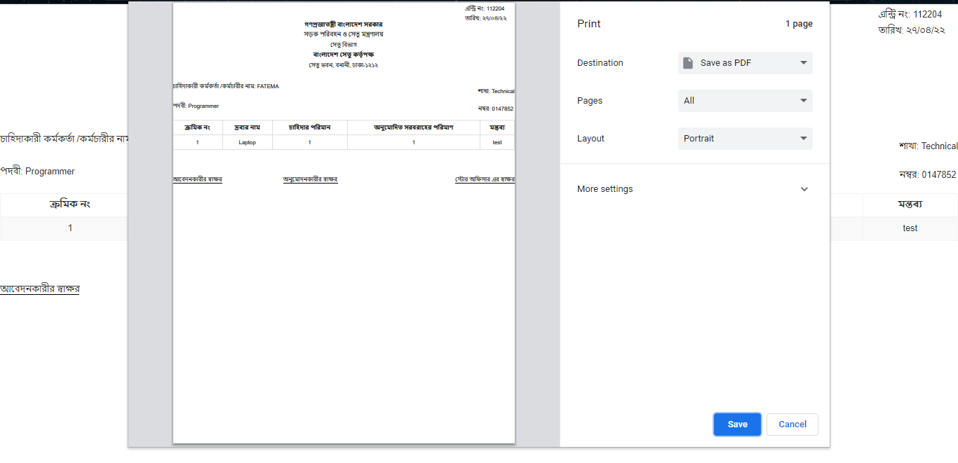

Figure 8.1.3.2: complete single requisition details print

### 8.1.4:Denied(Requisitions) **some problem has been occured**



Figure 8.1.2: view Approved requisition list

## 8.2: Maintenance Menu Overview

**Overview of Maintenance**

### 8.2.1.1:(Maintenance)View all the maintenance products information

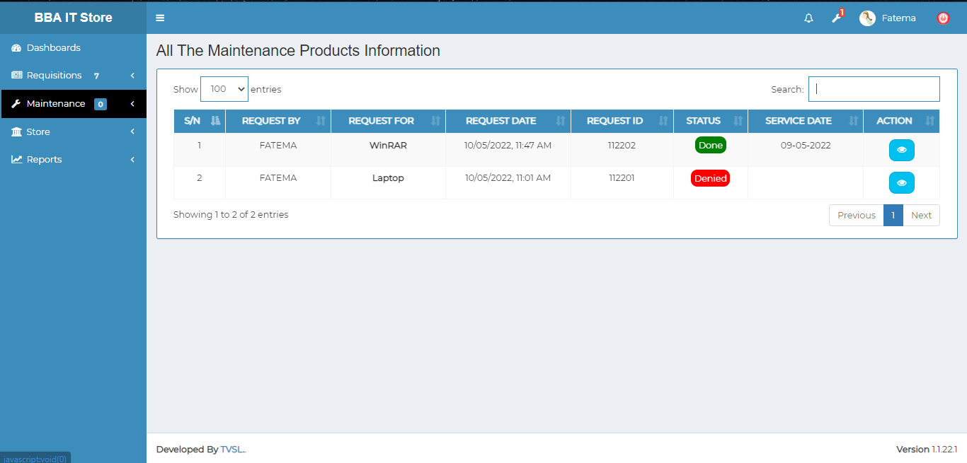

Figure 8.2.1.1: all the maintenance products information

View maintenance single products information : Click on the view button after that it will redirect to what looks like below scenario page.

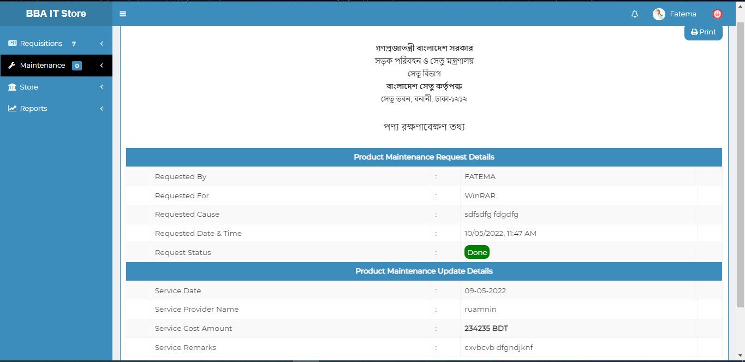

Figure 8.2.1.2: view maintenance single product information

Search specific data : Get the specific data from all the maintenance products information using search option.

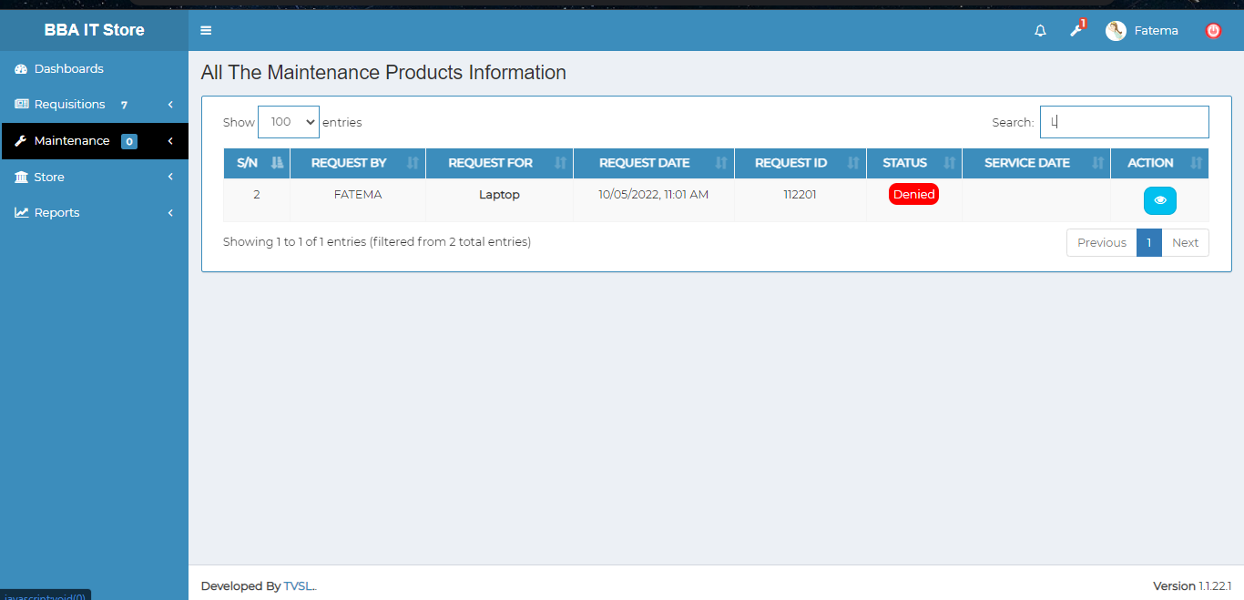

Figure 8.2.1.3: search maintenance products information

### 8.2.1.2:View(All Requisition)Search

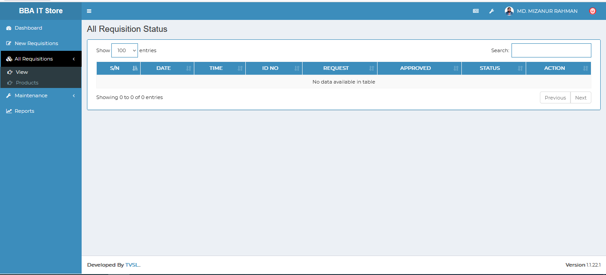

Figure 8.2.1.2: view( All requisition) Search

### 8.2.2.1.:Products(All Requisition)view requisition product details

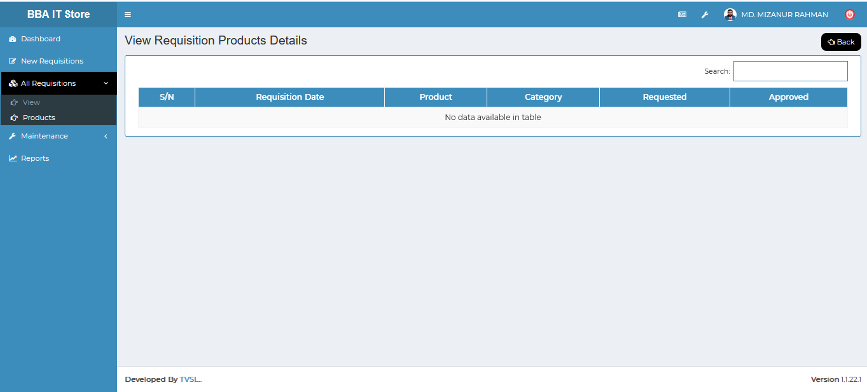

Figure 8.2.2.1: Products( All requisition) view requisition products details

### 8.2.2.2:Products(All Requisition)Search

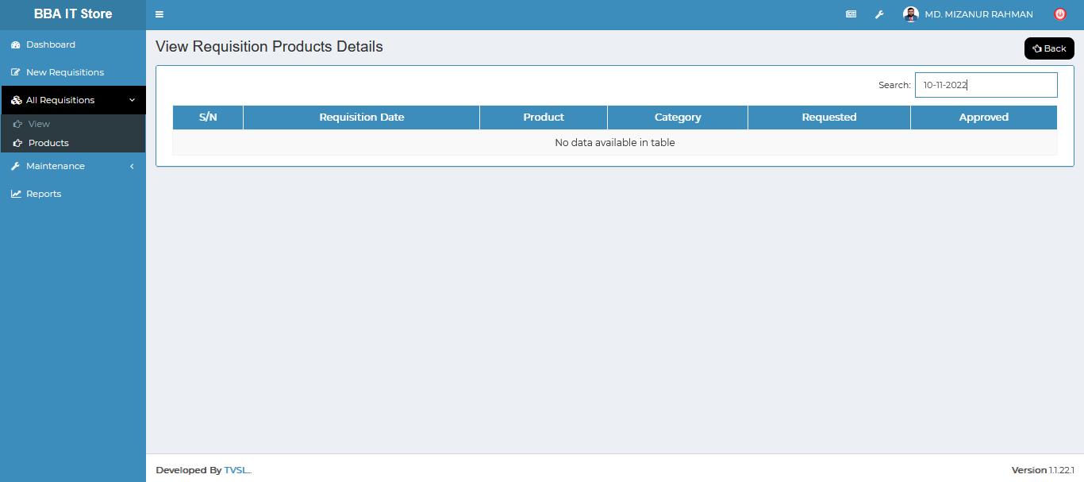

Figure 8.2.2.2: Products( All requisition) Search

## 8.3: Store Menu Overview

**Overview of Store**

### 8.3.1:Products(Store)View all bba store products

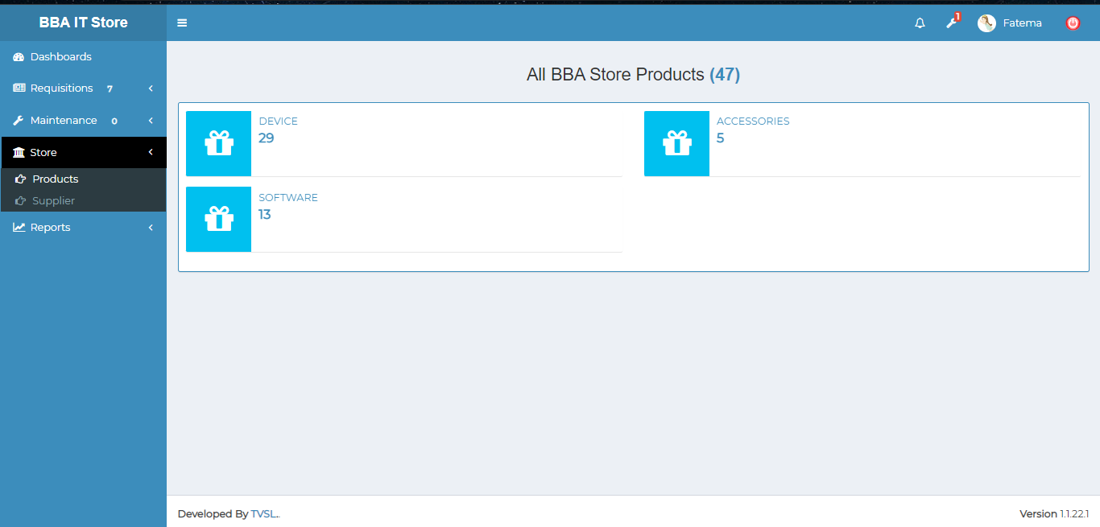

Figure 8.3.1: View bba all store products

### 8.3.2:Supplier(Store) View Supplier wise product information.

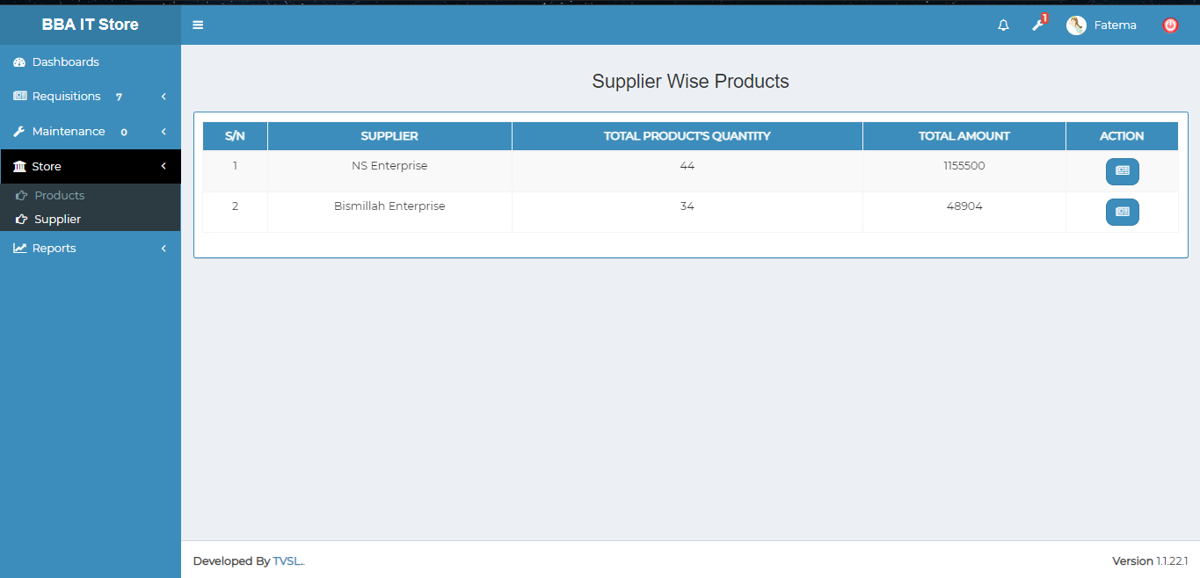

Figure 8.3.2: view supplier wise all products information

Individual Supplier Product Receipt list: Click on the receipt button after that it will redirect to looks like the product receipt page.

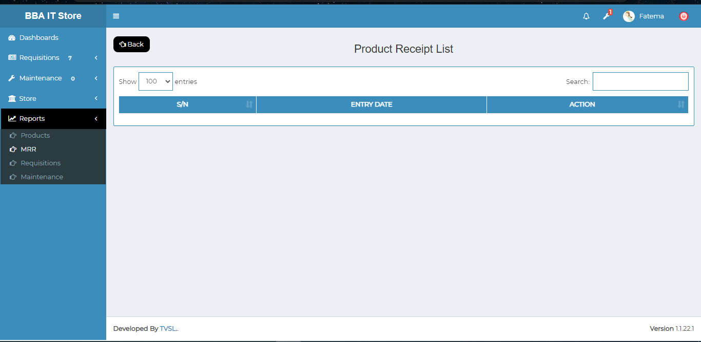

Figure 8.3.2.1: Individual supplier product receipt list

## 8.4: Reports Menu Overview

### 8.4.1:Products(Reports)Products report generator input field & Result

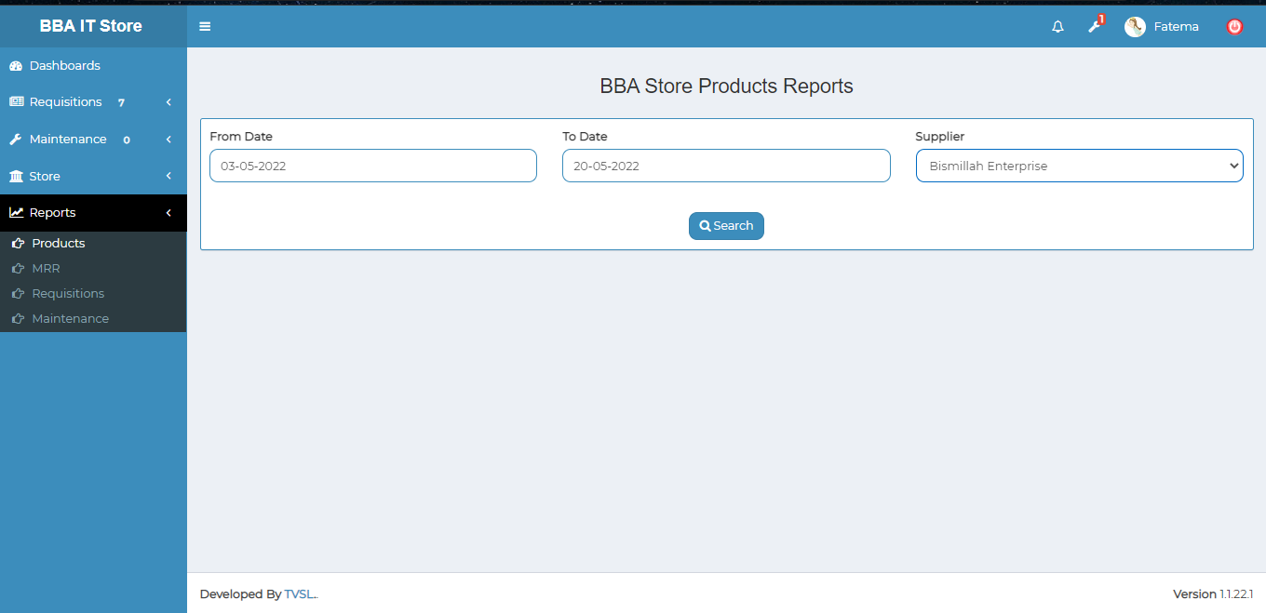

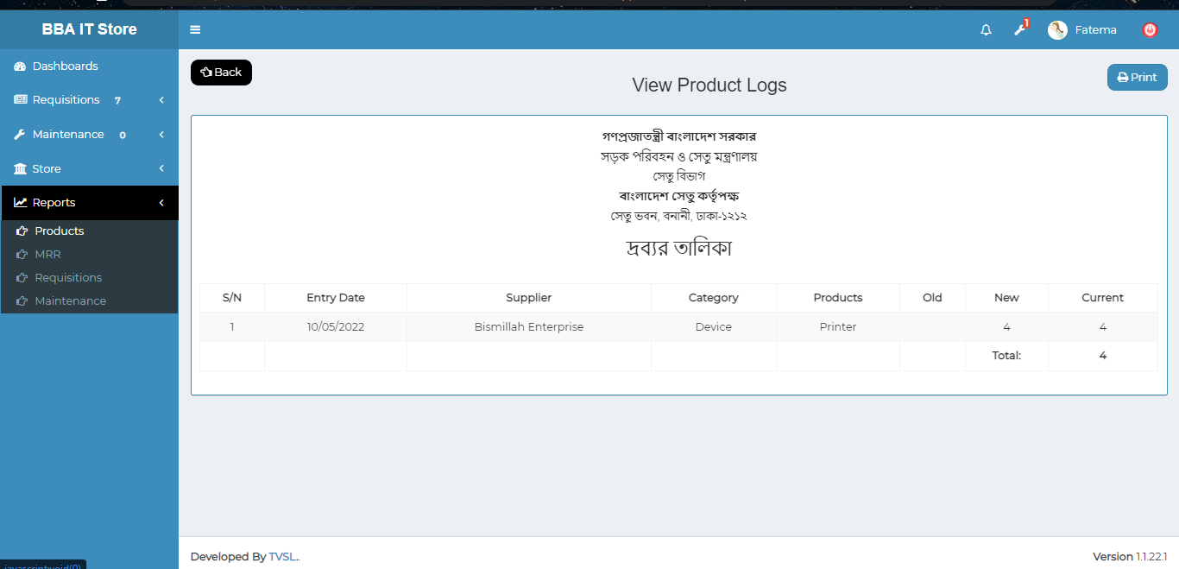

Figure 8.4.1: Product report generator input field and result

### 8.4.2:MRR(Reports)Supplier wise products view and receipt list

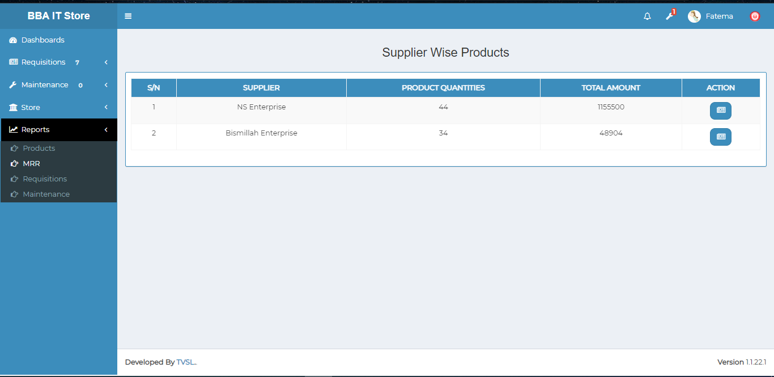

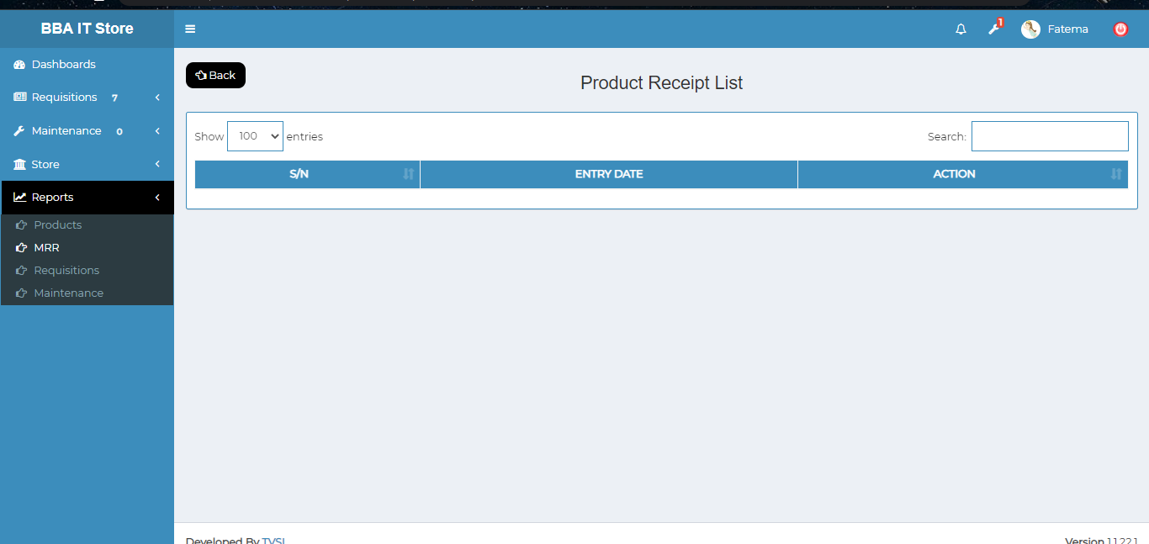

Figure 8.4.2: supplier wise products view & receipt list

### 8.4.3:Requisitions(Reports)Category wise requisitions report generator

**Date/Month Wise requisition report generating Process:**

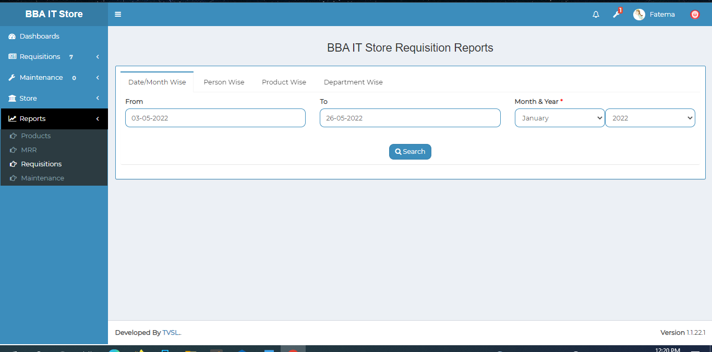

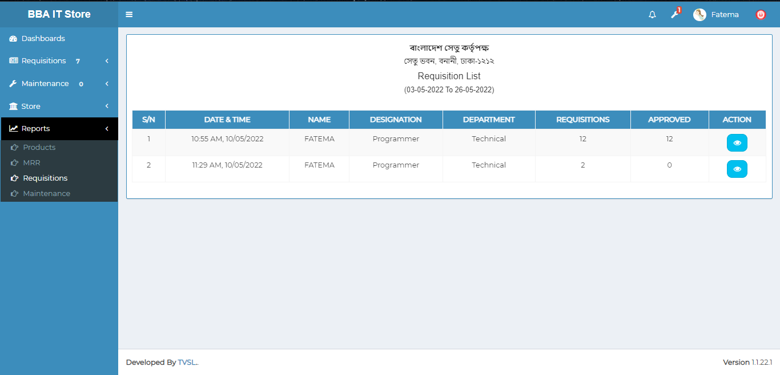

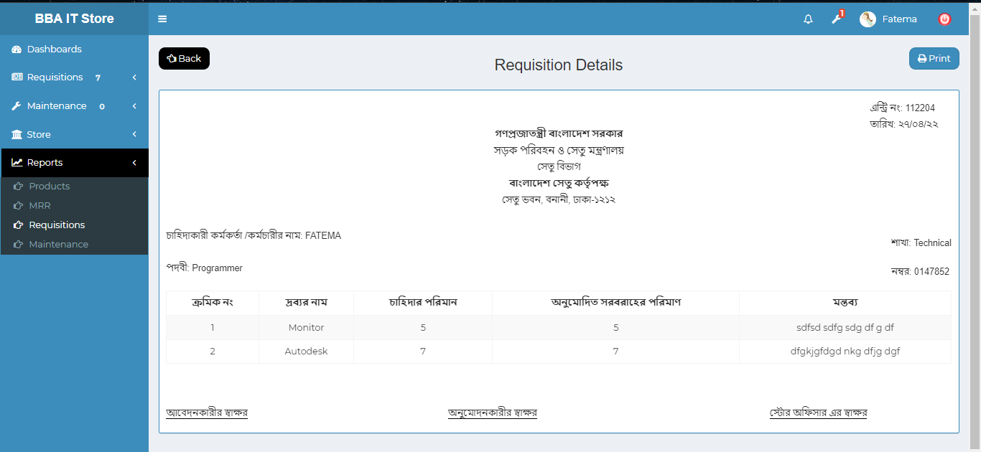

Figure 8.4.3.1: Date/Month wise requisition report generator process

**Person Wise requisition report generating Process:**

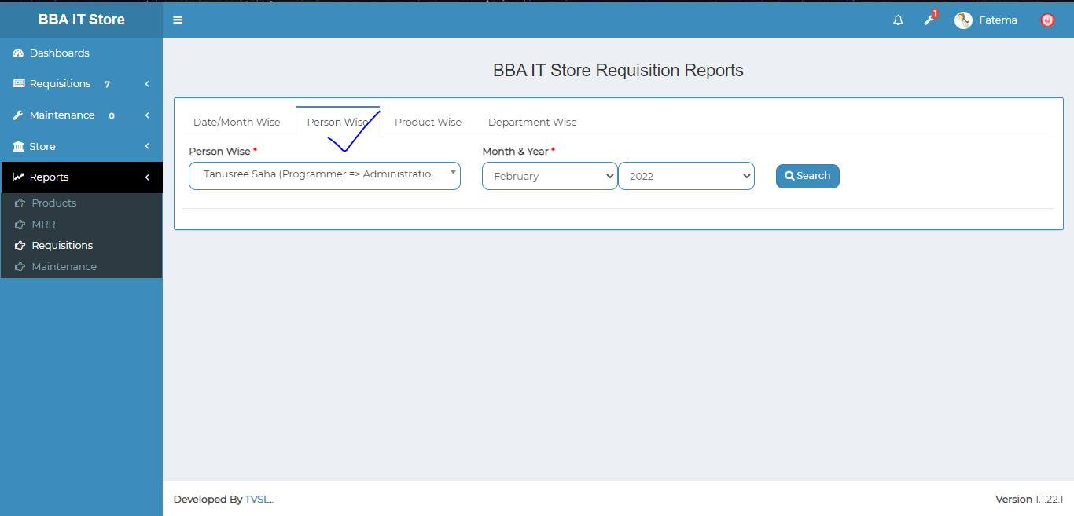

Figure 8.4.3.2: person wise requisition report generator process

**Product Wise requisition report generating Process:**

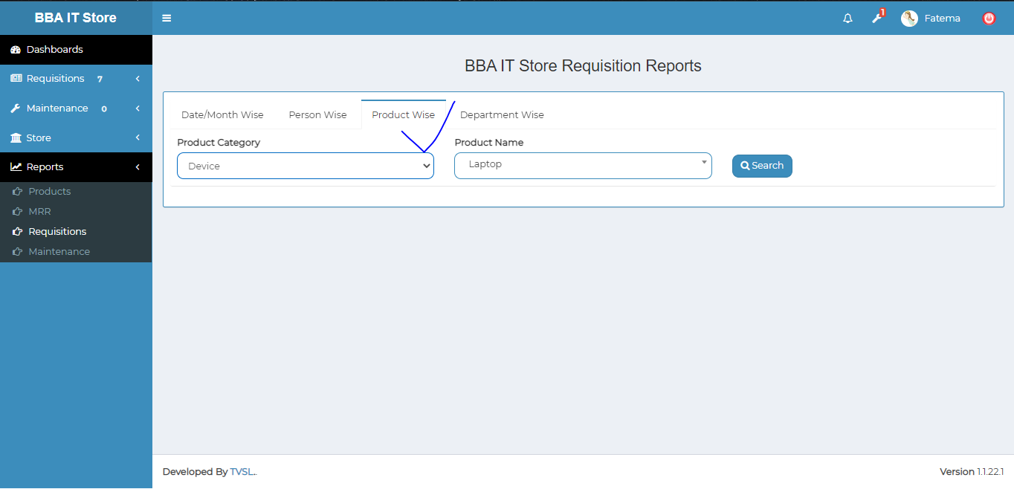

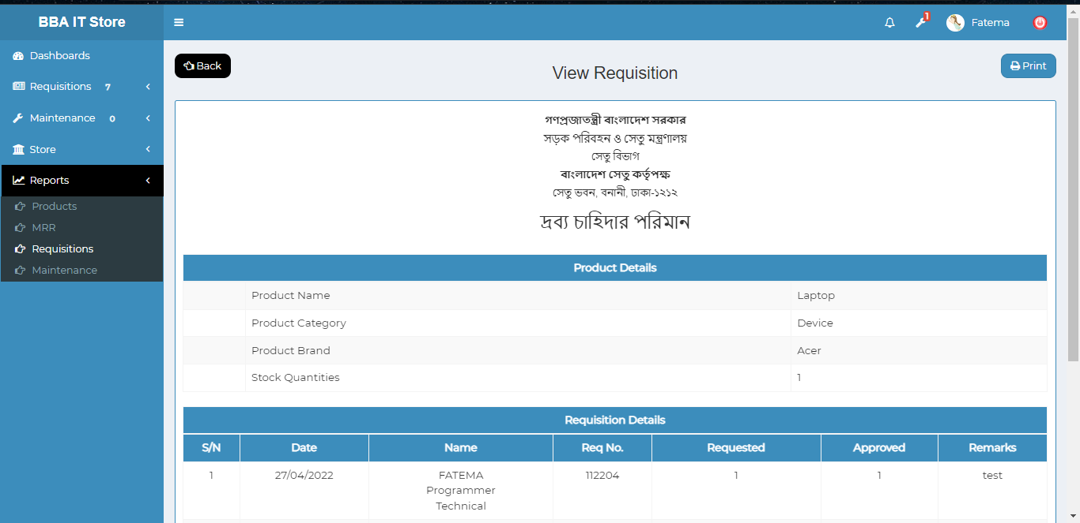

Figure 8.4.3.3: product wise requisition report generator process

**Departmant Wise requisition report generating Process:**

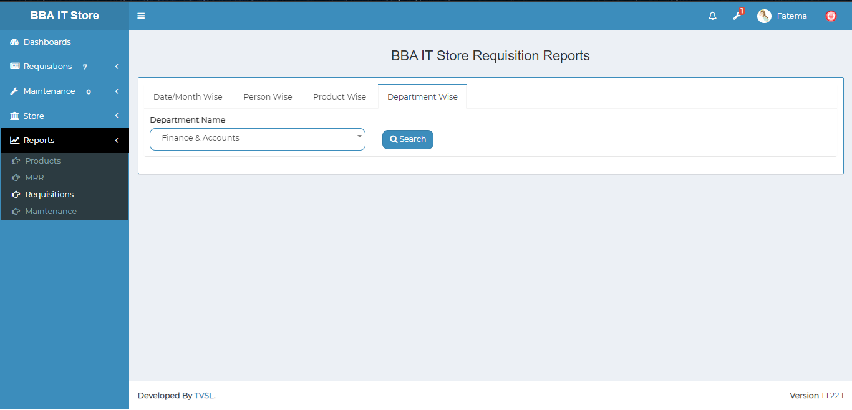

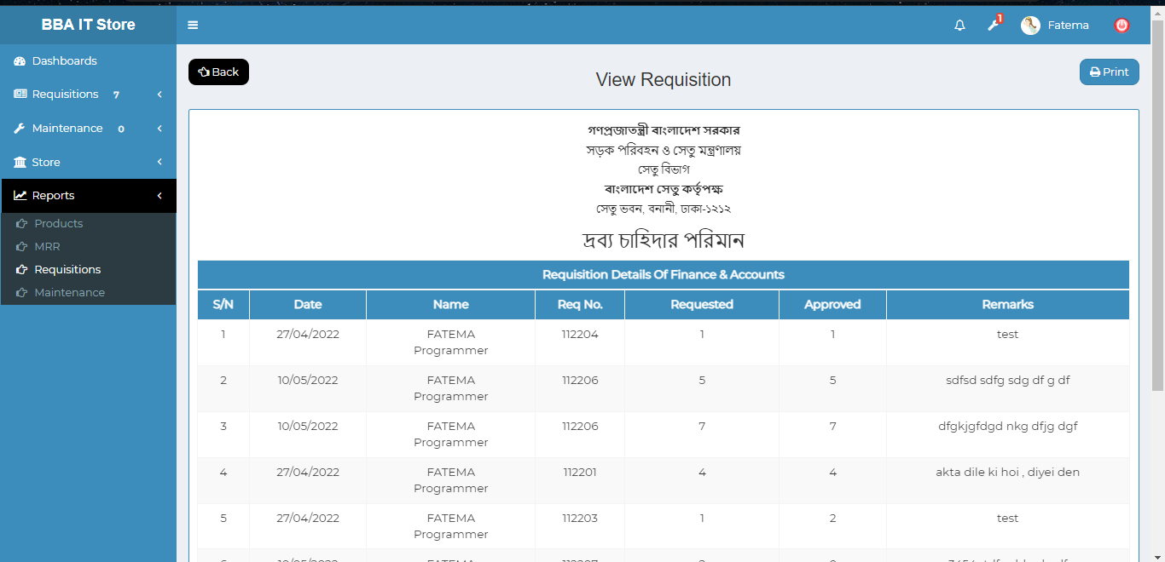

Figure 8.4.3.4: Department wise requisition report generator process

### 8.4.4:Maintenance(Reports)Product maintenance report generator & result

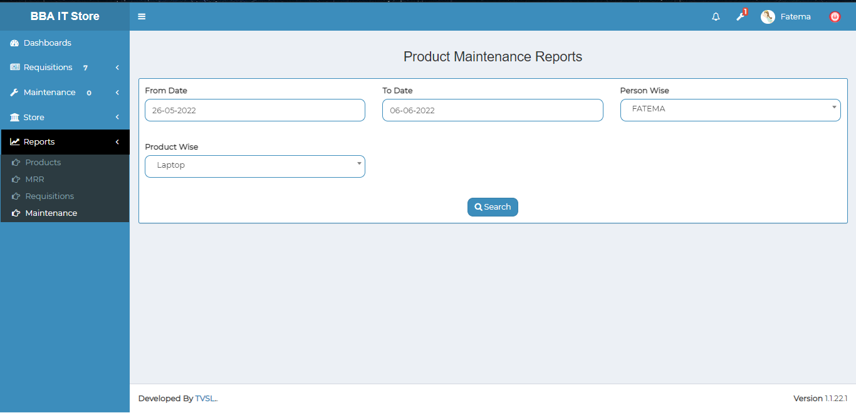

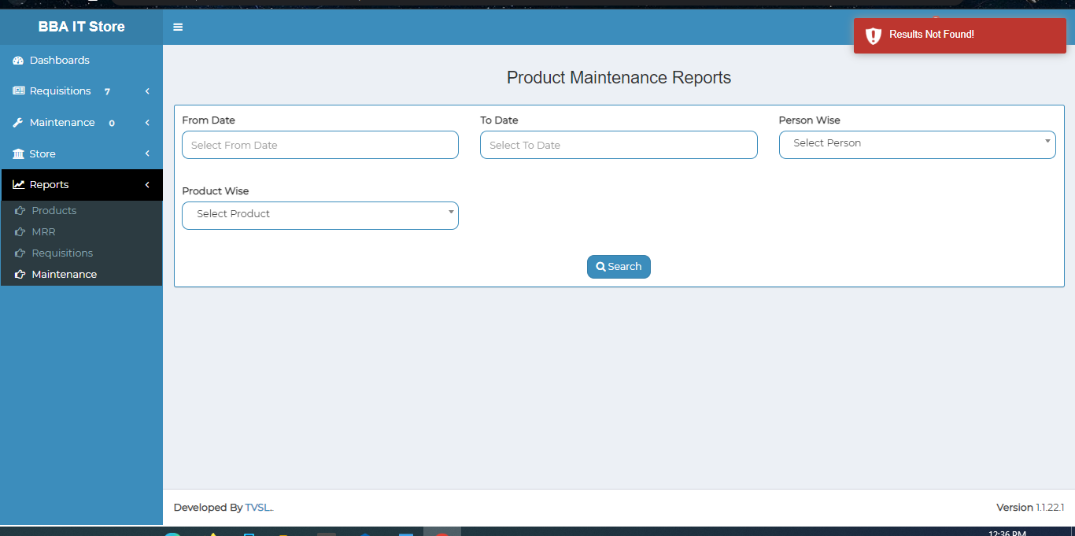

Figure 8.4.4: product maintenance report generator input field and result